Subject: Golf in San Diego (a South American Paradise)…

Yes, there actually is a place called San Diego in South America. I’m living there right now. Here’s the spectacular view from the balcony of my 24th floor apartment:

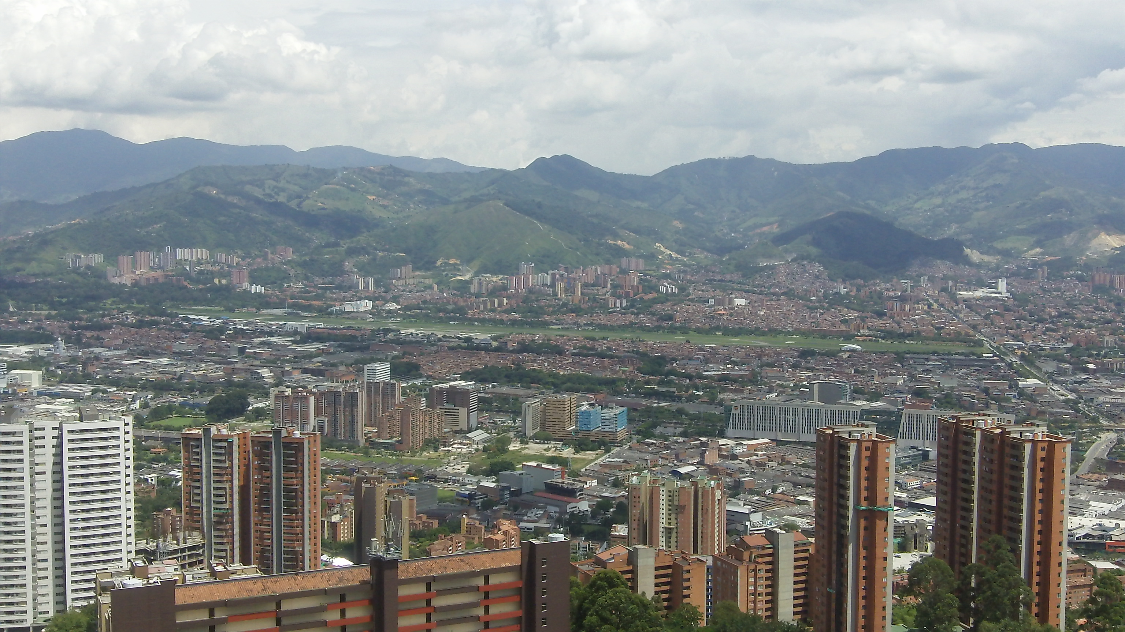

Can you see the airport? More on what’s so interesting about the airport a bit later!

San Diego is not the name of the city. It’s a neighborhood in the city. There’s no beach here like in San Diego, California. This paradise is nestled in a valley surrounded by a famous mountain range.

I have lived in San Diego, California, and believe it or not I think the weather is actually better here. The mornings are nice and cool with temperatures in the 60s as the sun rises over the Aburra Valley.

The afternoons are pleasant and warm with plenty of sunshine and highs in the low to mid 80s. Then the temperature cools down again as the sun sets majestically behind the mountains.

Sure, there is an occasional short rainy season. After all no place is perfect, right? Other than that though, you’ll experience the same nearly perfect weather day after day because this South American paradise is located near the equator so there are no seasons.

The weather is the same year round. To give you an idea, I rarely close the windows or the sliding glass door to the balcony. Neither heat nor air conditioning is necessary here at any time of the year.

And of course, you’ll find golf too. Unfortunately there are disappointingly few options as golf is not so popular here. However, I have played the home course of a certain PGA pro whose name you would definitely recognize. I’ll reveal his name later but I’m going to remain a bit mysterious for now.

One of the unique characteristics of this course is its location. The golf course is located near a small airport. I mean very near! And there is a steady flow of planes landing. These aircraft are especially noticeable on the first and last several holes.

And the runway is so near the 2nd and 17th holes that you seriously feel like you could hit the plane with your golf ball. If you don’t believe it, take a look for yourself and let me know what you think (My apologies in advance. I’m no professional videographer!):

[3 videos here] [http://UltimateJobToolkit.com/El-Rodeo/ - hint: the ones that have the word “plane” in the file and are .mov files]

I’ve played this particular course (the name of which I will reveal soon) several times now and I don’t find the planes particularly distracting to be honest. It’s not like there’s a plane landing every minute.

You can only see the planes on about six or eight holes and you can hear them coming so it’s no problem to back off for a few seconds to let a plane fly over your head.

I actually love this little quirk of the golf course. If nothing else, it’s certainly unique. I’ve never seen another golf course located so close to an airport.

The course itself can be quite challenging if you play from the back two tee boxes. Certain holes can be long and narrow. At 5,000 feet though, the length is not really an issue. I’m at least one club longer at this altitude – maybe two. Trust me, that makes you feel really good about your game!

The course plays much shorter and is quite a bit less challenging from the forward tee boxes. And the biggest challenge may not even be hitting some of the narrower fairways.

That’s because some of the greens are lightning fast. I don’t have a stimpmeter so I can’t give you a number. What I can tell you is I felt like I was putting on a parking lot or a sidewalk sometimes!

I’ll have more to share on this mountain paradise in my next message. You may be SHOCKED because having spent several months here I can tell you the world’s perception of this place is quite a bit different than the reality.

I’ll share more photos of the course too.

Until then…

Dedicated to Lower Scores and More Fun,

Robert “Mr. International Golfer” Phillips

P.S. Can you guess where I am? And what course I’ve been playing? Without using the Internet to cheat! Hit reply and send me your guess. I’ll reveal the answer in my next message.

NEXT POST

Subject: Spiderman’s Home Course (Part 2)…

In my last message, I introduced you to a mountain paradise in South America where I’ve been living and playing golf for the past several months. I told you how close the course was to an airport and even shared some videos of the planes flying so low you feel you could hit them with your golf ball.

If you missed that post, you can read it and see the videos here:

[link]

Today I’m going to reveal the location of this mountain paradise and explain why the world’s perception is so far off from the reality I’ve experienced in person. And I’ll share more about the course too.

Last time I teased that this was the home course of a PGA golfer whose name you’d recognize. That golfer is Camillo Villegas (aka Spiderman or Hombre Arana in Spanish). He learned to play golf at El Rodeo Golf Club in Medellin, Colombia.

That’s where I’ve been living for the past few months and I have to say I have thoroughly enjoyed it. I’m seriously considering making this my home base.

It’s near the equator so you’d think it’s hot and humid but it’s not. That’s because Medellin is located in the Andes mountains at an elevation of 5,000 feet. As a result the weather is nearly perfect year round – at least if you like an average temperature of 72 degrees.

And that doesn’t mean the average temperature is 92 some months and 52 other months for an average of 72. The average temperature is 72 degrees every single month of the year. There are no seasons since Medellin is located so near the equator. That’s why it is known as “The City of the Eternal Spring.”

Frankly, I’m at least a bit reluctant to share my experience because I’d rather this mountain paradise remained under the radar – at least until I invest in some real estate!

Seriously, though the world’s perception of Medellin, Colombia, is almost the polar opposite of what I’ve experienced in person. This is absolutely NOT the violent, drug infested, hellhole you may think it is.

Here’s a newsflash: Pablo Escobar took a bullet to the head over 20 years ago and the city has undergone a massive transformation for the better over the past two decades.

As a matter of fact, just last year Medellin, Colombia beat out New York City and Tel Aviv in being named The Most Innovative City in the World. I bet you didn’t know that! If you don’t believe me look it up on the Interwebs.

In other words, over the past two decades Medellin has transformed itself from a well-deserved reputation as “The World’s Most Dangerous City” during the Pablo Escobar days to now being known as “The World’s Most Innovative City.”

And it’s closer to America than you think. Medellin is actually about as close to Miami as Chicago. There are regular 3.5 hour non-stop flights from south Florida to Medellin on JetBlue and several other airlines. So getting here is easy.

Don’t get me wrong. Medellin is not perfect. No place is. There is crime here. You’re going to find crime in any city with a population of over 3 million. But I can say without hesitation that I feel infinitely safer walking around the streets of Medellin than I ever did when I lived in Baltimore.

OK, enough about Medellin. Like I said, I’d rather this place stayed under the radar for several more years. And this is about golf, right?

So let’s move on to El Rodeo – the golf course I’ve been playing while I’m living here. Unfortunately it’s a private course so you have to know somebody. But I’m pretty good at meeting people so it didn’t take me long to ask around and find a member who invited me to play.

The greens fees are very reasonable at around $40 during the week. They’re a bit higher on the weekends – about $65. There are no golf carts here so you’ll get a good workout walking the course considering it’s in the Andes mountains!

The good news is you’re required to use a caddie who will carry your bag. And the caddies are not expensive. You give them a “propina” or tip after the front nine and again after the back nine.

I always give my caddies 20,000 COP (Colombian Pesos). That’s a little more than $10 with the exchange rate these days at roughly 1,900 COP to one American dollar.

There are 4 tee boxes to choose from and here are the figures straight from the scorecard.

The Blue (or Azules) tees measure 6,808 yards with a rating of 71.1 and a rating of 132.

The Whites (or Blancas) play 6,512 yards (70.3/129).

The Whites/Reds (Blancas/Rojas) are 6,131 yards (73.6/131). I don’t know the origin of the name Whites/Reds. It must be a Colombian thing!

And finally the Red (or Rojas) tees at 5,604 (70.7/124)

By the way, the course is marked in yards, not meters so that is quite helpful. After all, golf is hard enough without having to convert meters to yards every shot!

The first hole is a 405-yard par 4 (from the white tees where I teed it up). Here’s the sign:

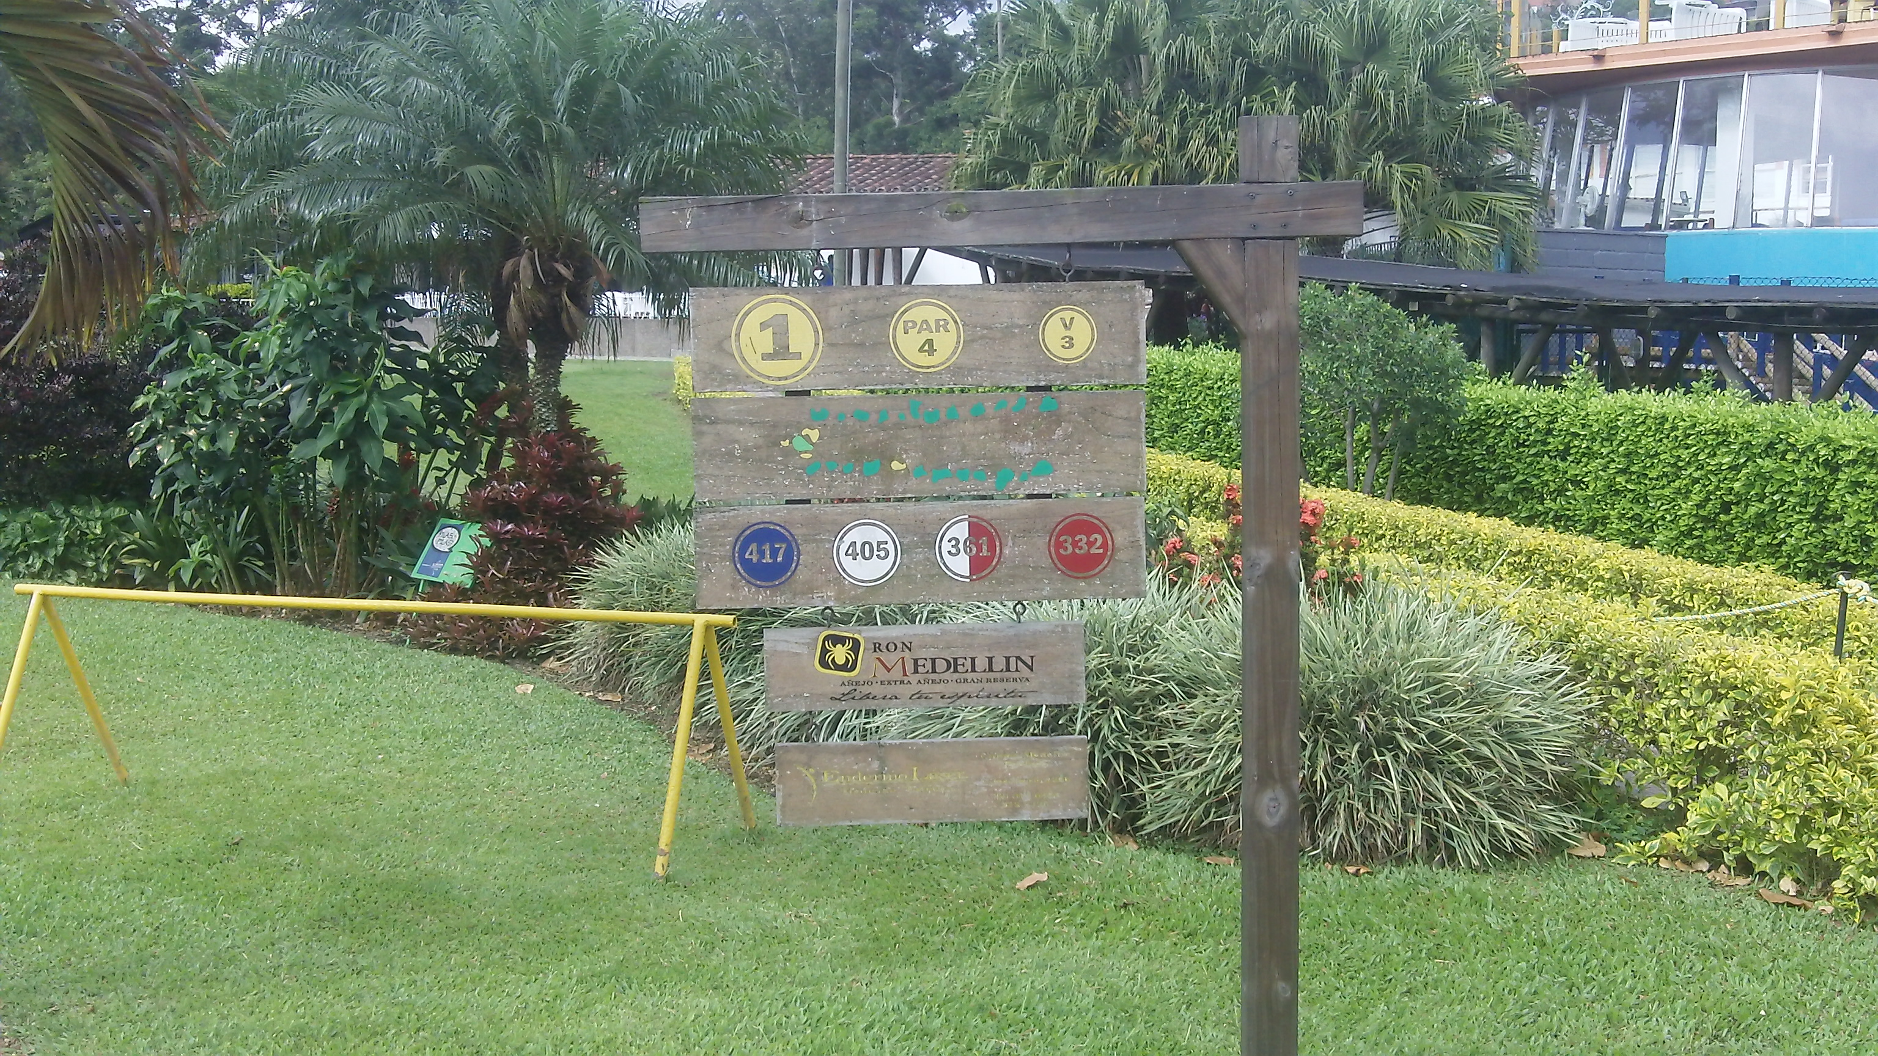

It’s a bit downhill with a slight dogleg right. You may want to favor the right side since the fairway slopes left.

It was bit hazy on this particular morning but you can still see the incredible view of the city from the first tee:

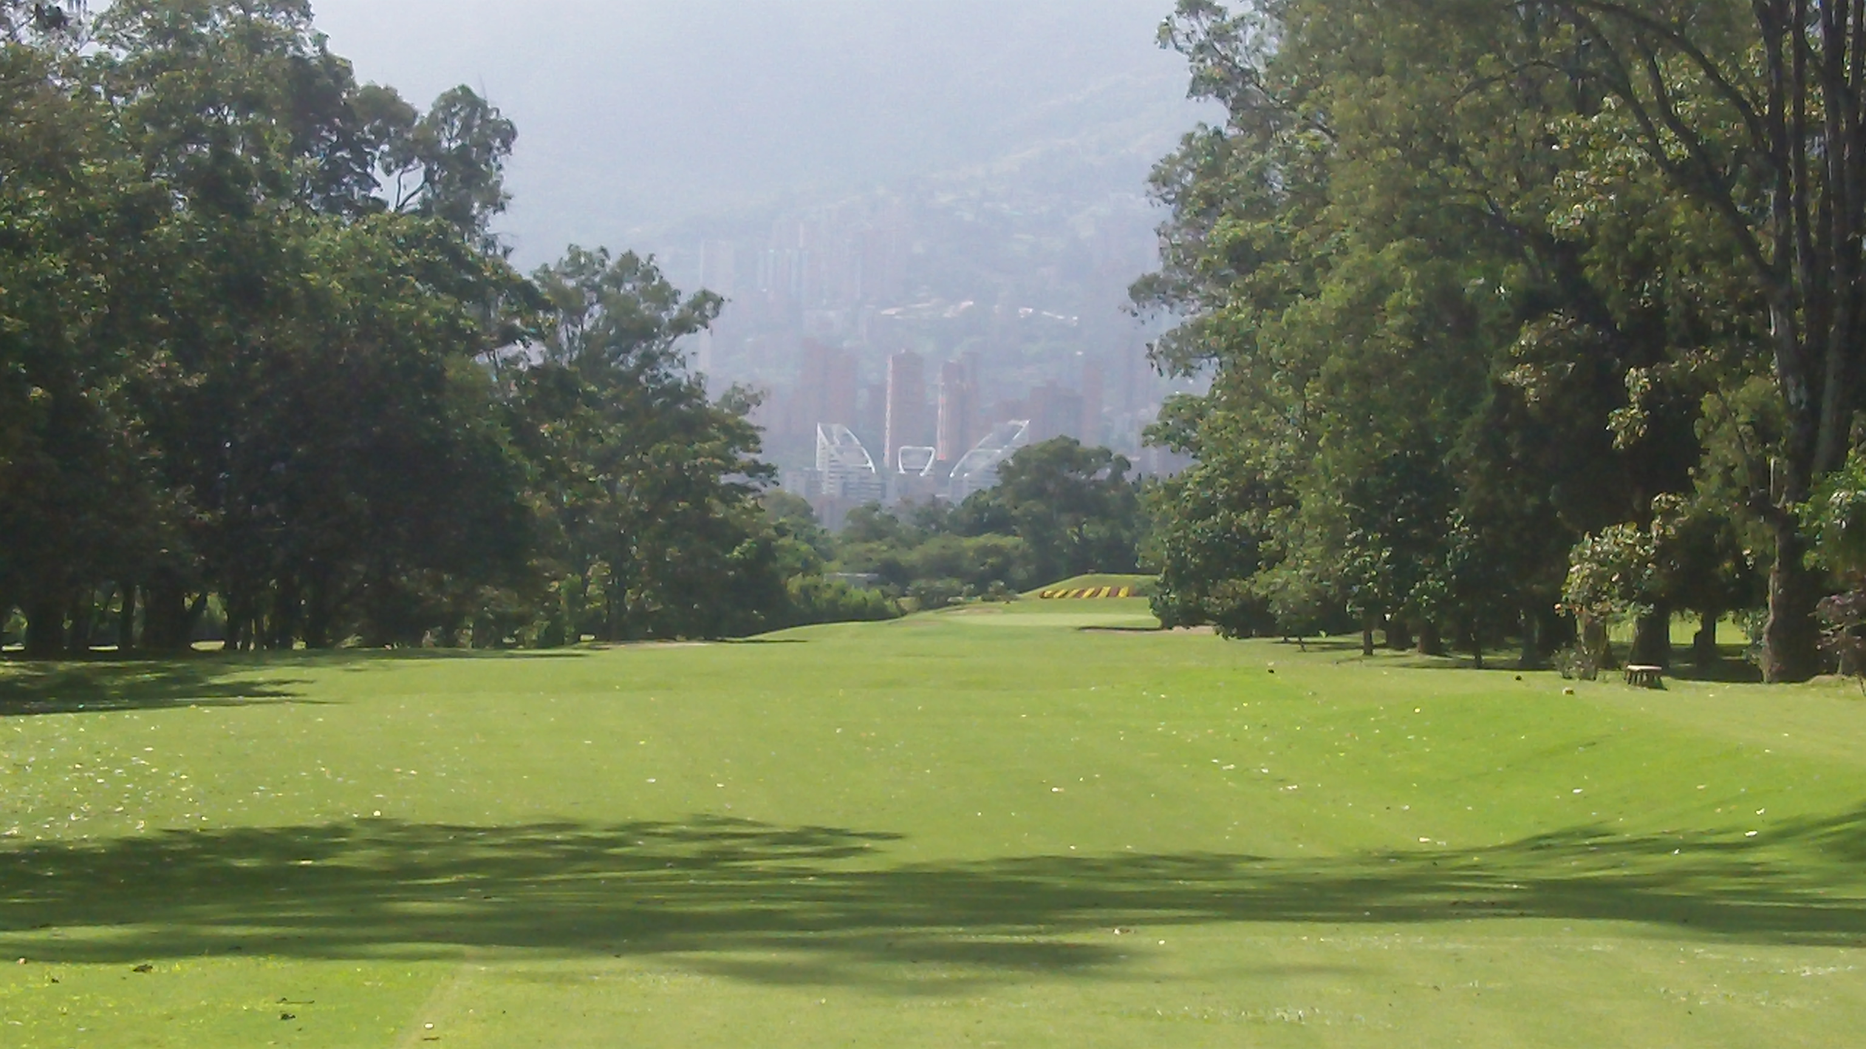

The last time I played this hole I had a 100-yard approach shot which means I launched a drive of about 305-yards. I’d say I am a bit on the long side when it comes to distance. Still, don’t be too impressed for several reasons.

First, this hole plays a bit downhill. Second, the course was dry that day so the ball was rolling further. And last, but not least, you have to remember this course is at 5,000 feet elevation so the ball is going to fly farther.

And of course I proceeded to waste my great drive with a skulled sand wedge over the green!! Fortunately it was in a good spot with plenty of green to work with. I saw the green sloping from left to right. My caddie told me “derecho” or straight.

I listened to the caddie and hit the chip shot straight at the pin. Then watched as the slope of the green took the ball further and further right – and eventually off the green!! These greens are F-A-S-T!!

At that point I decided I was not listening to my caddie anymore. In fairness, he’s not a regular caddie at El Rodeo. He was in for a tournament that was starting the next day. I two-putted for bogey.

In my next message, I’ll run you through more of El Rodeo Golf Club in Medellin Colombia including more photos. Including my two birdies.

Until then…

Dedicated to Lower Scores and More Fun,

Robert “Mr. International Golfer” Phillips

P.S. I’d be happy to answer questions. So if you have any questions about Medellin or golf at El Rodeo golf club, hit reply and ask away.

NEXT POST

Subject: Golfing in the world’s most dangerous city…

In my last two posts I’ve told you about the mountain paradise where I’ve been living for the past several months and why Medellin, Colombia is no longer the world’s most dangerous city. In fact, just last year it was named the world’s most innovative city.

And I’ve shared some photos and videos of El Rodeo – the golf course I’ve been playing in Medellin. Including the crazy quirk that has the golf course located right next to a small airport where planes fly so low you think you can hit them with a golf ball.

If you missed those posts, you can find them here:

[link]

And here:

[link]

Today I’ll share more photos of the course and some tips on playing some of the hole in case you ever get the chance to play here.

I told you about the first hole in my previous message so lets move on to #2 – a 160 yard par 3. This is where I discovered I’m 2 clubs longer at 5,000 feet elevation.

The first time I played this hole I used my 7-iron. That’s my 165-yard club – at least at sea level. The tee shot looked good in the air. However after a search, to my amazement I discovered the golf ball plugged 20-yards over the green!

So the next time I used a 9-iron, stuck it one the green pin-high and two-putted for par. Lesson learned.

Then after playing a few rounds I learned another lesson on the 3rd hole – a 370-yard par 4 with a dogleg right. There’s also water on the right but it’s not really in play if you can hit drive 200 – 225 yards. Here’s the tee box:

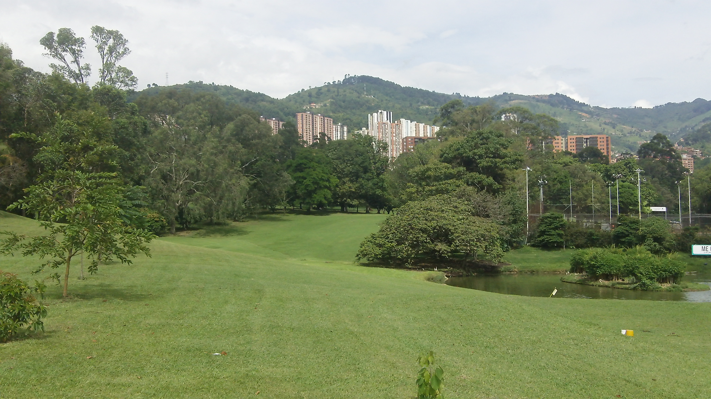

And here’s the lesson. This course plays A LOT shorter when the ground is dry. The first two times I hit driver off the tee and left myself in perfect shape. But the ground was wet and I was getting no roll.

The third time I played El Rodeo, the ground was dry and the same tee shot rolled deep into the woods – I mean deep! It was shocking how much roll you get when the ground is dry. So just keep that in mind if you play El Rodeo!

The 4th hole is a 500-yard par 5 (I’m giving distance from the white tees which is one up from the back or blue tees). Here’s the tee box:

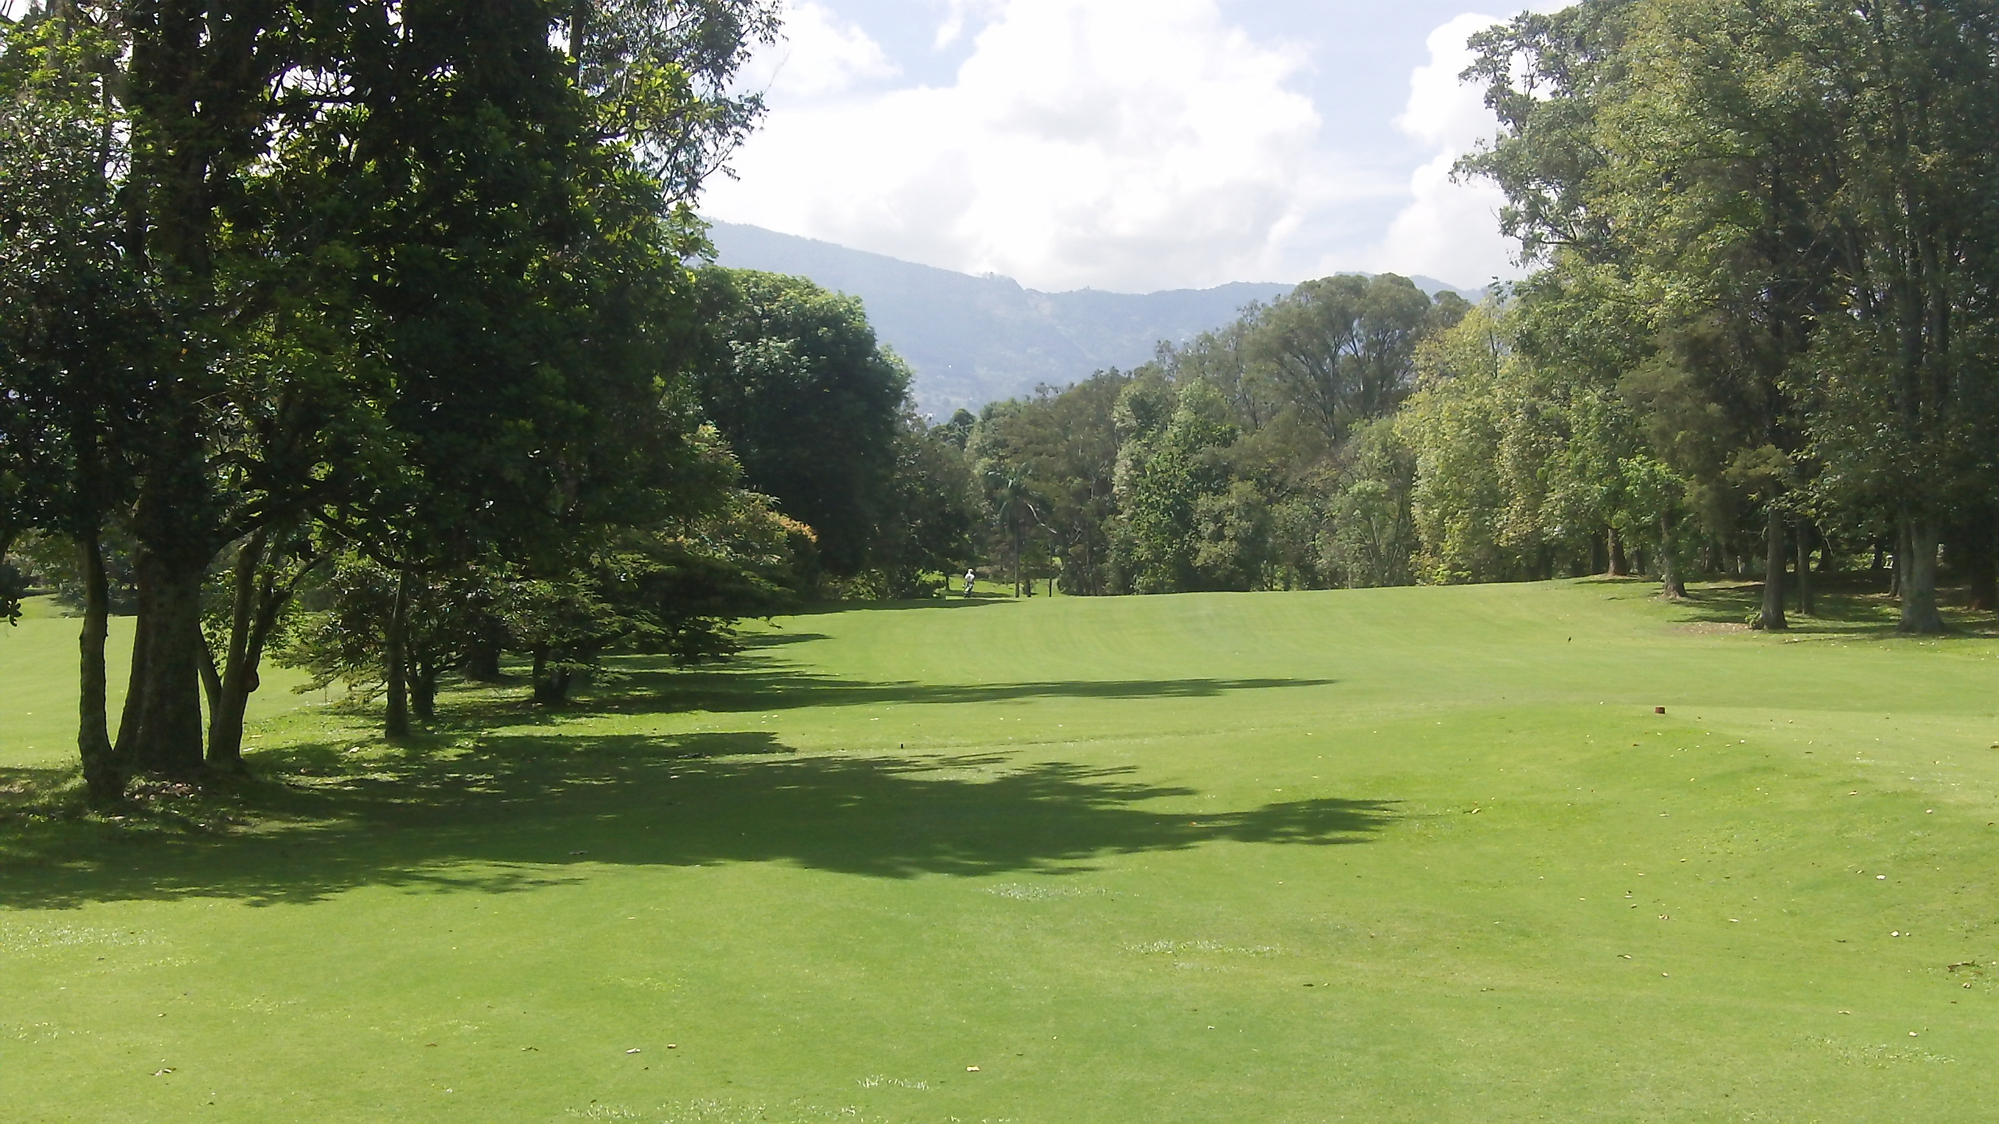

I’m not sure you can appreciate this from the photo but this fairway gets a bit narrow. The hole has dogleg left. The tee shot is a bit downhill but the 2nd shot is uphill over a ridge and it’s also blind. You can’t see the green.

The first time I played this hole I hit my drive right down the middle and had about 220-yards to the green. Remember the lesson I learned on #2 – that I can hit the ball farther at an altitude of 5,000 feet – I opted for my trusty 3-hybrid. Here’s a view of the 2nd shot:

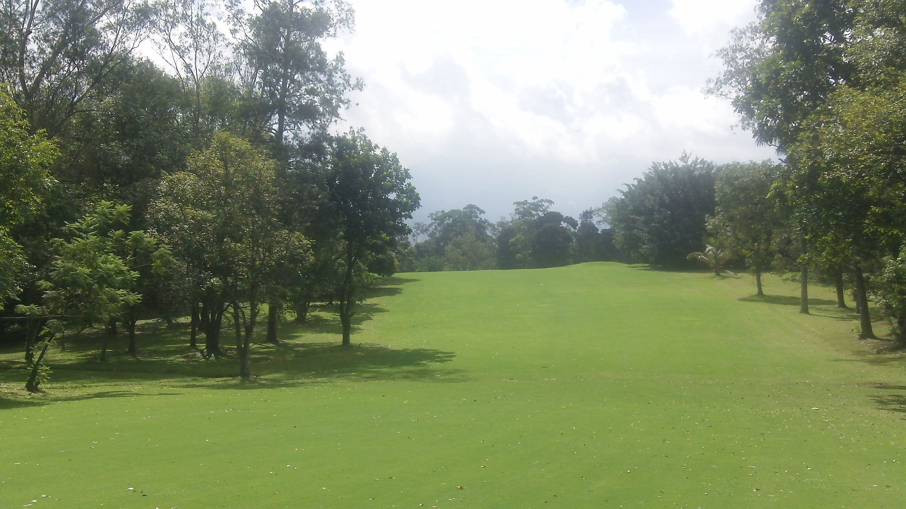

The green is over the ridge and a bit downhill. Since this shot is blind (not to mention I had never played the course!), my caddie gave me a spot and I struck quite a nice shot. It actually flew over the green! But just barely I was on the fringe so I used a putter. Here’s a shot of the green as you reach the top of the ridge:

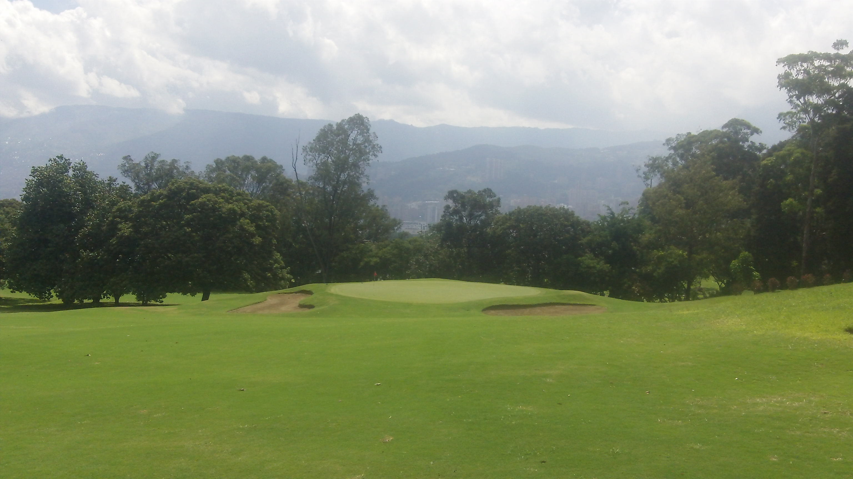

I lagged my putt (technically a chip since I was on the fringe) just past the hole and made the 3-footer for birdie! YES! Only 4 holes into my first round and I already had my first birdie.

Now onto the 5th hole – a 390-yard par 4 with a dogleg right. Another blind tee shot. There’s water on the right so favor the left side. Fortunately, the caddies are there to spot your drive. Here’s the view from the tee box (you can see the caddies in their white shirts):

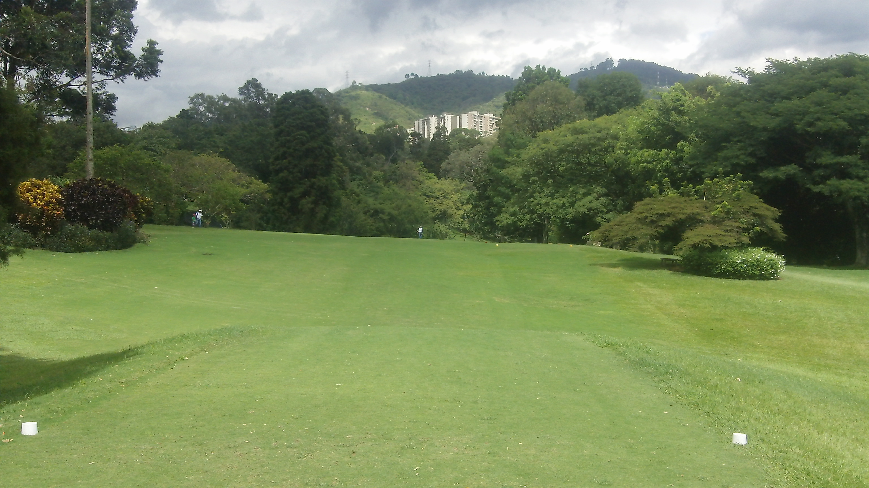

With a good drive you shouldn’t have more than about 125 yards to the green. Here’s a view of the approach shot:

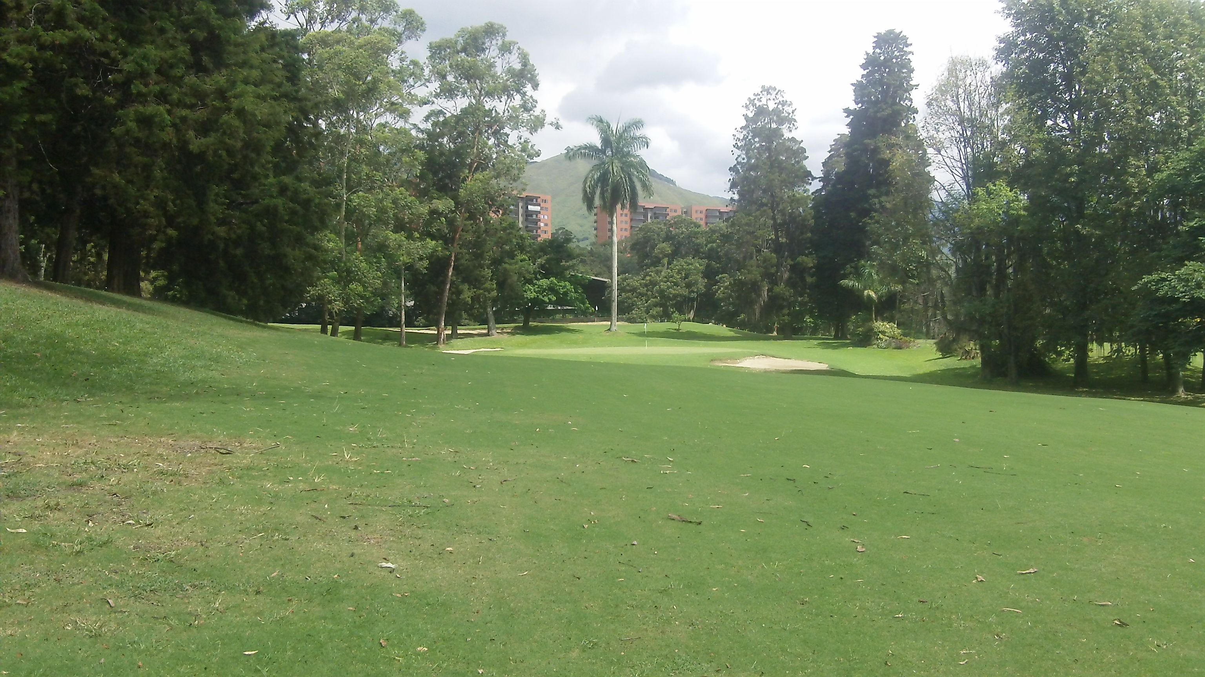

OK, that’s enough for today. I’ll show you the rest of El Rodeo’s front 9 in my next message.

If you have any questions, just hit reply and ask away.

Until next time…
Dedicated to Lower Scores and More Fun,

Robert “Mr. International Golfer” Phillips

NEXT POST

Subject: El Rodeo Front 9 (photos)…

The response to the last several posts about Medellin, Colombia, and playing golf at El Rodeo Golf Club have been tremendous. If you’ve missed any of the previous messages, you can’t find out what all the excitement is about here:

[link]

[link]

[link]

We’ve been through the first five holes at El Rodeo – where Colombian golfer Camillo Villegas honed his skills as a youngster. Today we take a look at the rest of the front 9 starting with hole number 6.

The sixth hole is a 355-yard par 4 with a dogleg left. This is a shortish hole so you may want to use less than driver off the tee. You may end up blocked by trees on your second shot if you hit your drive too far. I use 3-wood.

The hole may be short but this is a tight chute! You can see how narrow the fairway is from the photo below. It opens up after the trees. Just make sure you don’t hit the trees first!

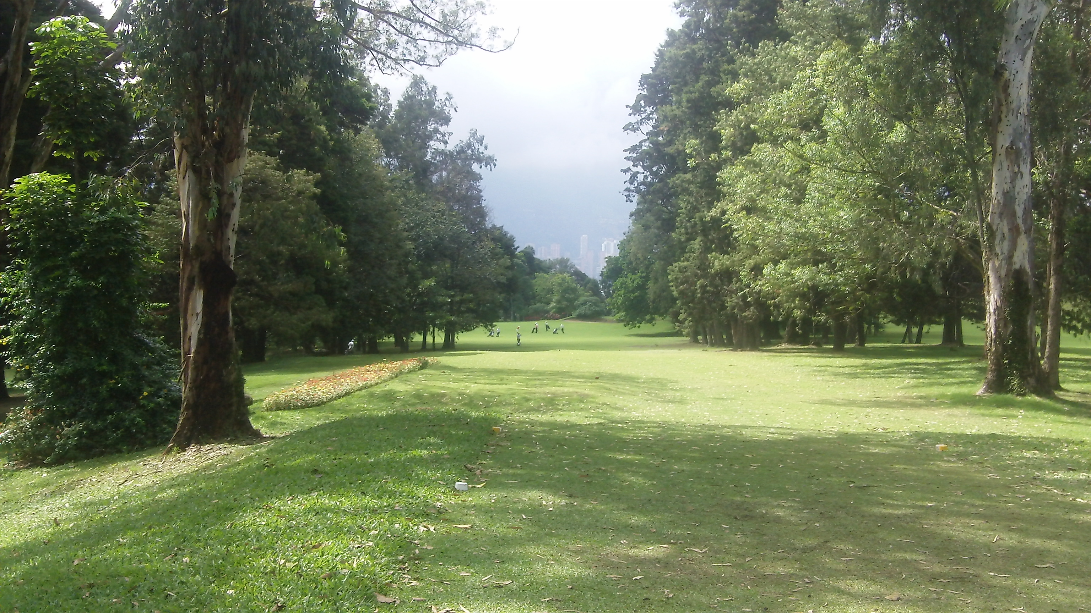

With a good tee shot you’ll have a short iron to the green. But don’ be long! There’s nothing but trouble on the far side of the green.

The 7th hole is a fun par 5 measuring 507 yards. It starts with a blind tee shot over a ridge. There’s a slight dogleg right and the hole is downhill once you get over the ridge. The fairway slopes to the right so you can favor the left side. Here’s the view from the tee box:

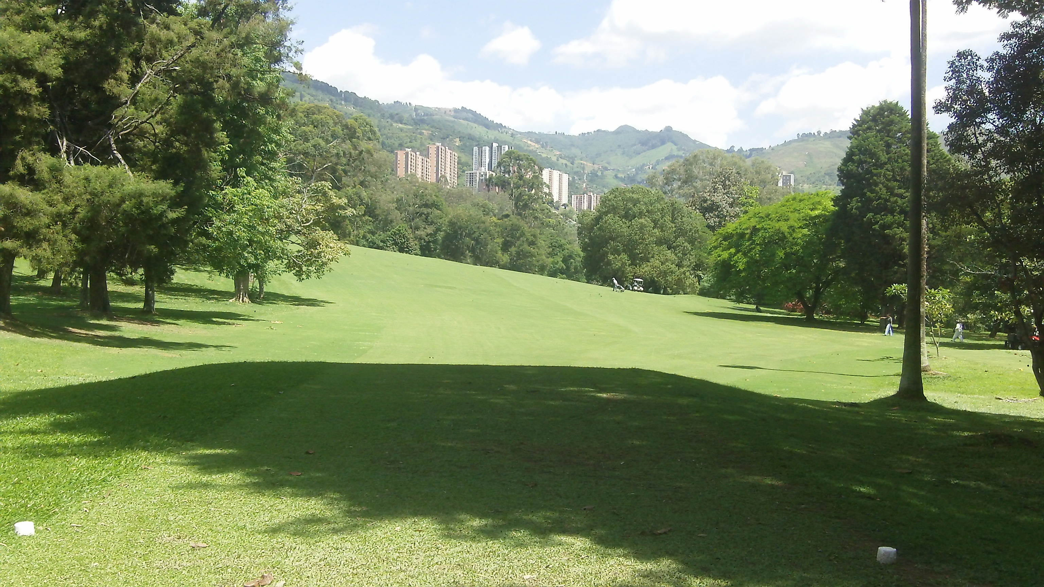

This fairway is wide open so you can bomb away! That’s probably why I like this hole so much. My best drive on this hole came on a dry day when the ball was rolling forever. It’s a blind tee shot so I couldn’t see it once it got over the ridge but I only had about 165-yards left to the green.

That’s roughly a 340-yard missile! But don’t be too impressed. Remember, El Rodeo is at 5,000 feet altitude so the ball sails farther. Here’s the view of the approach shot:

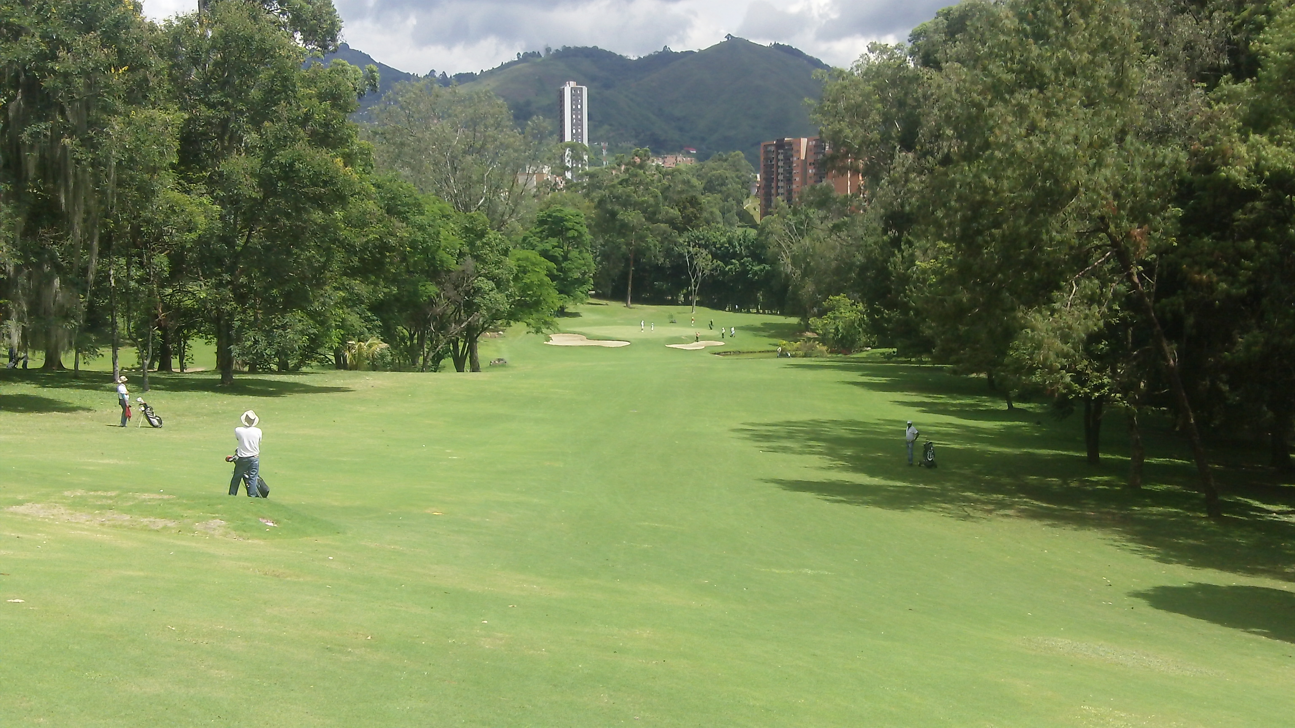

This is the view from the top of the ridge. There’s water on the right, trees on the left, and bunkers protect the front of the green. For my approach shot I grabbed a 7-iron and struck it well. Unfortunately it flew 15 yards over the green!

I should have known better. I’ll use an 8-iron next time. This green is slippery fast and slopes from the back to the front so being over the green I left myself in a tough spot. I ended up with a disappointing par. Next time!

On to the 8th hole – it’s a 198-yard par 3. Depending on the wind I either hit 7 or 8-iron here. It’s a bit down hill. You don’t really want to miss the green by much in any direction.

Bunkers guard the front and there’s water if you’re really short. There are trees long and trees to the right and it’s no bargain being left either. Here’s the view from the tee box:

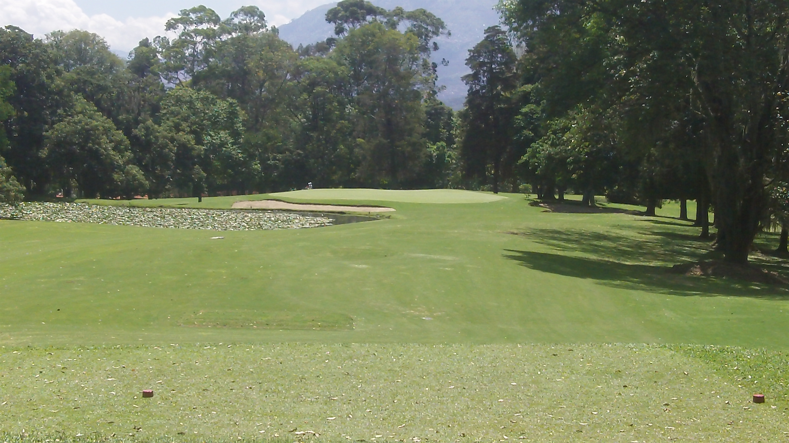

It’s not such a hard hole with a decent tee shot.

The 9th is a 410-yard par 4 with a big dogleg right – close to 90 degrees I’d say. From the white or blue tees driver is fine – unless the ground is dry that day! With the extra roll you may want to use 3-wood. Here’s the view from the tee box:

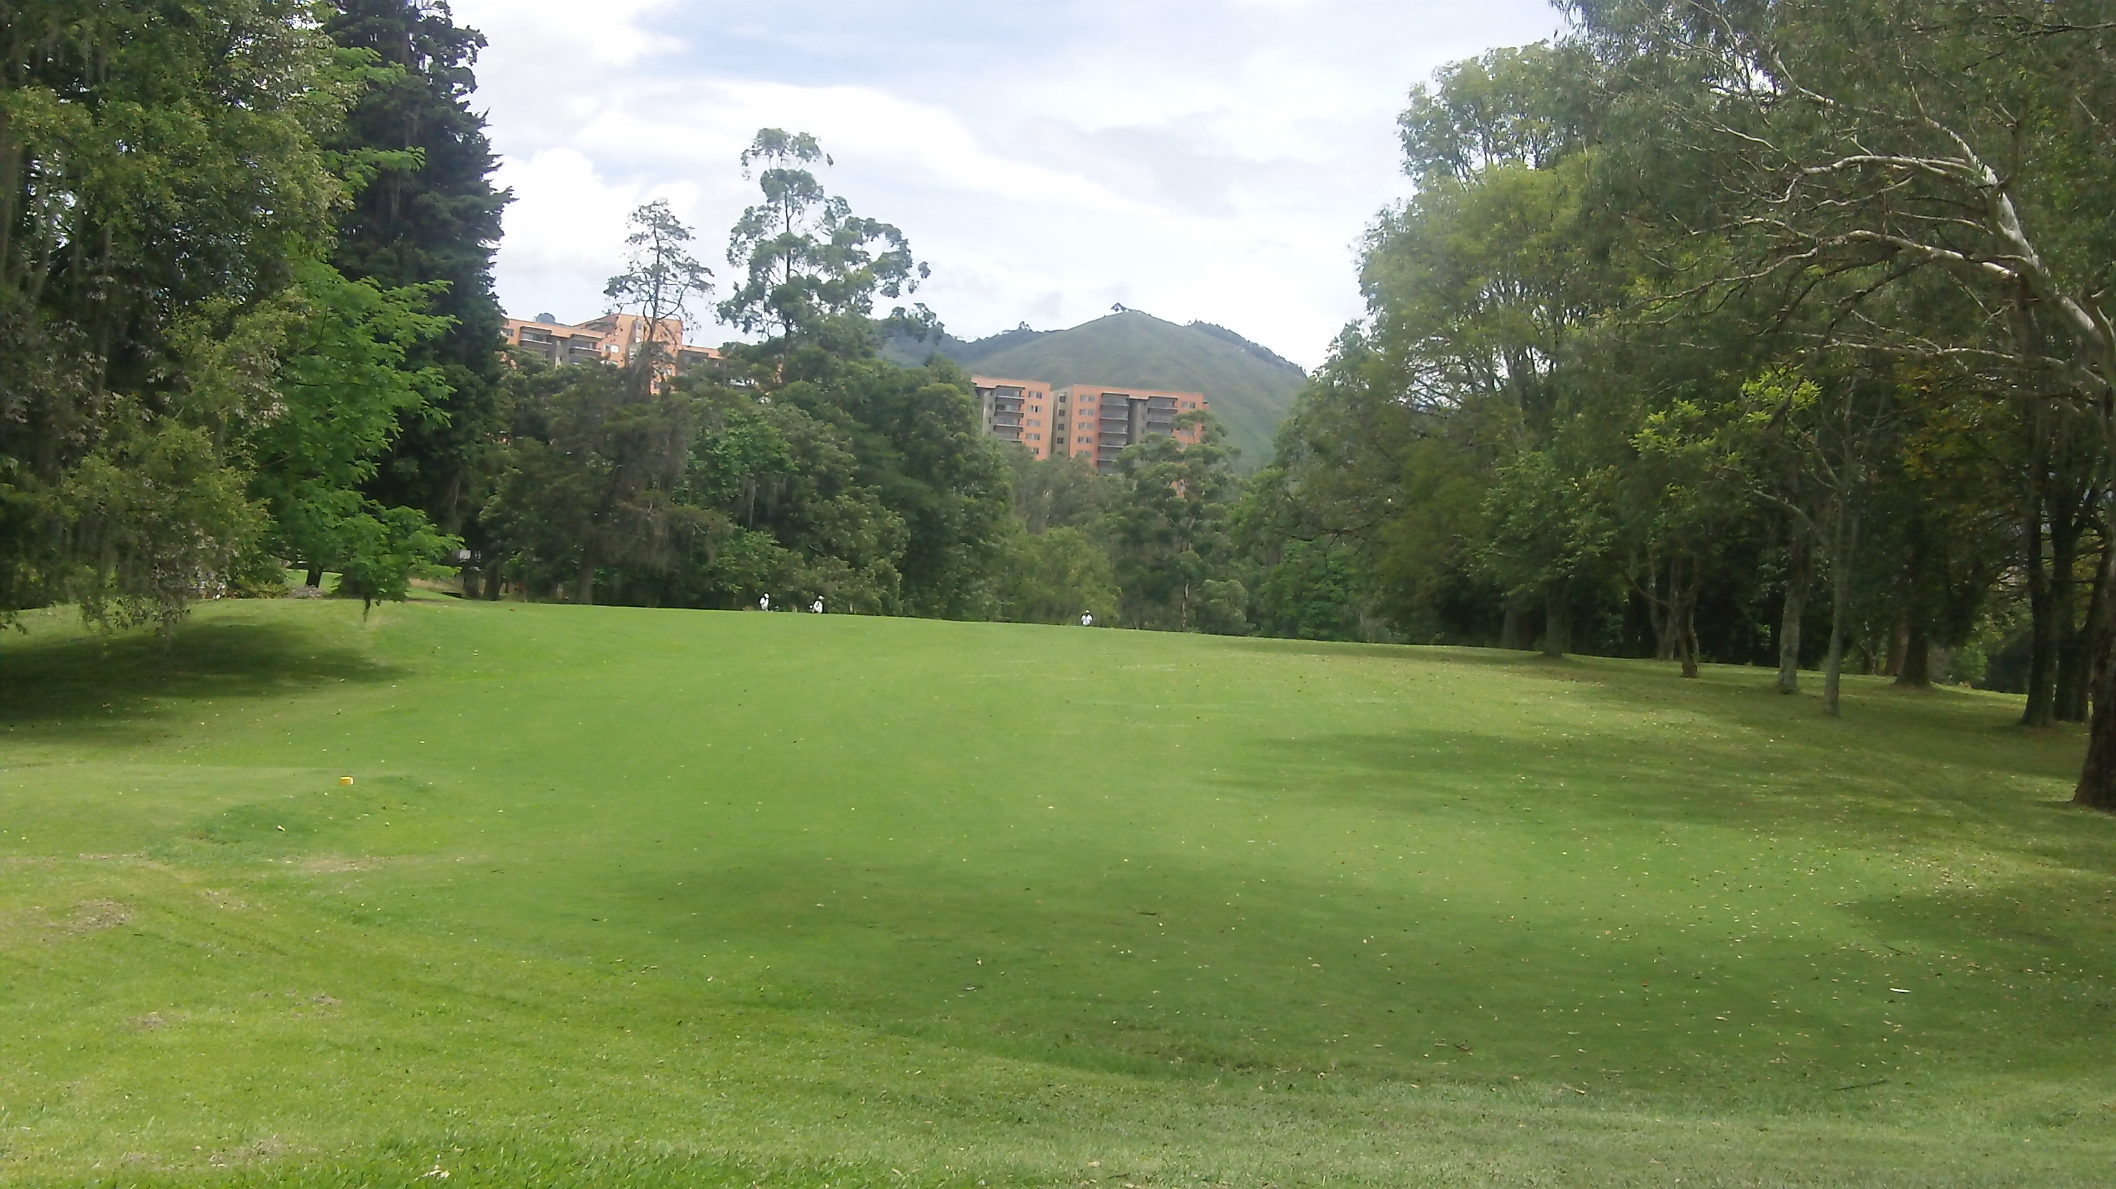

It’s another blind tee shot but not quite as blind as it looks in this photo. A good drive will clear the trees on the right leaving an open approach shot of about 150-yards to the green. Here’s the view from the fairway:
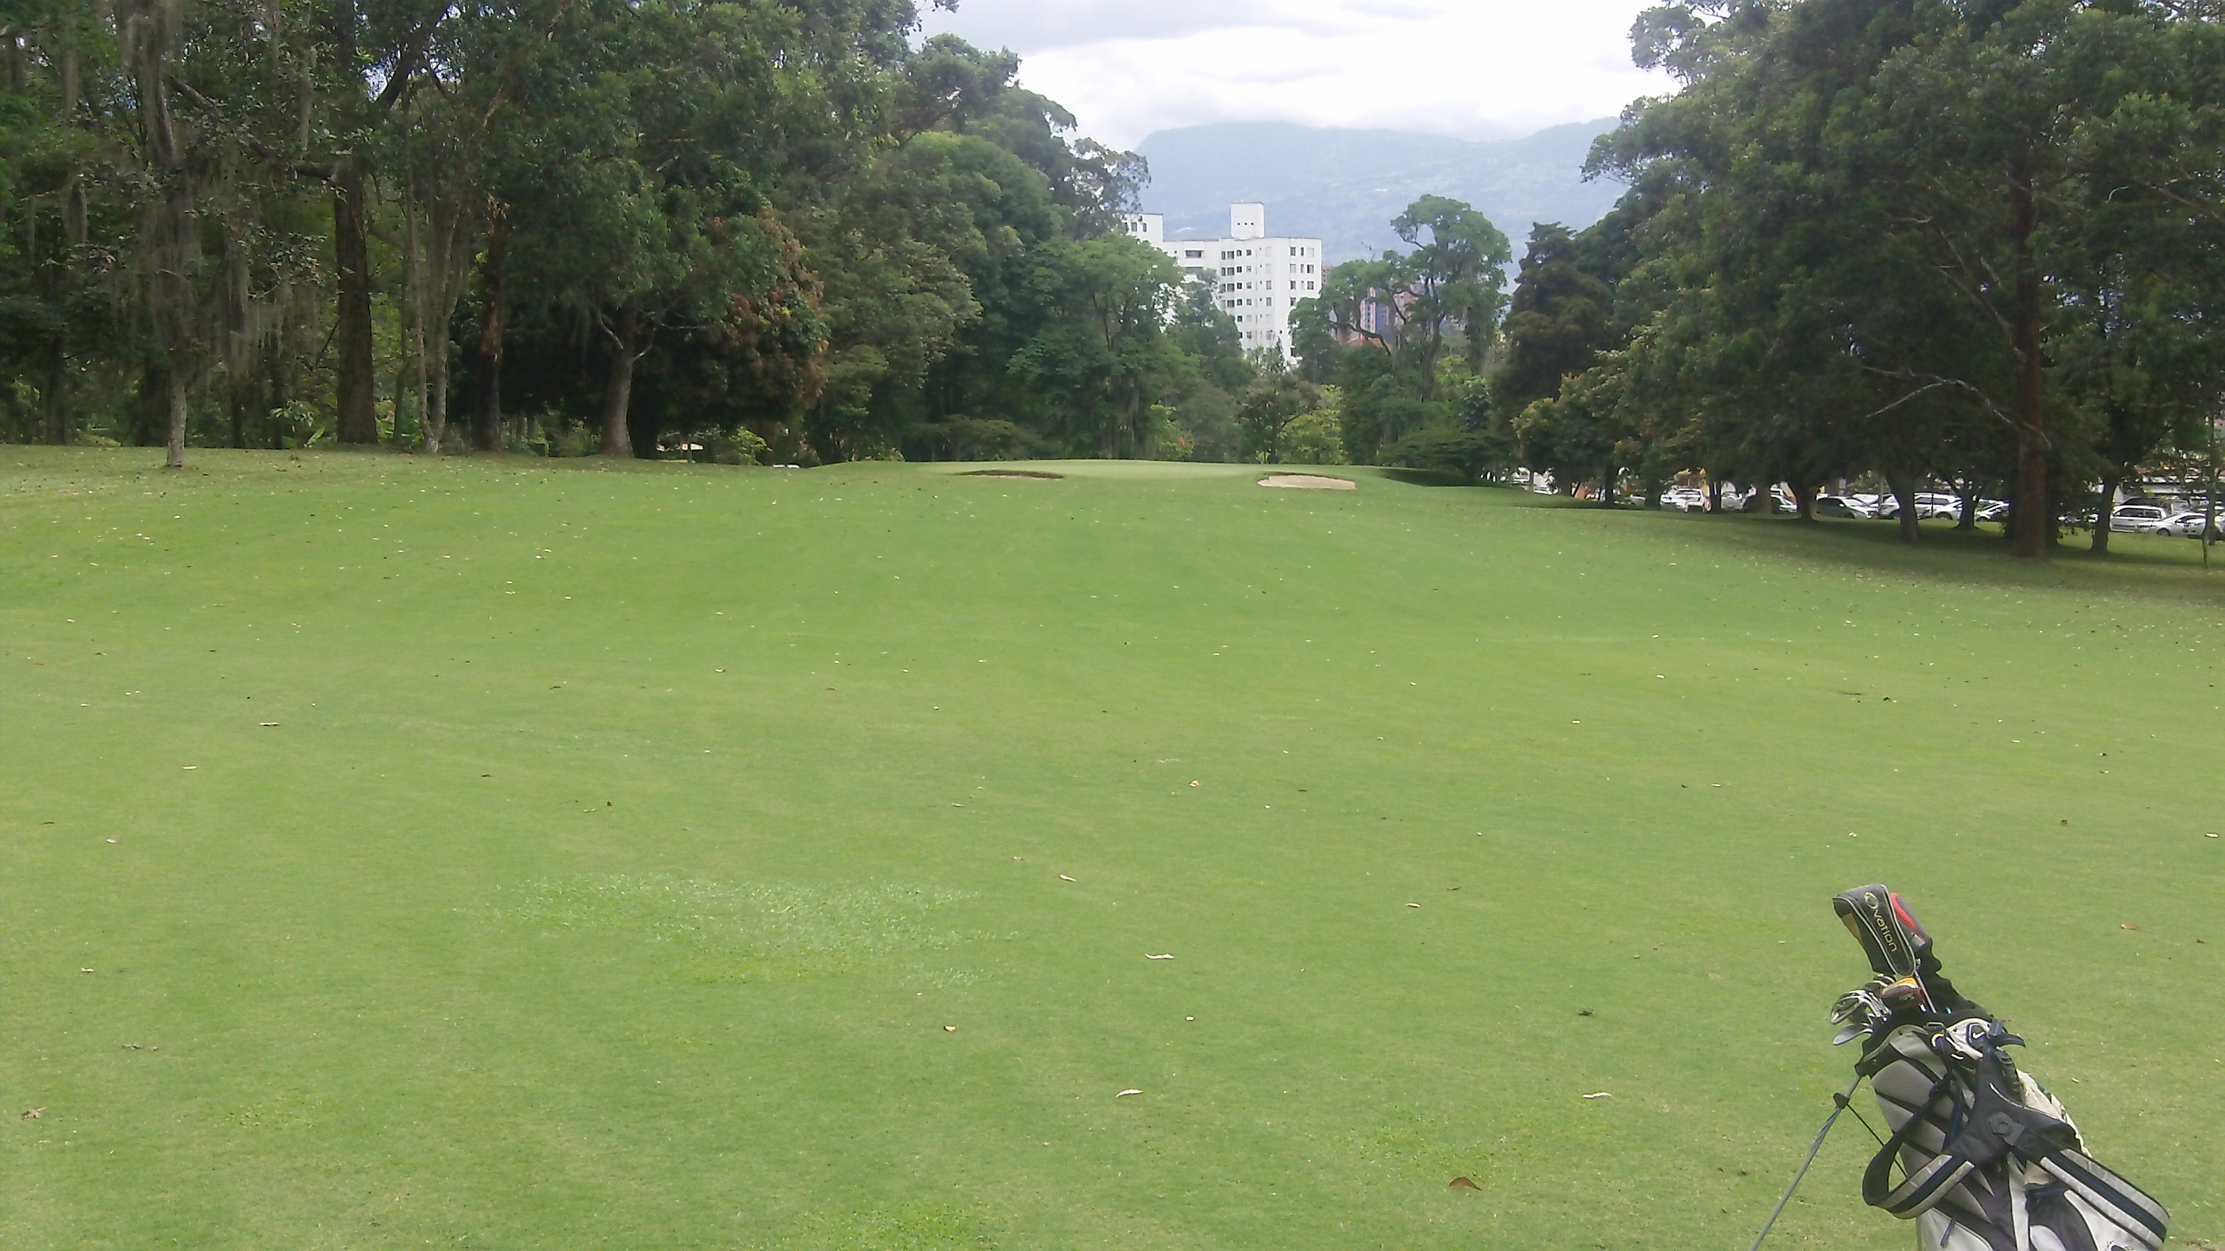

You don’t want to miss this green either. If anything favor being a bit short and leaving yourself an easy pitch shot on to the green. If you’re long, you may end up in the parking lot and there’s not much room either left or right either.

So there’s the front 9 (or primera vuelta as they say in Spanish) at El Rodeo Golf Club in Medellin, Colombia. I’ll show the back 9 in upcoming messages.

Until then…

Dedicated to Lower Scores and More Fun,

Robert “Mr. International Golfer” Phillips

NEXT POST

Subject: La Segunda Vuelta (El Rodeo)…

What the heck is “la segunda vuelta”? Well during one of my recent rounds at El Rodeo Golf Club in Medellin, Colombia, I asked my caddie at the turn how to say “front nine” and “back nine” in Spanish.

His answer was front nine is “la primera vuelta” and back nine is “la segunda vuelta.” It doesn’t translate literally but that’s not unusual.

In case you’ve missed it, I’ve been living in Medellin for several months and my last several messages have been about Medellin and playing golf at El Rodeo Golf Club while I’m here.

You can find the previous posts here:

[link]

[link]

[link]

[link]

Today I’ll share photos and strategies for playing the back nine – or la segunda vuelta – at El Rodeo.

In my estimation the 10th hole may be the easiest hole on the course although the scorecard ranks it the third easiest hole. This is a short 325-yard hole with about a 45-degree dogleg right. The approach shot is also down hill making the hole play even shorter. Here’s the view from the 10th tee box:

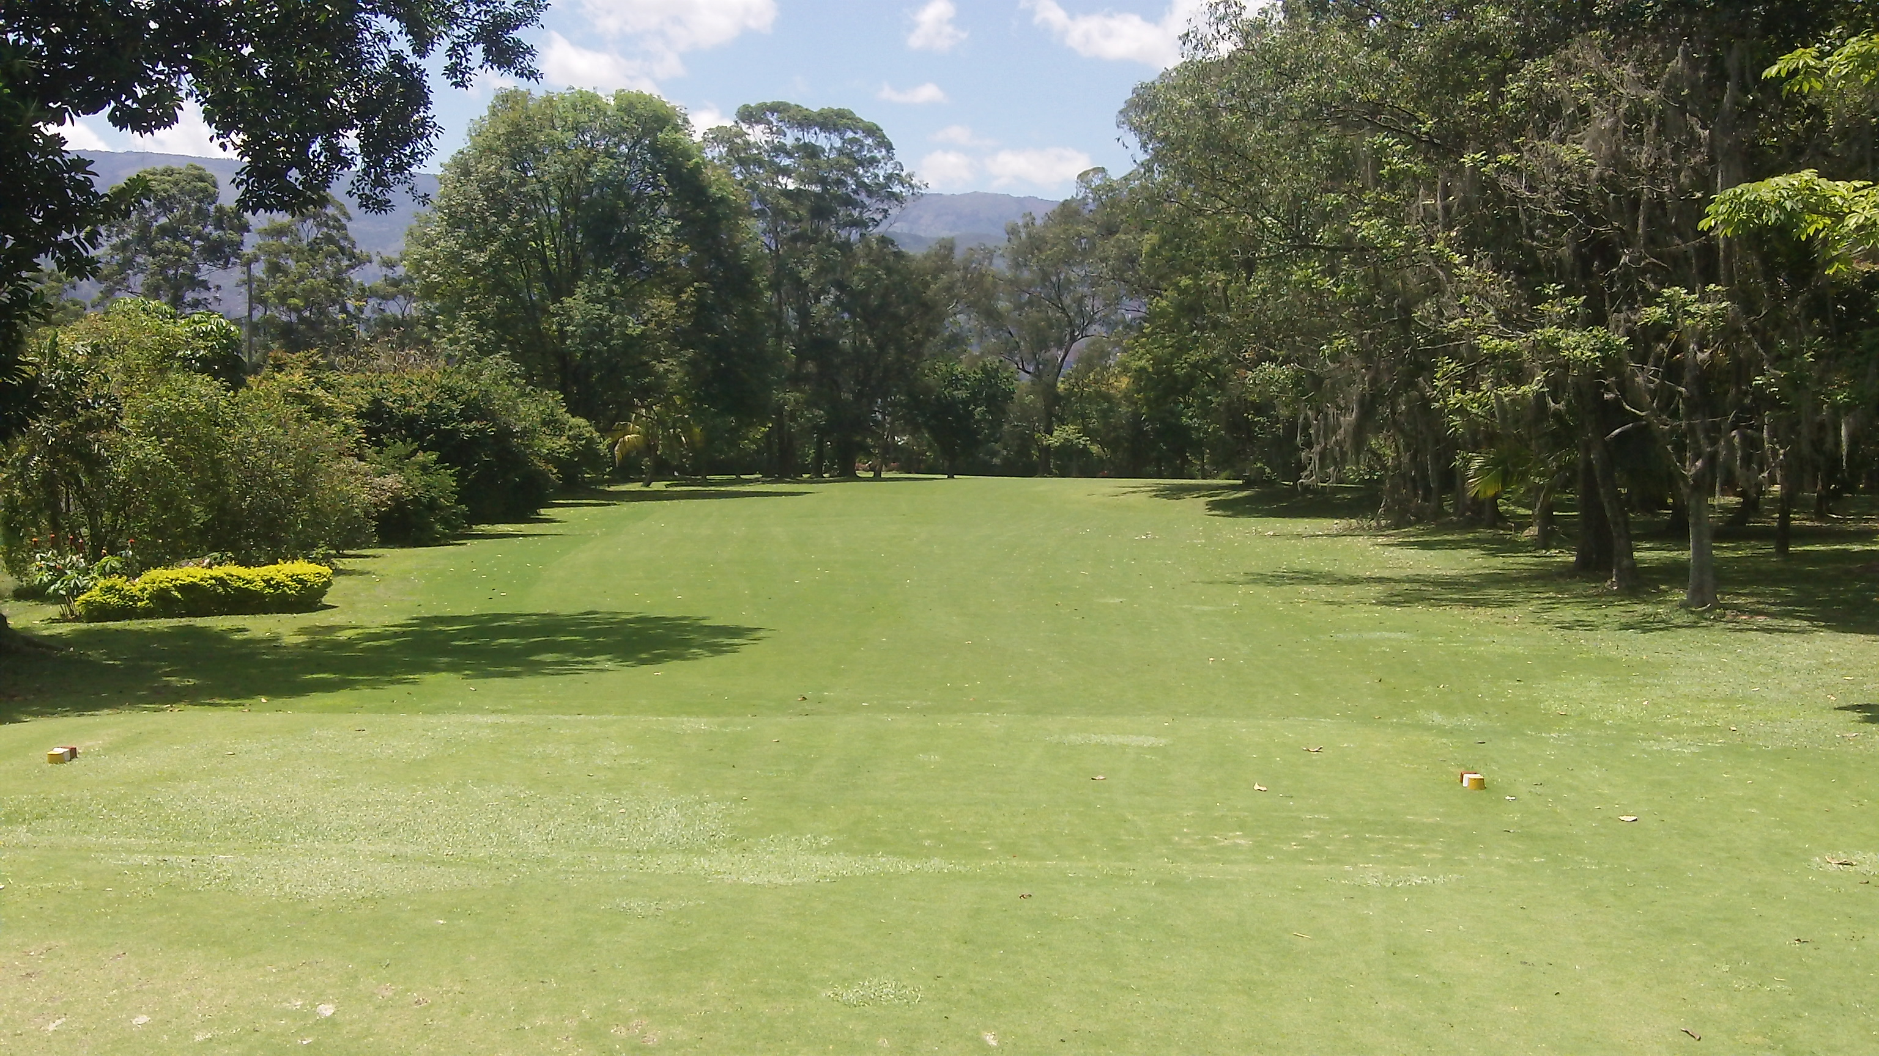

If you can put a big fade on your tee shot you may even consider driving this green. Personally I don’t bother since my natural shape shot is the opposite!

The easy (and smart play) is to hit an iron or hybrid off the tee leaving a short-iron to the green. Here’s what the approach shot looks like – with a nice view of the city and the Andres mountains in the background:

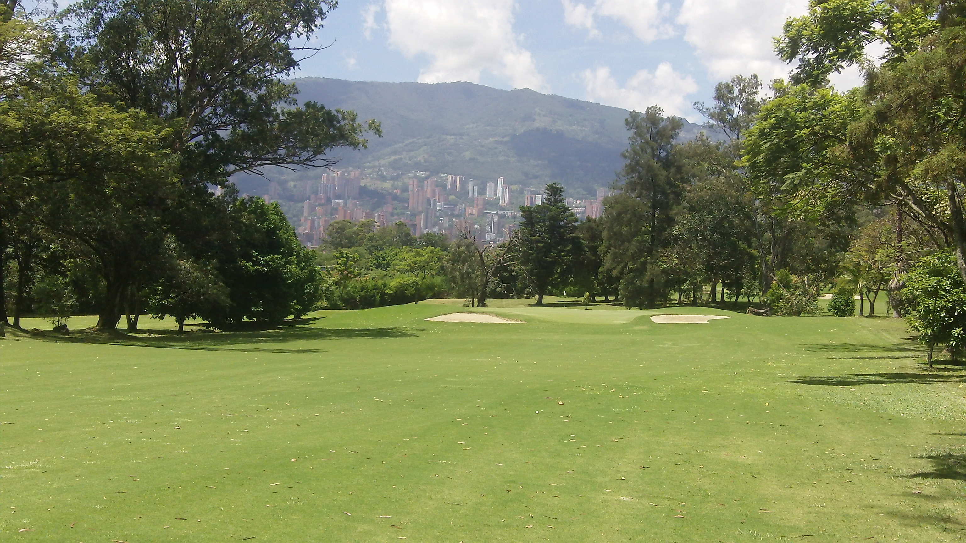

#11 is a 501-yard par 5 that’s not particularly difficult – except that depending on the pin placement this green can be devilishly quick! There’s a big dogleg left but unless you can bomb your drive over 300-yards you don’t need to worry about the dogleg. Here’s the view from the tee box:

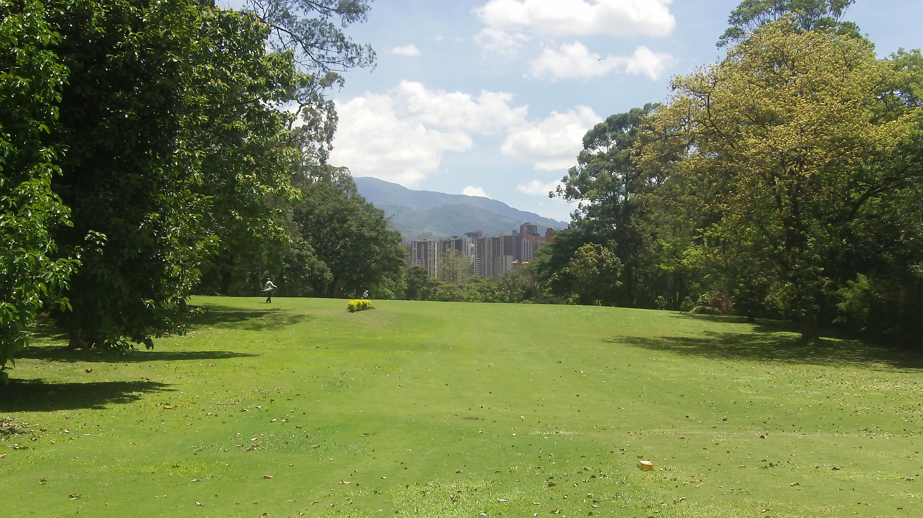

It’s a blind tee shot but it’s not real difficult. The fairway is wide so just rip it! And favor the left side if you can so you’ll have a shorter second shot. Here’s the view from the fairway:

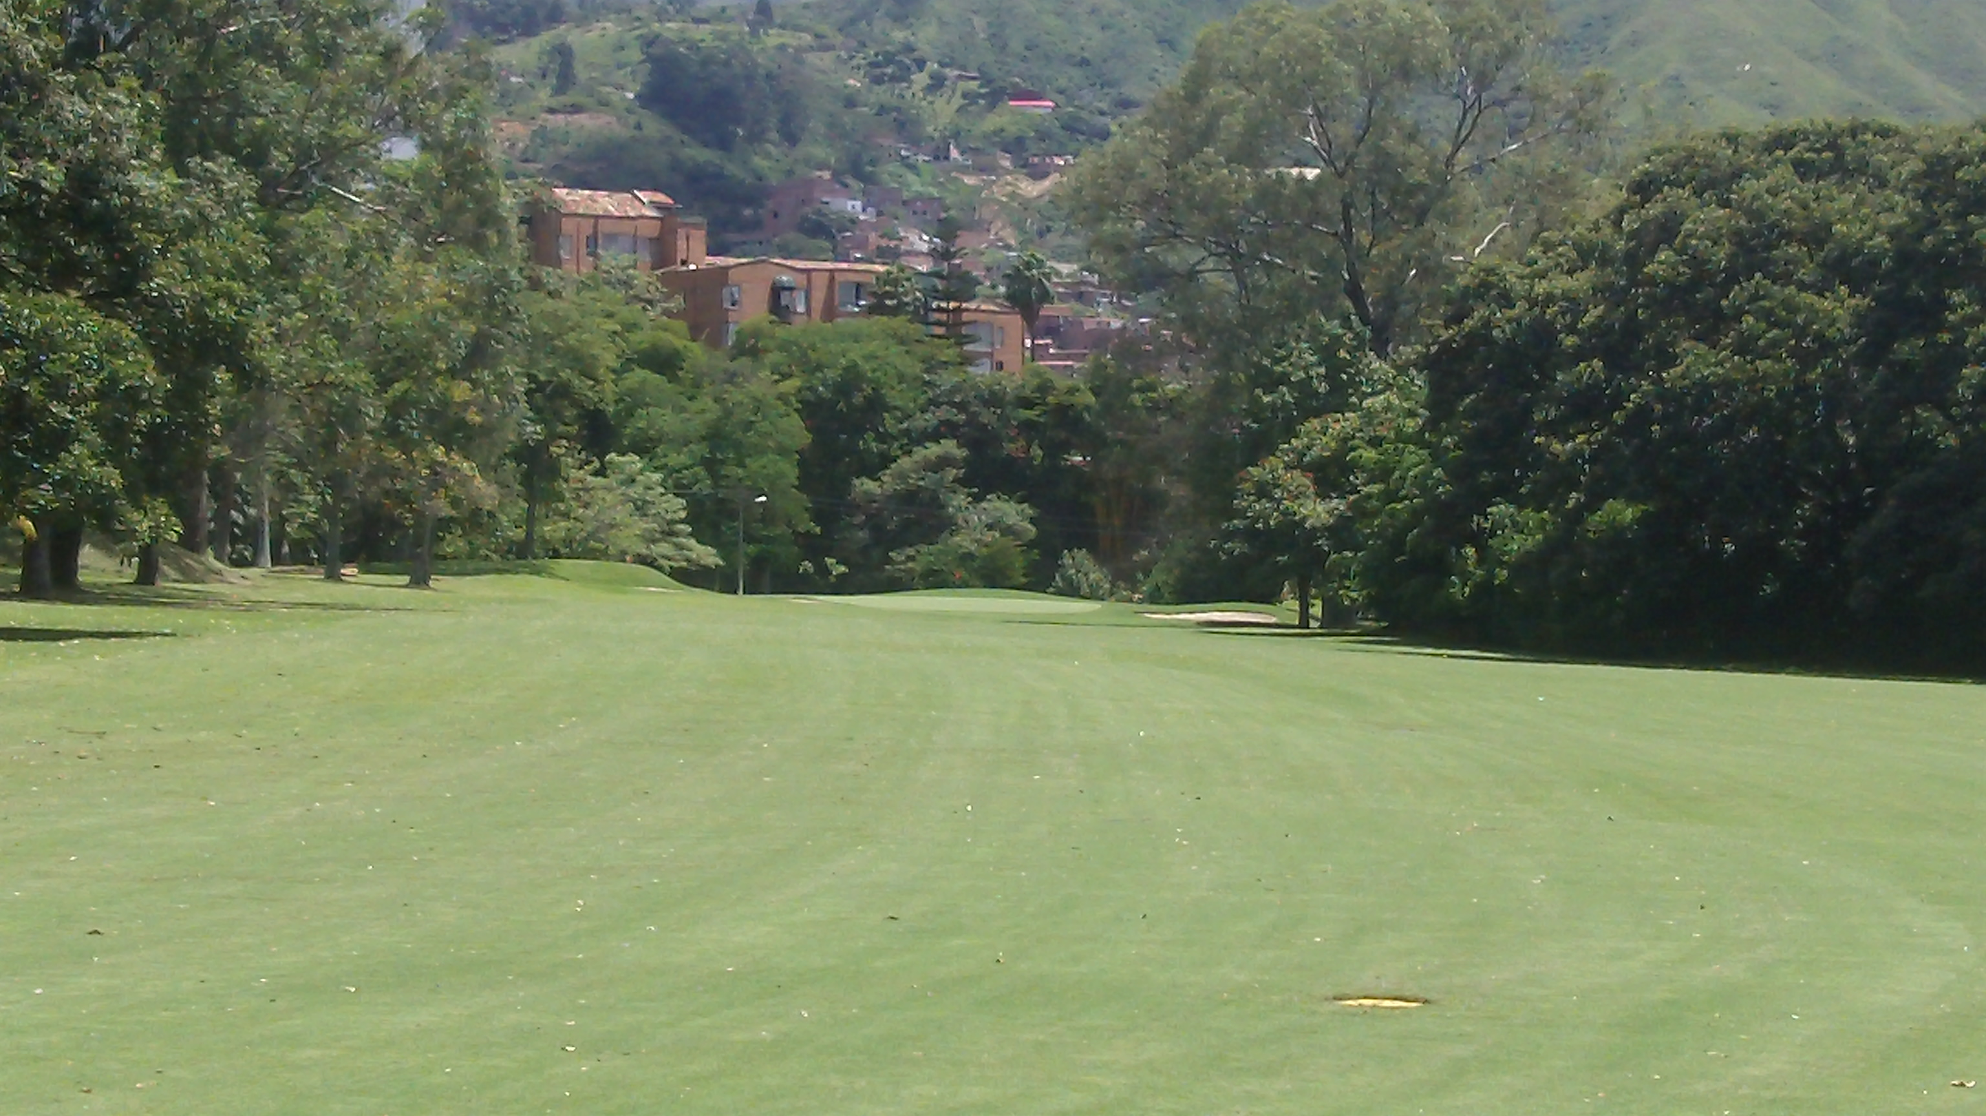

This green is definitely reachable in two shots. I’ve never actually been on the green in two but I have been pin-high in two shots twice – and I’ve only played the hole three times as of this writing. I even managed a birdie the first time I played this hole!

For me, the 12th hole is without question the most difficult hole on the course. It’s a 388-yard par 4 with a dogleg right and you’ll need to knock your drive past the trees in order to have a clear approach shot to a green that’s protected by water.

None of that is what makes this hole difficult to me though. It’s just very unpleasing to my eye from the tee box. There’s no room at all to the right – nothing but trees. And that’s not a good image for a guy like me who generally hits a draw.

The ideal shot shape here is to blast one straight down the middle or play a fade if you prefer. Here’s the terrorizing view from the tee box (at least for me):

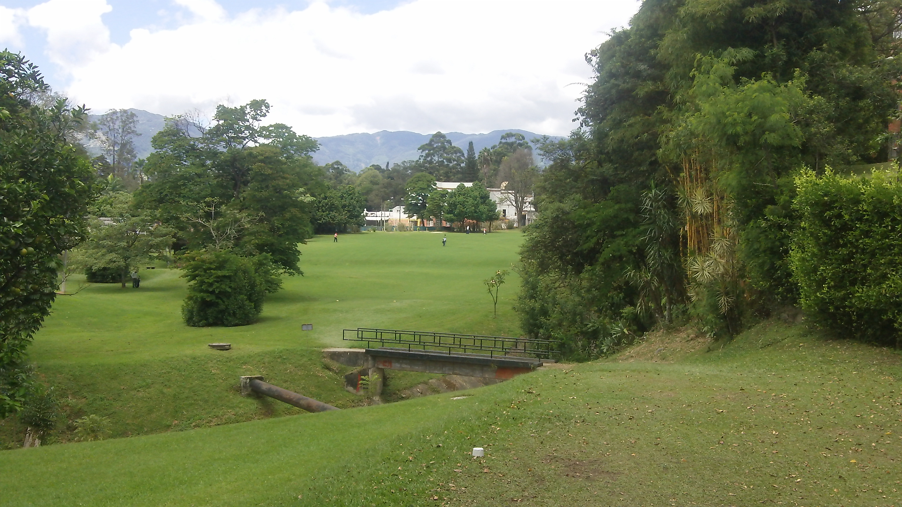

I can’t speak for everyone but I don’t even like looking at that! In any event, if you can manage the tee shot, you’ll have an easy approach shot – especially if you’re not afraid of the water short of the green. Just be aware that just like most of the greens, this one can be F-A-S-T!

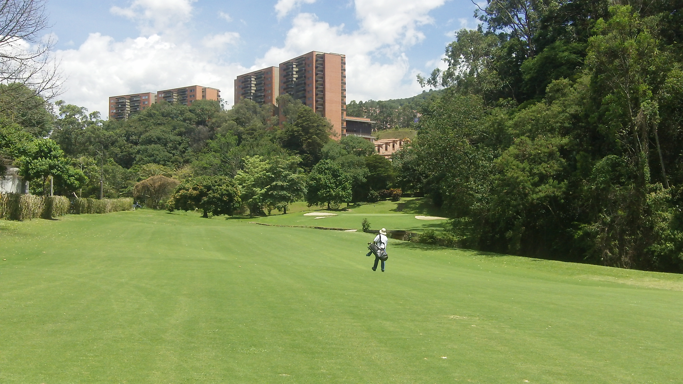

On to 13! This is a 344-yard par 4 with almost a 90 degree dogleg right. I find this hole challenging for the same reason as 12 – although it’s not as tough as 12. It’s shorter so you can hit a long-iron or hybrid off the tee but you still have to avoid starting right because those damn trees are in the way!
The goal is to knock past the trees so you have a clear approach shot to the green but without knocking it through the fairway. Here’s the view from the 13th tee box:

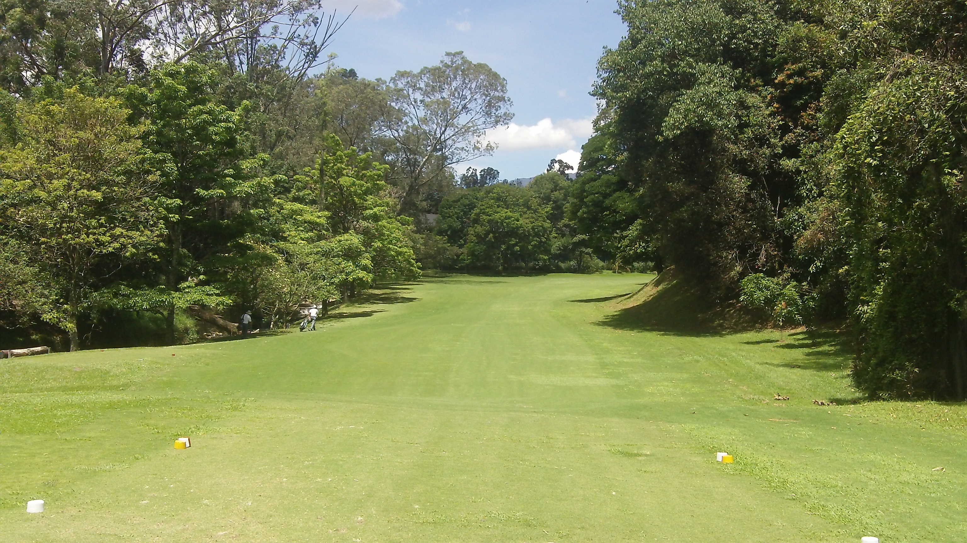

And with a good tee shot, here’s what your approach shot from the fairway looks like:

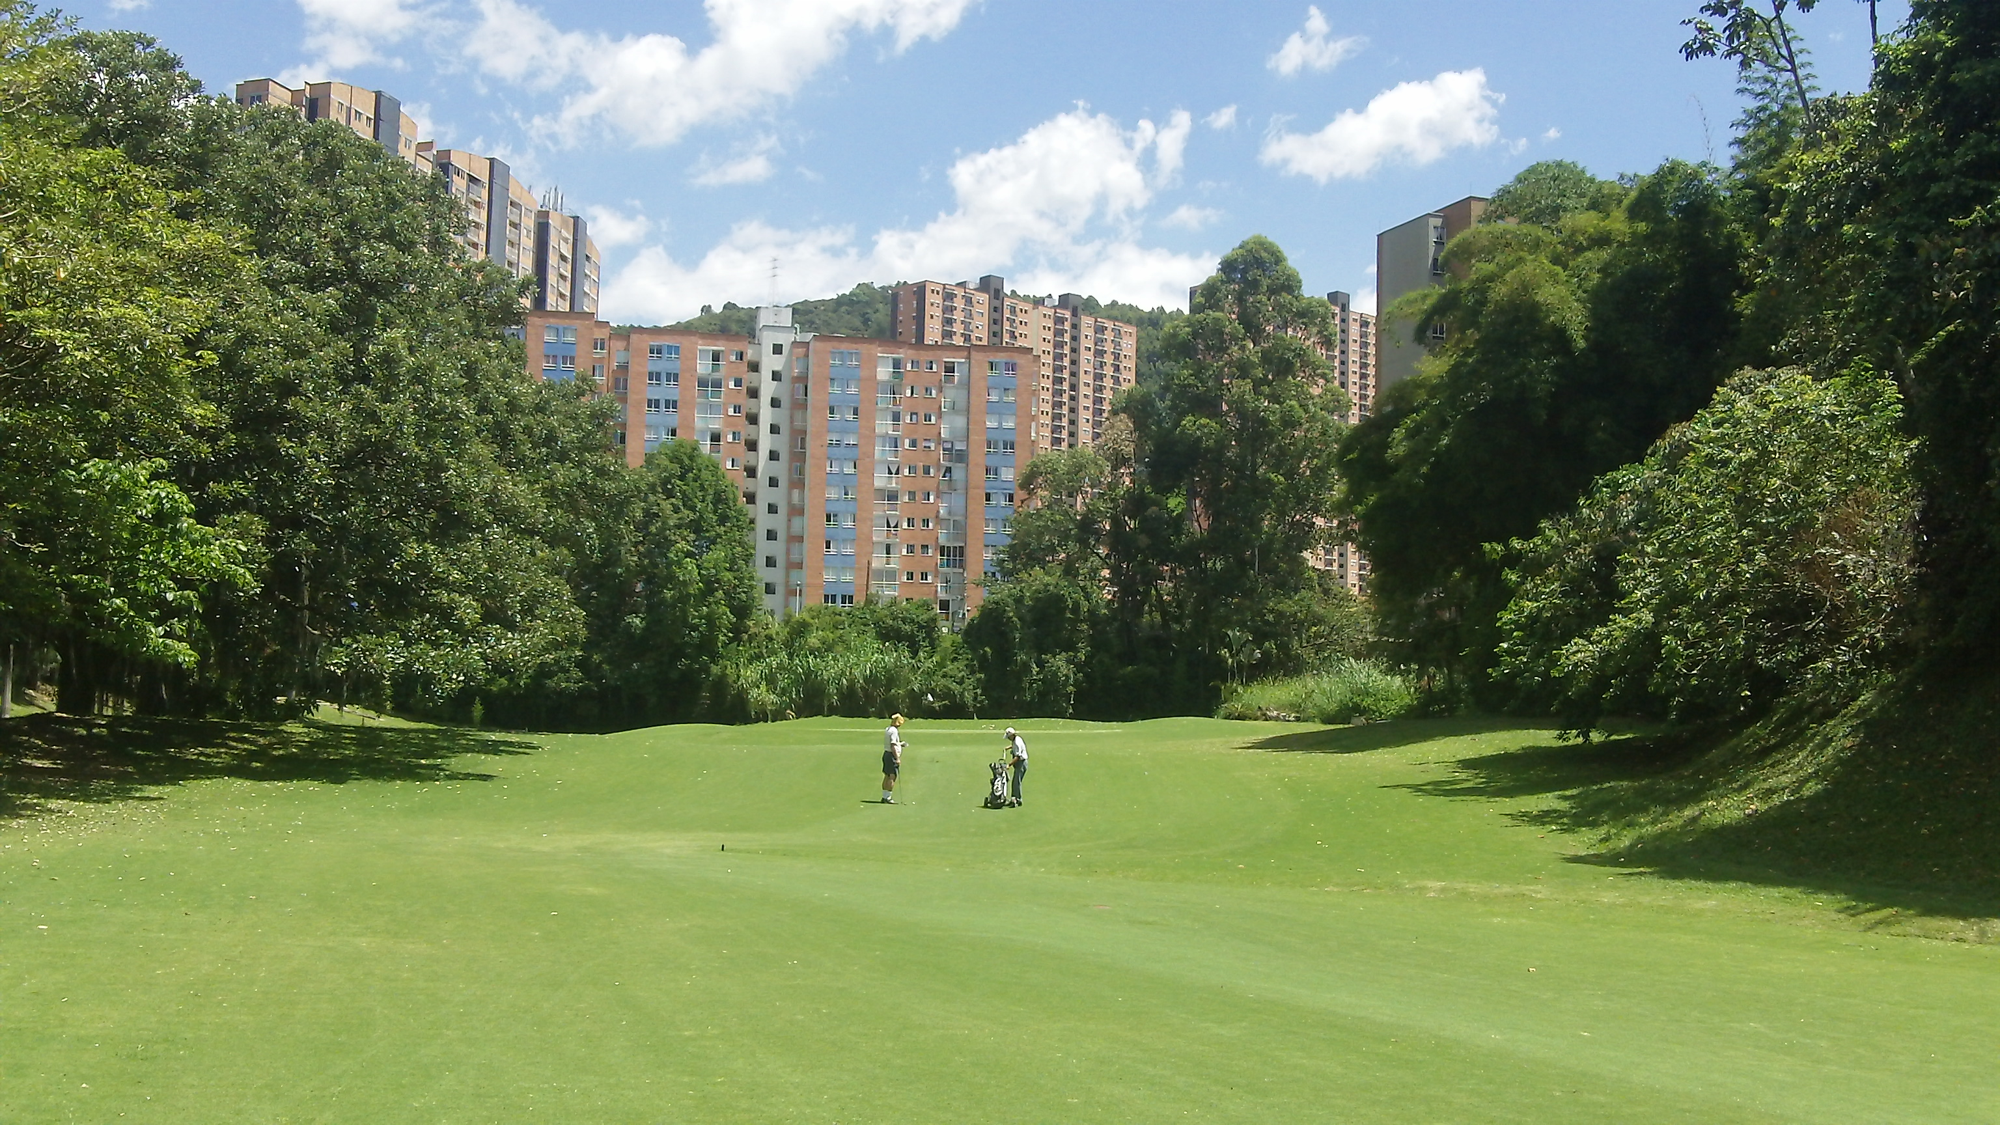

WARNING: If the pin is in the front of the green and you’re putting from the back of the green, just tap it. This green is lightning fast and slopes from back to front.
14 is ranked as the easiest hole on the course. It’s certainly not that difficult but I don’t agree it’s the easiest. I’d say there are several easier holes, but that’s me.

This hole is a short 460-yard par 5 in a valley. The tee box is high and so is the green but you’ll hit your drive down into a valley and your approach shot will be up a steep hill to a green you can’t see. You can see the flag but not the green.

Here’s the view from the tee box. What you can’t see is that there are two bunkers waiting to claim your tee shot at the bottom of the valley. How thoughtful of the course architect! I don’t know who designed the course.

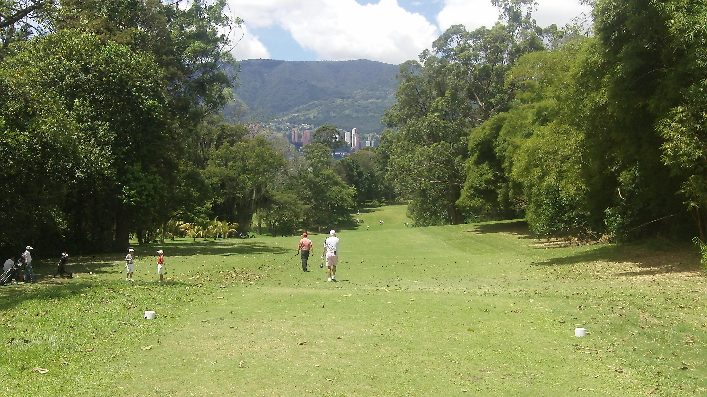

Here’s the view looking up at the green. The fairway bunkers I mentioned are behind me in this photo. I have found this green difficult to hit. I’ve been long which isn’t so bad and I’ve been left in the bunker you can’t see.

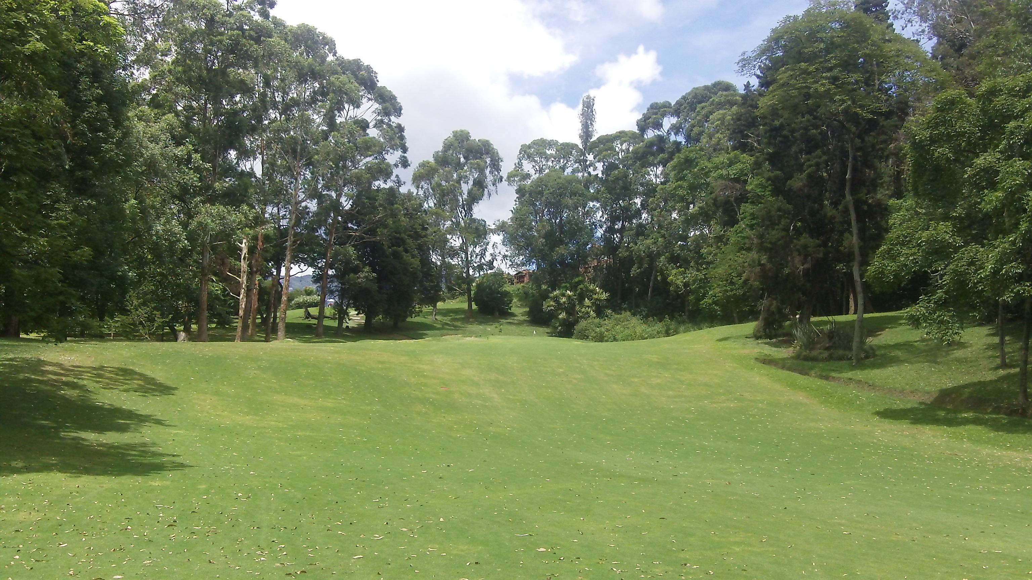

That does it for the first 5 holes of la segunda vuelta at El Rodeo Golf Club in Medellin, Colombia. Stay tuned for the closing holes coming up in my next message.

Until then…

Dedicated to Lower Scores and More Fun,

Robert “Mr. International Golfer” Phillips

NEXT POST

Subject: La Segunda Vuelta (Part II)…

This is the last in a series on golf in Medellin, Colombia. Specifically I’ve been playing at El Rodeo Golf Club. The same course where Camillo Villegas learned to play golf as a young lad.

Today we’ll take a look at the final four holes of the back 9 – or la segund vuelta – as my Colombian caddie told me. If you’ve missed any of the previous posts, you can find them here:

[link]

[link]

[link]

[link]

[link]

Last time we left off after the par 5 14th hole so let’s pick up at the 199-yard par 3 15th hole. Don’t be intimidated by the distance. As I’ve said before, El Rodeo is situated high in the Andes mountains at 5,000 feet elevation so you’ll probably be at least one club longer than usual.

Second, this hole is steeply down hill. I can easily reach the green with a 7-iron or I’ll use a 6-iron if the pin is deep. That being said, don’t miss this green! Long is not good. And there are bunkers both left and right. So if you’re going to miss the green, make it short.

And this green is another one that is speedy. It slopes from right to left so if you’re putting or chipping from the right side of the green beware that the ball will roll forever! Consider yourself warned. Here’s the view from the elevated tee box:

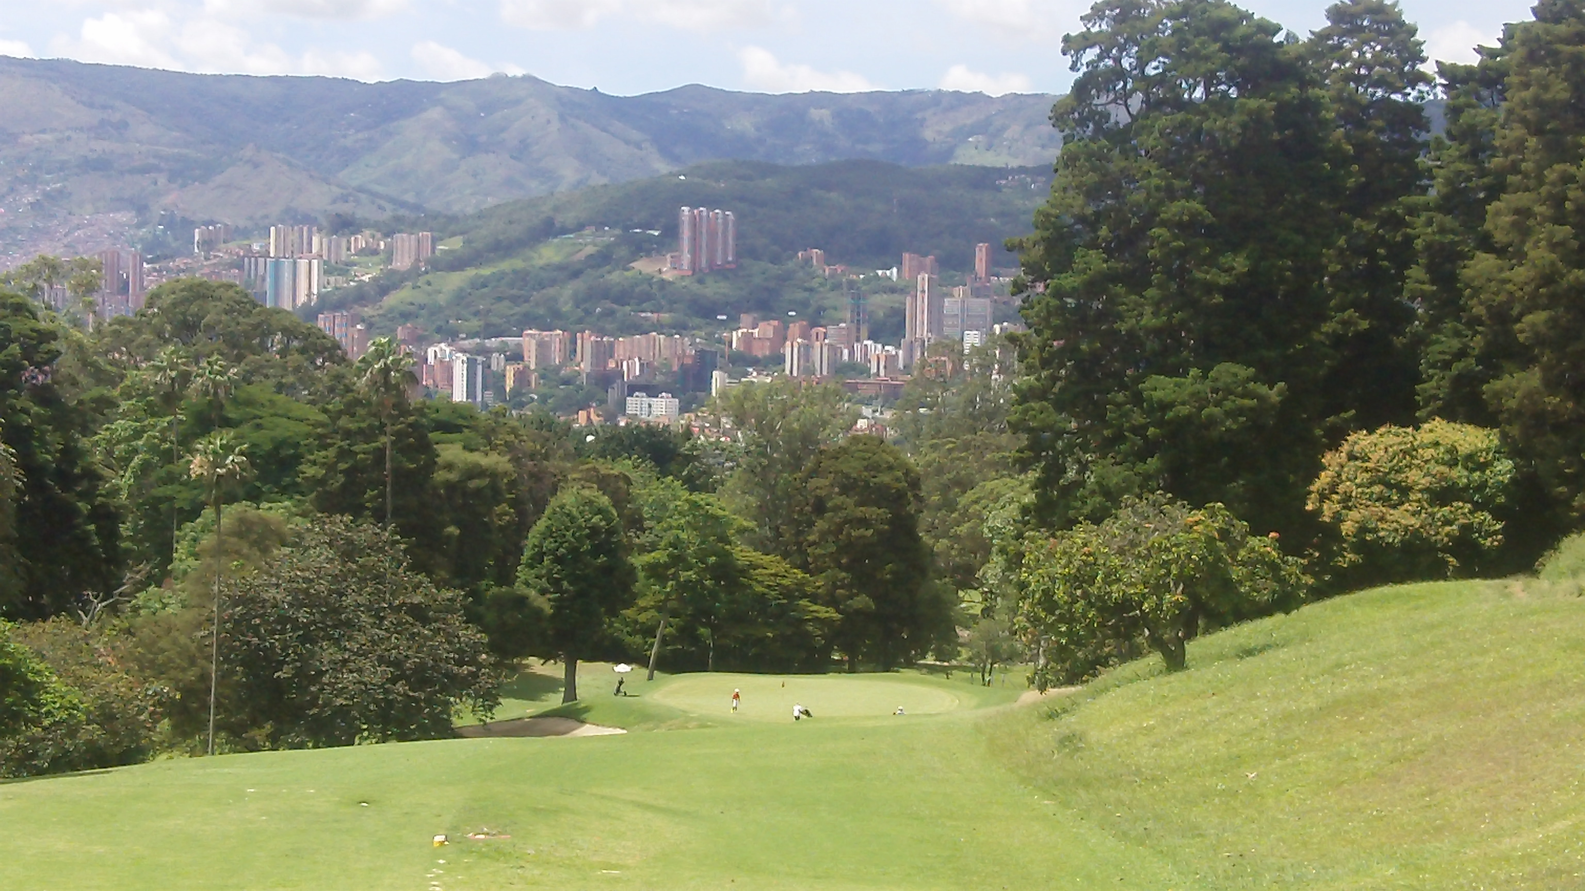

The 16th is another par 3. This one measuring 190-yards. Nothing fancy here. It’s pretty simple and straightforward. If you’re going to miss the green, then make it short and left to leave yourself with a simple pitch shot.

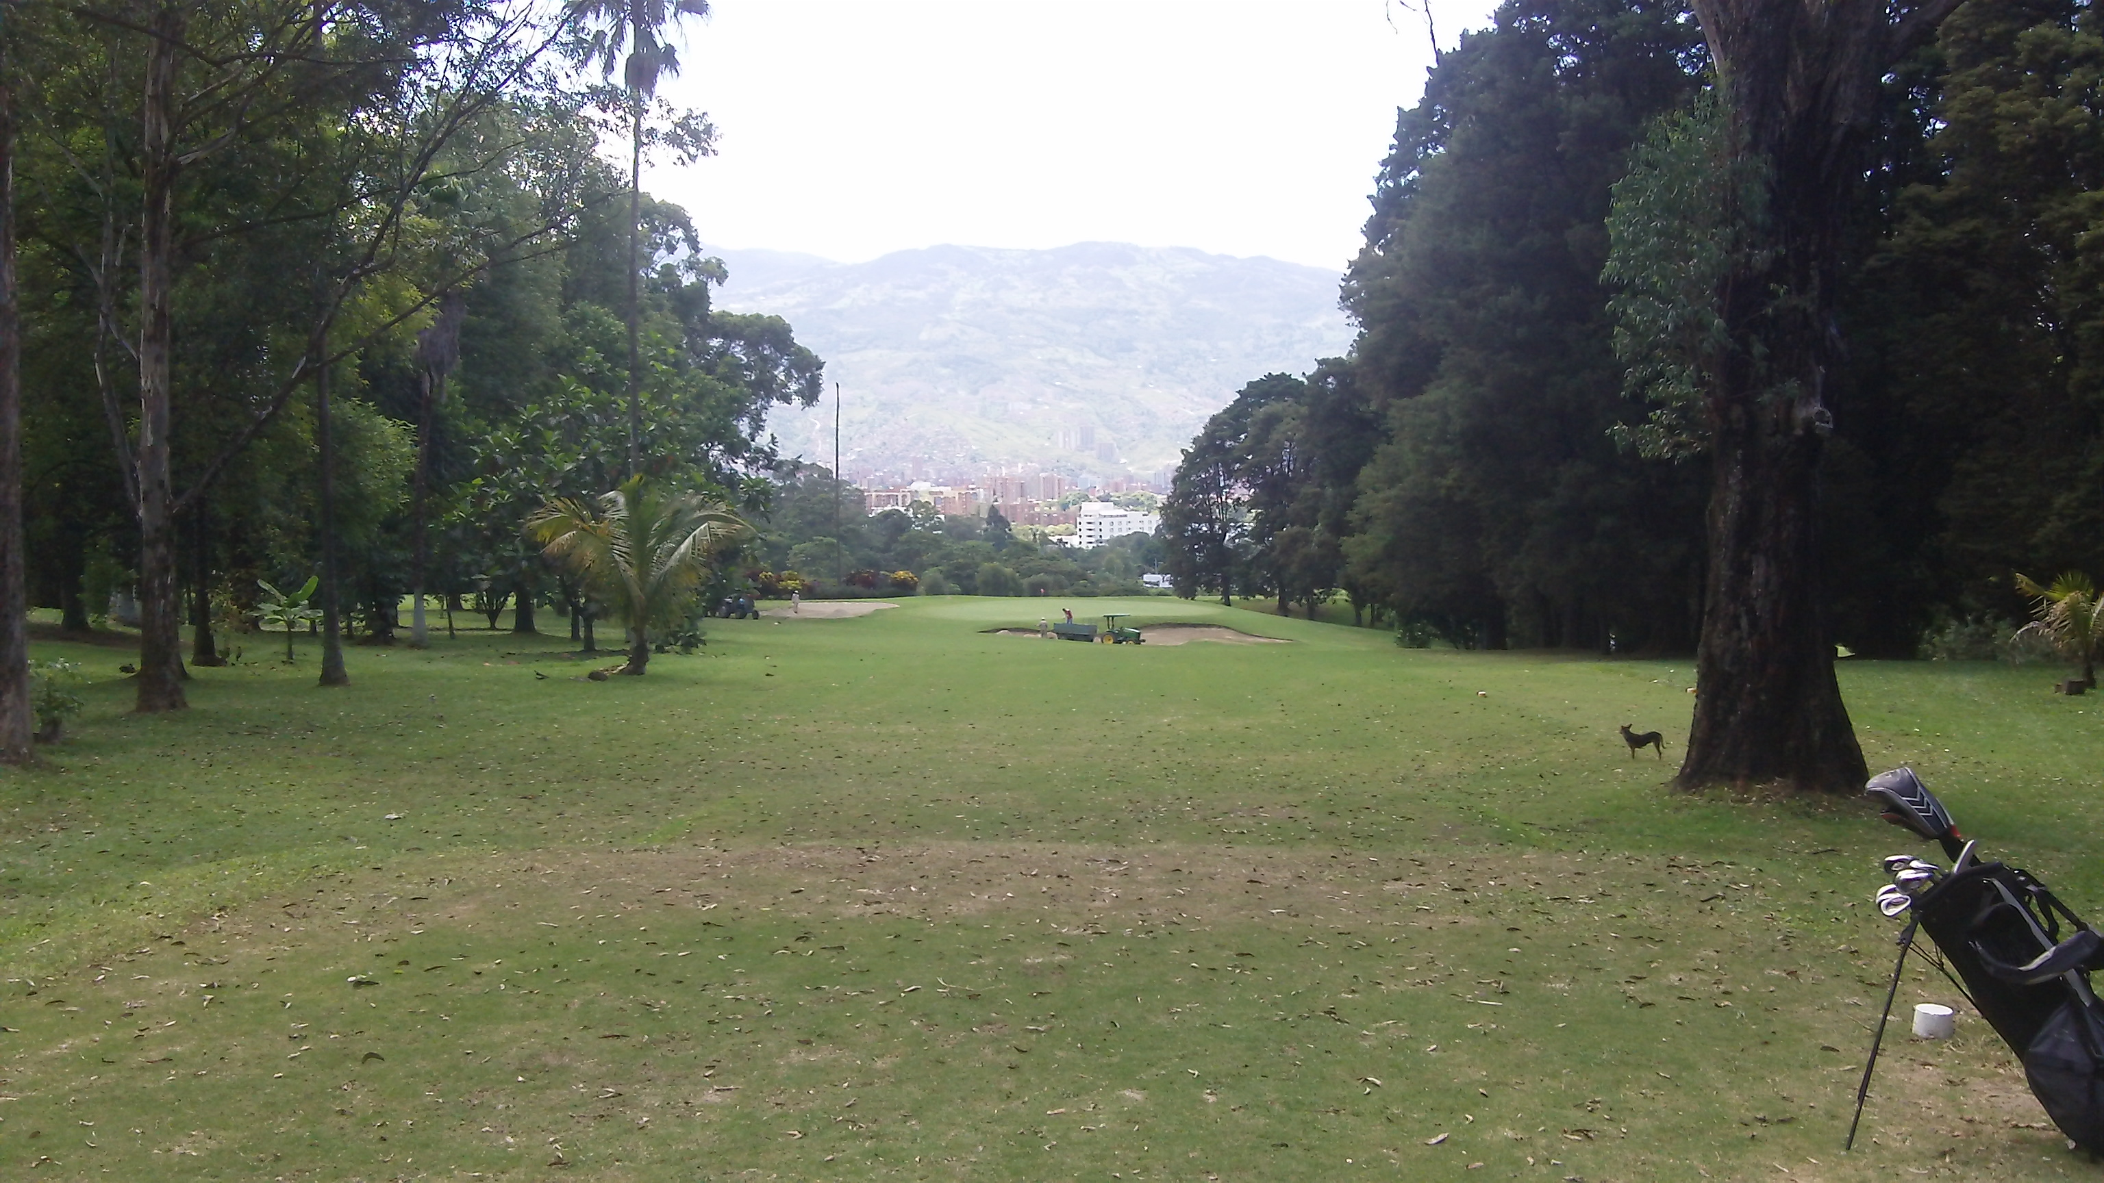

They tell me 17 is the signature hole. I can see why considering the 17th green and the airport runway are literally separated by a row of bushes! Yes, the airport is that close. It’s incredible. If you missed the videos I shared of the planes landing see my previous posts (links above).

Spray your drive right and you’ll be out of bounds in a cemetery. Miss left an and you could be in the water. I’ve found the smart play is to back off and lay up short of the water. I hit a 3-hybrid of this tee.

This hole by the way is a 430-yard par 4. It’s pretty straight but a slight dogleg left and the hole plays shorter because it’s downhill. Here’s the view from the tee box (notice the airport runways in the background):

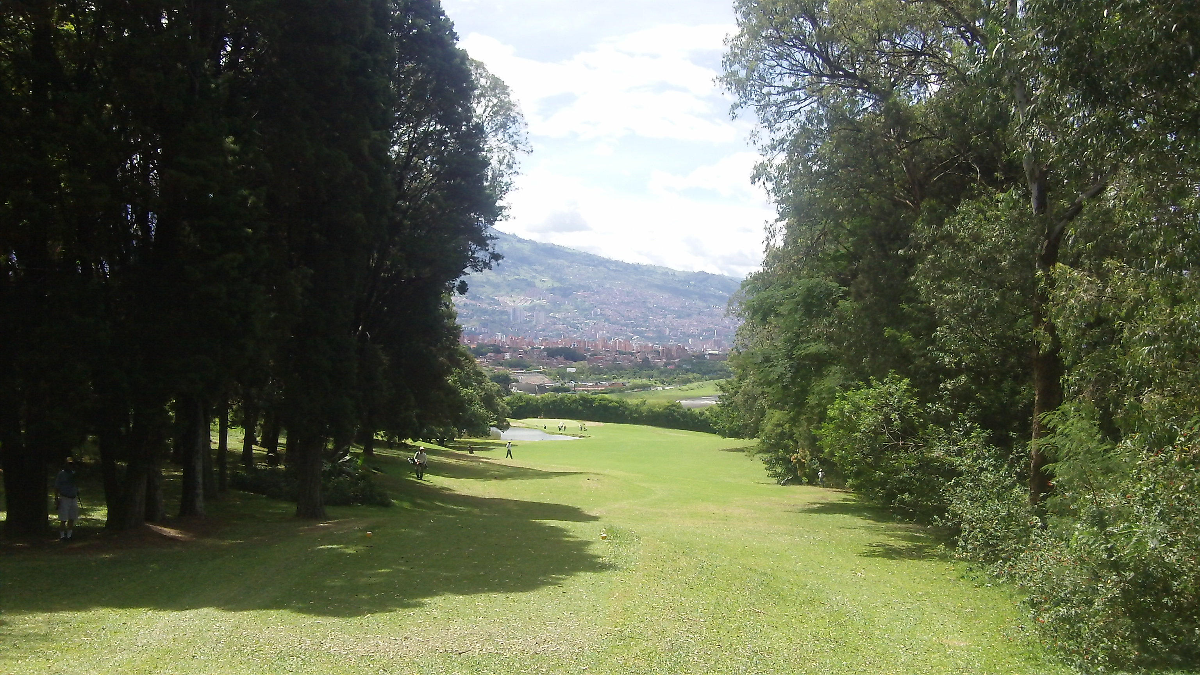

Even with a hybrid, I still only have a 9-iron or pitching wedge left into the green. This photo was taken as I was walking down to my ball – which is actually up by the water. So the approach shot is much shorter than this photo may indicate. Again, if you look closely you can see the airport runway in the background.

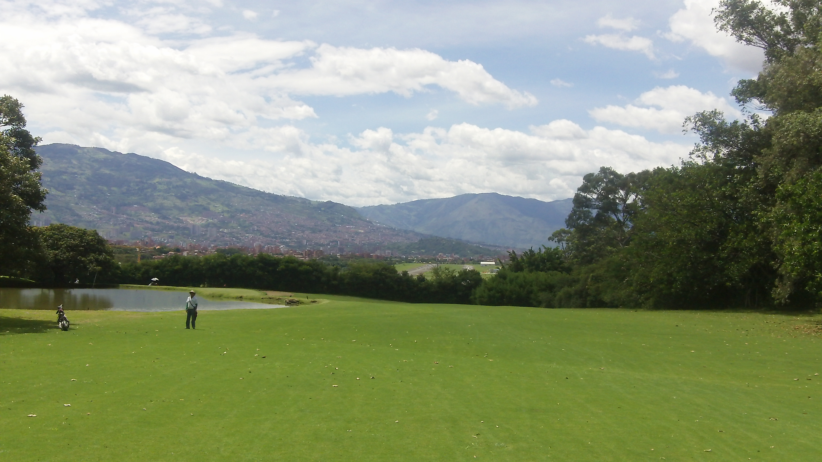

And finally the 18th hole – a 380-yard par 4. This is a short straight hole. I use less than driver because if you’re not careful and you go just a bit left you can end up in the tennis courts (OK, I admit I know this because I did it once!)

But I learned my lesson and I hit 3-hybird off the tee now. It takes both the fairway bunkers and the tennis courts out of play and still leaves a short-iron approach shot to the green. Here’s the view from the 18th tee box:

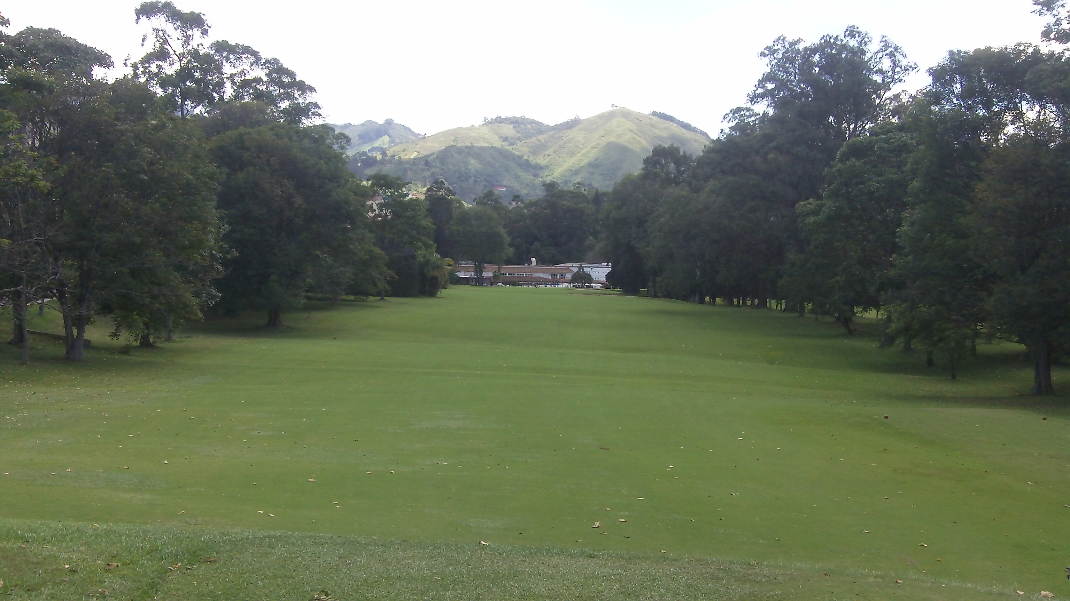

And here’s the approach shot. Don’t go long or you might hit the patrons enjoying lunch and a cold beverage at the 19th hole! Again this photo was taken as I was walking up the fairway. My drive is usually up near the fairway bunker.

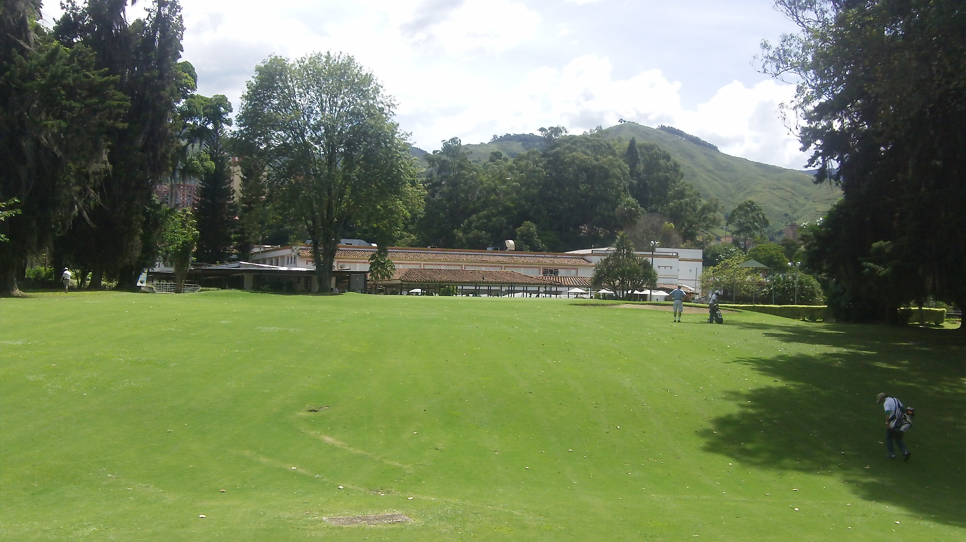

And there you have it – El Rodeo Golf Club in Medellin, Colombia. It’s a bit of a quirky course – specifically with the airport and the planes – but I like it. It’s got a good mix of some easy holes, some holes I find quite challenging, and some other in between. The greens are among the fastest I’ve played and they can be difficult to read too.

All in all I’d recommend a round of golf here if you can find a way on to this private course. After all, the weather is perfect for golf almost every day in Medellin.

Please send your questions, comments, and suggestions by hitting reply.

Until next time…

Dedicated to Lower Scores and More Fun,

Robert “Mr. International Golfer” Phillips

[END!]

HTB90

Subject: Having trouble reading greens?

We recently received a comment from James T. who said he was having problems reading greens so I wanted to share some simple thoughts that might help.

Unfortunately the only way to get really good at reading greens is to practice which means to play more golf and/or practice your putting more frequently. However, we can make some general observations.

Obviously greens are not flat. They are all purposely sloped in some direction so water will flow off of them when it rains. It’s not usually very difficult to examine the green as you walk up to it and notice which parts or sections of the green are more elevated than the others. You should be able to see the slope of the green while you’re standing on it too.

Not always, but generally greens slope from back to front. In other words, the back of the green is higher and the green slopes downward from back to front.

This means putts from behind the hole (as you’re looking at the green from the fairway) will tend to be faster than putt in front of the hole. This is because putts from behind the hole will be downhill putts and putts from in front of the hole will be uphill putts.

It follows the putts from the left side of the hole (again looking at the green from the fairway) will tend to break left to right because from that point the green slopes downward from left to right.

In other word from the left side of the hole saying the green slopes from back to front is the same as saying the green slopes from left to right because from the left side of the hole the back of the green is to the left and the front of the green is to the right.

Similarly putts from the right side of the hole will tend to break from right to left because from that side of the hole the green slopes downward from right to left.

Again this is only when the green slopes from back to front which is a general guideline. If you notice a particular green slopes from front to back then the opposite would be true.

Another simple way to read greens is to look at the cup. Is it level? Or is one side of the cup noticeably higher than another side? The putt will break to the low side of the hole because of gravity. Of course there could be another break in the green before the ball reaches the cup so you need to take that into consideration too but at the hole the ball will break to the low side.

If the greens are wet, you can also look at the water. Is the water collecting in a certain area of the green? If so, the green is probably sloping in that direction.

Lastly – and importantly – I would say that while reading putts is definitely a critical skill, speed is more important than the line so as they say “don’t fall in love with the line.”

Gary Player says speed is more important than line so I think you’d be wise to take his advice. Speed is more important because even if you read the line perfectly, failing to stroke the putt with enough pace could leave you five feet short. And that’s not what you want. If you miss your first putt, you want a tap-in. That’s why speed is more important than line.

And if your read on the putt is just fractionally off plus the pace of your putt is too strong you could end up in the same situation five feet or more past the hole. That’s less than optimal too.

However, even if your read is terrible and your speed is perfect, you ought to leave yourself a short putt of two feet or less which you’ll make almost every time. So certainly develop your skill for reading greens but remember that speed is more important than the line.

And finally, with few exceptions when you have a putt of three feet or less forget about the line! The line is straight into the back of the cup with enough pace to eliminate all but the biggest of breaks.

All kinds of bad things can happen if you “lag” a three-foot putt into the hole. In addition to the ball taking any subtle breaks, there tend to be footprints and ball marks around the cup due to the high traffic.

Putts will react more to these impediments as they lose pace. The solution is to confidently stroke short putts with enough pace that the ball should not be affected by any of these external factors. It will just roll straight in to the back of the cup.

I call the imaginary three foot circle around the hole your “circle of confidence” and creating this type of confidence in your putting skills is a key to eliminating three putts which may be the fastest way to reduce your scores.

Discover more about eliminating three putts here. [link to Kindle book on 3-putts]

Dedicated to Lower Scores and More Fun,

Robert “Mr. Speed is More Important Than Line” Phillips

P.S. Being able to read putts is a great start but there’s more to putting than reading greens. I’ve created a resource packed with tips and drills to help you develop your putting skills and eliminate three putts. Get all the details here.
[We could also promote indoor putting drills when it’s ready]

NEW POST

Subject: How I added 50-yards off the first tee (anyone can do this)…
OR How to “activate” your golf muscles in 2 minutes (and add 50 yards)…

The other day I was standing on the first tee at El Rodeo Golf Club in Medellin, Colombia, and I decided to try something new. It’s called “activating” your golf muscles.

Stretching your muscles before your round is important but “activating” your golf muscles is different. And make sure to stretch BEFORE you “activate” your golf muscles.

There are two groups of golf muscles to “activate” – the upper body and the lower body. This hole routine took me about two minutes – maybe even less.

Let’s start with the lower body – mainly the glutes, hamstrings, and quads. All I did was a few of what I call “side jumps” or lateral jumps. You can start with either foot. For arguments sake let’s start with the right foot.

Put all your weight on your right foot and jump laterally to the left with the emphasis on distance rather than height. When you land on your left foot, regain your balance and explosively jump laterally back to the right. Repeat this five or ten times with each leg to “activate” your lower body muscles.

If there is a bench on the first tee, you could also do some bench jumps. Jump up onto the bench, land with both feet, then immediately jump back down to the ground. When you land on the ground, regain your balance as quickly as possible, then jump back onto the bench. Do about 10 to 20 of these.

If you prefer you could also do “frog jumps” where you jump like a frog. Maybe three jumps forward followed by three jumps backward. And repeat three or four times.

Next you’ll want to “activate” the golf muscles in the upper body. You’ll do this by swinging a golf club two different ways. First you want “overspeed.” You’ll do this with a light club. Actually I use an alignment rod with a golf ball duct taped to it for a little extra weight but it’s definitely lighter then a normal club.

You could also just take your driver (or any club really) and hold it upside down. In other words, grip it at the bottom near the club face so you’re swinging the shaft.

Take five to ten swings with as much speed as possible. This “activates” the golf muscles with a focus of adding more speed to your swing. Next take your driver and swing it five to ten times with a focus on speed. This gets your upper body golf muscles used to the weight of your driver.

And that’s it. Your golf muscles are now “activated” and your ready to blast your first tee shot. Here’s how this actually worked for me…

I don’t know about you but off the first tee, I usually just want to hit my drive 250-yards and in the fairway. I can certainly hit my drives farther than that but off the first tee I generally don’t want to be too aggressive, overswing, and start my round off with a duck hook into the woods!

That works well on easy opening holes. You know what I mean, something like a 375-yard par 4 where a 250 yard drive leaves you with a short iron for your approach shot.

The challenge at El Rodeo is that the first hole is 405 yards. So my 250 yard drive leaves me about 155 out for my second shot. That’s not bad but the first green at El Rodeo is heavily guarded by bunkers both right and left so I’d much rather be hitting a wedge from 100 to 120 yards out than a 7 or 8-iron from 150 or 160 yards.

When I stepped up to the tee after “activating” my golf muscles. I felt more confident over the ball and took a more aggressive swing than normal. And I roped my drive down the left side of the fairway.

My approach shot was from 110 yards which means I blasted my tee shot 295 yards. Now those pesky bunkers were much less of a problem.

And I have to tell you that my playing partners – the same guys who may have been wondering “what the heck is he doing” while I was “activating” my golf muscles on the first tee box – were impressed.

My drive was a good 30 to 50 yards past theirs. I added about 50 yards to my tee shots from the first few times I played this course. I continued to bomb drives the entire round. And as far as I’m concerned it’s all because I took two minutes on the first tee box to “activate” my golf muscles.

Try “activating” your golf muscles on the first tee box before your next round. Don’t worry about your playing partners reactions. Trust me, they’ll be impressed when you blast your first drive past theirs!
Dedicated to Lower Scores and More Fun,

Robert “Mr. Golf Muscle Activation” Phillips

P.S. [promote one of Chris’ fitness programs here]

[Sidenote: This may be a good headline idea. Knock off the classic headline “They laughed when I sat down at the piano, but when I started to play…” Something like “My playing partners laughed when I “activated” my golf muscles on the first tee box, but when I smashed my drive 50 yards past them all…]

#3 ??? HTB90?, Common Faults & Fixes (could be 4 emails)….

#4 Thank You and Announcement

thanks for making HTB90 #1 and announcing the 2.0 version….

