Record-Setting Gold Deposit Discovered Near One of the
7 Wonders of the World

“This is one of the largest gold deposits found in the last decade.”
– Jonathan Guy, Gold Analyst, Royal Bank of Canada

Most importantly, it’s one of the largest gold deposits on the planet NOT owned by a major
mining firm – and it has already produced over 526,000 ounces of gold.

Since I first recommended the tiny firm behind this discovery a few months ago, shares are already up 100%. But it still costs less than $2 per share, and I believe if you invest today you could make 5-times your money in the next five years.

Dear Reader,

Recently, a major gold discovery was made in a location you’d never guess in a thousand years.

If it were buried beneath the Empire State Building… or the Eiffel Tower, it would probably be less surprising.

That’s because this massive discovery was made near an extremely popular tourist attraction. As a matter of fact, about 30 MILLION people have visited this place over the past 10 years and none of them realized how close they were to the largest gold discovery of the past decade.

“No one had thought to prospect for gold because there was no tradition of mining there,” says mining journalist, Michael Theodoulou.

That is, until a geologist with a small mining outfit, based out of London, [or is it Australia? They have offices in both places but I think HQ is in Austrailia] realized the land near this instantly recognizable landmark could contain incredible amounts of gold and other precious minerals and began exploring the area. It turns out his instincts were correct.

How much gold has been discovered?

You might be surprised when you see…

Jonathan Guy, an Investment Analyst with the Royal Bank of Canada says “This is one of the largest gold deposits found in the last decade.”

Mining journalist Lawrence Williams calls it, “The world’s largest new gold mine.”

(I’ll show you the surprising totals in a moment.)

As it stands right now, this could be THE largest gold mine on the planet NOT owned by a major mining firm.

And here’s where it gets really good…

- One of the mining industry's leading audit firms, Roche Process Engineering, has independently reviewed and verified the size and recoverability of this massive gold deposit in a Definitive Feasibility Study. In plain English, that means there’s real gold – A LOT of real gold – in this deposit.
- The mine has already produced over 526,000 ounces of gold and is expected to ramp up to 500,000 ounces per year by 2016. That’s enough gold to make this one of the top producing gold mines in the world.
[insert image of NRH study of the top 50 producing gold mines in the world – Sukari Hills is #25]
- The total value of the gold in this enormous deposit (over 15 MILLION ounces and growing) is conservatively estimated at more than $25 BILLION – more than 10 times the value of the small company that made the discovery. The value of the deposit will be even higher if the price of gold continues to climb as most experts predict.
- And the best part might be government support. The government sees mining as a huge opportunity for economic development. They’ve already granted the small company that made the find exclusive rights to mine all the gold in a large area surrounding the discovery for 30 years (renewable for another 30 years). And this agreement has been signed into law.
What makes this situation even more remarkable is that practically no one is paying attention to this situation, except for a handful of the world's smartest geologists.

Shares of the small company sitting on this giant golden treasure are trading for practically nothing (less than $2 per share) compared to the value of the precious metals it controls. Since I first recommended this small company, the stock price is up 100%. But that is just the first, tiny tip of the iceberg. I think investors who get into this company today could easily make 500% gains over the next few years… and with very little risk.

Remember, this mine is already producing hundreds of thousands of ounces of gold. It produced over 200,000 ounces of gold last year. It’s on pace to produce 250,000 ounces of the yellow metal this year. And production is expected to more than double by 2014.

- They already have all the permits they need. They already have a deal with the local government. They already have all of the mining infrastructure in place. In other words, the big risks are already behind us. If gold stays at today’s current price, goes up, or even drops a little, the folks who get into this company today are going to make several times their money in the next few years. And the gains could be off the charts… up to 1,000% or more.

There’s really been nothing like this in recent years, yet the story has been completely unreported in the mainstream press. It has not appeared at all in the Wall Street Journal, Barron’s, the NY Times or any other mainstream publication that I’m aware of.

- And part of the reason for that is because this major find is sitting in a very unusual place… in the shadow of one of the world’s most popular and famous landmarks!

The important thing to remember here is that once the word really starts to spread, I expect this discovery to gain worldwide media attention. And due to a specific event that has recently taken place — this tiny stock could become VERY popular.

I’ve seldom seen such a one-way bet in my entire professional career.

With that said, I don't think this situation will remain a secret for much longer.

Where exactly has this incredible discovery taken place… how much gold did they find… and is this opportunity right for you as an investor?
Here’s the full story of…

One of the Largest (and Most Unusual)
Gold Discoveries of the Last Decade

Hi, my name is Matt Badiali.

I’m an investment analyst at a boutique investment research firm called Stansberry & Associates, headquartered in Baltimore, MD. My area of expertise is in the energy and precious metals sectors.

I’ve spent the better part of the last decade helping everyday folks learn how to generate above average returns in the natural resources markets.

One of the ways I’ve found to make a lot of money in resource stocks, for example, is to take advantage of big situations before the mainstream investment community becomes aware of them.

Let me show you some of the kinds of situations I’m talking about…

I introduced subscribers to an incredible opportunity to get in early on China's emerging precious metals industry. I saw an opportunity to double our money and I recommended buying shares of Silvercorp at $3.25 in June of 2009.

That was well before Investor’s Business Daily touted the stock in December 2010. If you waited for the mainstream press to tell you about Silvercorp you missed the boat.

A month after the article was published, in January 2011, I gave the sell signal when shares were trading for $11.66. That's a gain of 269% – more than double the initial investment.

There’s also the “Alaskan Gold” story. I recently investigated the discovery of the largest unmined gold deposit in the world. As it turned out, the company is run by a
40-year veteran of the mining industry with a long track record of success.
In March of 2009, my recommendation was to buy shares of Northern Dynasty at $4.18. That was more than a full year before a story about “A Mind-Boggling Alaska Goldmine” hit the mainstream press in August 2010.
By the time that story was published, we were already up 60.8%. And share prices had risen to $17.64 when I gave the sell signal in February 2011 – a quick gain of 322%.
"On Northern Dynasty Minerals I made 167% and on Parker Drilling Company 161%."
– Karl Blanchard, Austin, TX

And finally, there’s the story of Jinshan Gold which owns one of China’s largest gold mines. More importantly, I discovered the company had the strong backing of the Chinese government – a government with a mandate to develop China’s vast mineral wealth. I recommended shares of Jinshan at $1.05 in July of 2009 – more than a year before one report labeled the company “the Golden Egg.”
By the time that article was printed shares had already skyrocketed to $4.50. You’d have missed most of the gains if you had waited for the story to hit the mainstream. Two months after the Jinshan story was out, in May 2010 – just 290 days after my initial recommendation – you could have sold those same shares for $4.61 and banked a 339% gain.
As you can see, I have a history of identifying great investment opportunities in precious metals early – before they become popular and their share prices soar.

And that brings me to the incredible discovery – in a VERY unusual location – I mentioned earlier.

So where exactly was this massive gold discovery made? And which of the 7 Wonders of the World sits nearby?

This major gold deposit is located…
“Egyptian gold is
as plentiful as dust.”
– Mining Weekly⁷

435 miles south of Cairo, Egypt…
15 miles west of the shores of the Red Sea…
In the shadows of the Great Egyptian Pyramids…
In all, the massive gold strike covers 160 square kilometers in the eastern part of the Sahara Desert.
It’s said to be the same source of gold mined by ancient Pharaoh’s like King Tut and Cleopatra. And as it turns out, the ancient Egyptians barely made a dent in the vast supply of gold.
After all, tremendous advancements in mining technology have been made since the days of the Pharaohs.
Indeed, while modern Egyptians were going about their daily lives and millions of tourists were flocking to major attractions like the Great Pyramids, the Sphinx, and taking cruises down the Nile…one of the largest gold mines in the world was practically right at their feet where it has sat basically untouched for thousands of years.
The estimated gold treasure in this deposit has skyrocketed from 2 million ounces in 2000 to over 15 million ounces today…and the estimate of the mine’s vast gold reserves continues to grow as exploration advances.
Here’s a graph showing the steady growth in the amount of gold reserves over the past decade.
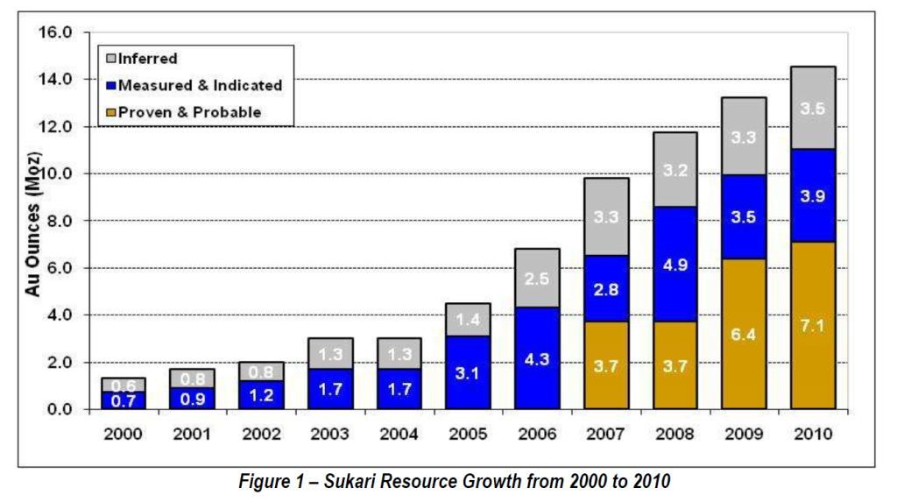
NEED TO MAKE THIS GRAPH LOOK BETTER…
USE SOLID BARS (NO DISTINCTION BETWEEN INFERRED, MEASURED, AND PROVEN

The size of this record-setting gold deposit keeps growing as exploration continues. The estimated gold reserves have soared from 1.3 million ounces in 2000 to over 13 million ounces today.
Is it a problem that this chart stops at 2010 and we are now well into 2012?

According to the latest figures, there are 15.4 million ounces of gold making it one of the largest gold resources – and the only producing gold deposit over 10 million ounces – not held by one of the world’s major gold producers
Why Should Investors Be Excited
About the “Egyptian Gold” Story?
That’s a fair question considering what’s been happening in Egypt over the past few years. I’ll admit it – I was skeptical myself at first. But when you peel back the layers of the situation and investigate further, you may be surprised at how good the opportunity looks.
The first several reasons are obvious.
- I’ve already mentioned the 15 million ounces of gold and the mine that has already produced over 526,000 ounces of gold and is on track to double production by 2016. This may be the largest producing gold mine not owned by a major gold producer.
What most people don’t realize is that Egypt’s economy is projected to be among the world’s top 10 fastest growing economies in the world over the next several decades by multiple sources. And mining could be the leading growth industry.
A director at the Egyptian Mineral Resources Authority makes it crystal clear when he says: “Egypt is full of mineral resources. The only choice for us is mining…”
Egyptian officials know the development of the mining industry could give a huge boost to their economy for many years to come. And government officials are excited about the possibilities of creating an industry that could generate more money than oil, tourism, and the Suez Canal combined.
Egypt’s gold mining industry could outstrip oil, tourism, and Suez Canal receipts combined.
Al-Ahram Weekly

So it comes as no surprise that the government has thrown its strong support behind the development of this massive gold mine (and the jobs and revenue that come with it).
They’ve even passed a law specifically granting exclusive mining rights to the small company that struck the gold. The exclusive rights are good for a period of 30 years and renewable for an additional 30 years. The government has also waived taxes for a 15-year period and provided fuel subsidies as further enticements to speed development of the mine.
And perhaps most importantly, the Egyptian government will participate in the profits of the mine so they have a vested interested in maximizing gold production as quickly as possible. This is key. With the government as a partner in this project, it makes it very unlikely to fail, to get shut down, or to find any political trouble.
All the pieces of the puzzle are falling into place and the stock price of this little-known mining company is set to soar due to the single event I referred to earlier in this presentation. As I mentioned, I’ve been following this situation very closely for the fast few months. And since I first recommended this company, the share price is up about 100%. But we still have a long, long way to go.
And don’t worry, you won’t need to send any funds to Egypt take advantage of this opportunity. That’s because the company has offices in London and its stock is traded on both the Toronto and London stock exchanges. So you can easily pick up shares through online brokers like Scottrade, TD Ameritrade, E-Trade, and many other discount brokers.
But perhaps the biggest reason for investors to take notice is an upcoming event mentioned earlier. This development is exciting because…
Similar Breakthroughs Have Created Gains of 953%,
1,530%, even 1,973% for Investors that Got in Early…
What is this event that has repeatedly produced triple and quadruple digit gains in mining stocks?
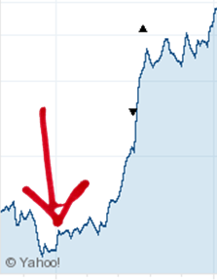Let me give you some examples…
Newmont Jumped 953% After This Event...
Today Newmont Mining is the 3rd largest gold miner in the world, but it wasn’t always that way. Newmont’s major growth spurt started in the 1980’s.
After a specific event that took place in 1985, the company’s stock price took off as you can see in the chart to the right. In January 1985 you could have bought a share of Newmont for $2.95. By February 1990, that same share was worth $31.06 – an increase of 953%.
In 1985 (where the red arrow points), after specific event took place the stock price of Newmont Mining exploded. The same event is happening right now with a small mining stock I have uncovered.
When this event occurred in 2007, shares of China Gold International Resources jumped from $1.99 in July 2007 all the way up to $6.26 in April 2010 – a gain of 216%.
That same event could generate triple digit gains (or more) the less-than-$2 stock of the small mining company I’m introducing today.
Goldcorp Soared 1,973% After This Happened…
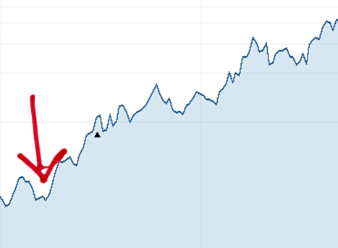The same identical thing happened with gold mining juggernaut Goldcorp (the world’s 2nd largest gold mining company) in 2001.
At the end of 2000, shares of Goldcorp were trading for $2.39. This event happened in early 2001, and by May 2006 the shares had jumped 1,530% to $38.95. If you held your shares until July 2008, your investment could have skyrocketed 1,973% to $49.55 per share.
In early 2001 (where the red arrow points), something happened. After this event occurred, the share price of Goldcorp jumped 1,530% from $2.39 to $38.95. That exact event just took place in a small mining and its share price could rip higher hundreds of percent in the coming months.
The exact same catalyst – an event that has actually already taken place – could send shares of this small mining company on a similar upward climb.
I could show you several more examples but you get the point. After a specific event takes place, these gold mining stocks soared.
So what is this event? What happened before these stocks exploded?
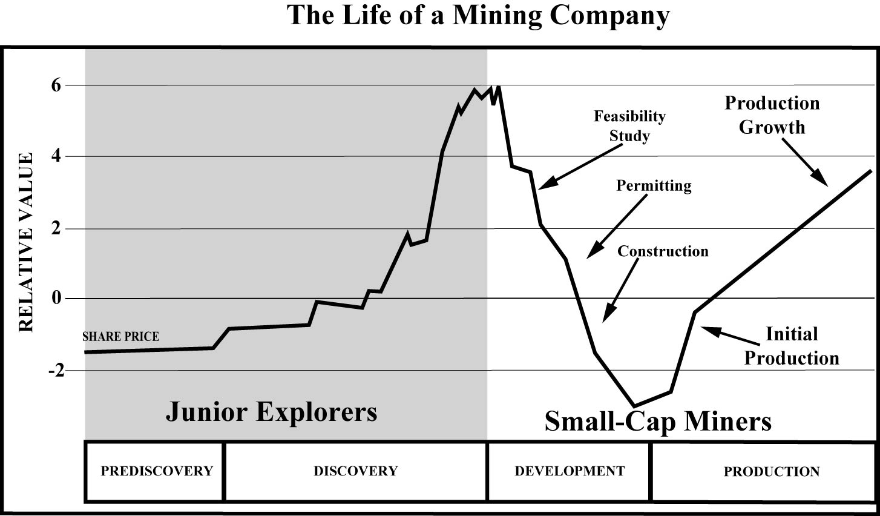The illustration below will help… [red circle production and rising stock price?]

As this chart shows, the share prices of gold mining stocks can climb quickly after initial production begins. I’ve identified a small mining company that is now producing over 200,000 ounces of gold each year. The share price could soar as production ramps up to 500,000 ounces annually over the next few years.
The graph above shows the life of a mining company. Specifically it shows how the share price tends to rise and fall over the different stages of a mine’s development. In many cases, the share price will jump when a discovery is made (a new gold discovery tends to excite investors).
But discovery is just the beginning. There’s no guarantee a gold discovery will lead to a successful mining operation. Before a single ounce of gold is produced, the site needs to be developed and the mine needs to be built.
This can take several years and hundreds of millions of dollars – and a lot can go wrong. Further exploration can show there’s not as much gold as originally thought. It can be challenging to find the funding to build the mine, and there can be delays in construction due to weather or with the permitting process.
This stage of a mine’s life can be financially challenging too. After all, millions of dollars are being spent on developing and building the mine but it’s not producing any gold so there are no profits to offset the large capital expenditures. Any bad news can send the share price tumbling and it’s not unusual for the share price to fall during this stage of a mine’s life.
But when a mine begins operating and starts producing gold and generating revenues, the stock price can soar. And it can happen quickly. This is the single event that can be the catalyst that generates triple-digit returns in a short period of time. Early investors who get in when the mine starts producing real gold and before production ramps up can potentially make a fortune.
In each of the three examples I just described, the catalyst that sent the share price soaring was the commencement of production.
- These firms finally began producing real, hold-in-your hand gold. And soon after that, the stock prices shot up as the demand for shares of these gold mining companies increased dramatically.
- This is exactly what investors want to see… a company delivering on its potential.
And that’s exactly where we find ourselves today with this massive gold mine in the shadows of the Great Pyramids of Egypt. The gold was discovered, the site was developed, the mine was built, and now it’s producing gold – A LOT of gold – over 200,000 ounces last year. And production is projected to ramp up to 500,000 ounces annually over the next few years.
- It’s a real sweet spot for investors, because you have very little risk… yet the bulk of the investment world still has no clue this opportunity even exists.
This could be a golden opportunity to get in early and set yourself up for triple-digit gains – maybe even more if the price of gold continues its upward trend.
- Of course, this is why the people who know the most about this company—the corporate executives—are now personally loading up on shares.
- SHOW THE DETAILS OF THIS… HOW MUCH ARE THEY BUYING AND WHEN WAS IT?
You get the idea. My focus is on finding the biggest opportunities in the lucrative natural resources sector. And that’s exactly what I’ve discovered in this small mining company. This could be one of the most profitable investments I’ve ever uncovered. I believe you could double or triple your money – or perhaps even better – in the coming years.
As I mentioned earlier, I’m a geologist and investment analyst at Stansberry & Associates – one of the largest independent investment research firms in the country headquartered in Baltimore, Maryland.
I write an investment newsletter called The S&A Resource Report . The people who follow my research – and act on my recommendations – have had an opportunity to make a lot of money investing in one of the most lucrative sectors of the market: resource stocks.
Averaging 20% Per Recommendation
...as high as 100%!!
"I am most pleased to say that your reports have been outstanding and very profitable... My average return on each trade has been in excess of 20% plus. Some as high as 100% plus. Keep up the good work as you have won a faithful customer. I'm a satisfied customer."
– Donald M., Indianapolis, Indiana

I’ve dedicated myself to becoming an expert in resource stocks and identifying the best investment opportunities. For the past 15 years, I've spent time on drill rigs, taught at three prestigious universities, and presented my research findings to companies such as Anadarko Petroleum and ExxonMobil.
And for the past few years, I've devoted a large portion of my time to the precious metals industry, learning everything possible about the gold and silver markets – and more specifically the best ways to make money investing in gold and silver stocks.
My experience and contacts have helped me uncover some very profitable natural resource investments early – while they’re still under the radar. And that’s the key – getting in early.
Today I’m inviting you to join the growing list of people who receive my monthly research as part of The S&A Resource Report. Just give it a try and I’ll send you my full report with all the details. It’s called “Triple-Digit Profits from the Pharaoh’s Gold,” and I’ll send it to you immediately, and FREE of charge.

But that’s not the only thing I want to give you today…

You see, things are getting exciting and right now we have some extraordinary opportunities before us in the gold and silver sectors. Here’s something else I recommend you take advantage of right away… [test the buy button here vs. no buy button]

The “Canadian Silver Program”…

You probably already know Canada is one of the most important countries in the world when it comes to natural resources. But here’s something about the precious metals industry that even most Canadians don’t know…

Our friends from Canada have created a unique silver opportunity, which has the potential to generate huge gains for investors over the next few years — even if silver prices don’t go up a single penny.
What I call the “Canadian Silver Program” is truly one of a kind – you won’t find anything quite like it anywhere else in the world.
And get this…
Since 2005, an investment in the “Canadian Silver Program” has soared more than twice as high as ordinary silver bullion.
If you believe silver is a smart play over the next few years, as governments around the world keep printing and borrowing money at staggering rates, then I recommend you Act Now while this investment is still incredibly cheap.
If you’re interested in this idea, I’ve prepared a comprehensive Research Report called: “The Canadian Silver Program.” This report explains, in full detail, everything you need to know about this operation, how it works, and most importantly how to profit.

I’d like to give you this report today – completely FREE of charge.

This report is yours when you accept this risk-free trial invitation to try my monthly research advisory, The S&A Resource Report. As I mentioned, this is exactly the type of opportunity we look for – and your chance to get in on a great precious metals investment at a bargain price.
In fact, since 2008, my research team and I have made 33 investment recommendations that have gained double-digits or more. [update this? There could me more double-digit winners since I wrote the SLW promo]

I firmly believe energy and mining stocks are the best places investors can have their money over the next few years.
Of course, I can't tell you for sure whether or not it will be right for you, but here's what some S&A Resource Report readers – including many veterans of the resources industry – have told us recently...

30-year Amoco Veteran:
"Matt Badiali's Report is my favorite newsletter... and I would recommend it to anyone."
– Mike Hourihan, retired from BP/Amoco after 30-year career
Director Of NYSE Company
"Your letter, in many instances, has confirmed good ideas under consideration and at other times introduced new ideas, which have proven to be very profitable! I look forward to your report each month and find it to be extremely valuable. Keep up the good work!"
– Gerald Wilson, director of a NYSE listed E&P company
9-Year Energy Industry Veteran
"I know all the big names in energy and energy services... but the S&A Resource Report has introduced me to faster growing, small energy service companies that are performing extremely well. I am very satisfied with the performance of these investments overall."
– Harold Dickens., PhD., 9-years in global energy services
I know... I can only tell you so much. You've got to try The S&A Resource Report for yourself before you can decide whether or not it's right for you.
So, here's what I propose...
Claim Your 2 FREE Research Reports along with
4 Risk-Free Issues of The S&A Resource Report Today

I’d like to send you a complimentary copy of the two Research Reports I’ve mentioned:

Research Report #1: “Triple-Digit Profits from the Pharaoh’s Gold”
This comprehensive report provides all the details on the small mining company that discovered perhaps the largest gold mine of the past decade in the shadows of the Great Pyramids. The mine has been built and is producing record-breaking amounts of gold. Insiders are loading up on shares of company stock and its share price is set to explode. You’ll know how to reap potential triple-digit profits when you finish this report.

Research Report #2: “The Canadian Silver Program”

A group of Canadian businessmen has created a new silver opportunity with the potential to generate huge gains over the next few years – even if the price of silver doesn't go up a single penny. Since 2005, this silver investment has soared more than twice as high as ordinary silver bullion. In this Report, you’ll get full details on the lucrative “Canadian Silver Program.”

These two new Research Reports will be the first things you should read when you accept your Risk-Free invitation to test drive The S&A Resource Report.

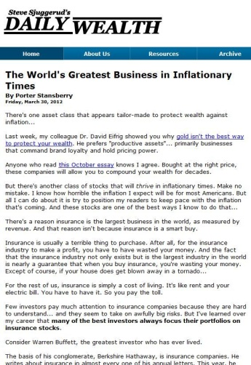 Over the course of the next year, you'll receive 12 issues of The S&A Resource Report. Every month (for the next year), you'll be getting my latest ideas for how to best capitalize on opportunities in the highly lucrative resources sector.
We'll also begin sending you DailyWealth which has quickly grown to become one of the most widely read financial e-letters in America. Our 420,000+ readers regularly learn about investments they'd never hear about anywhere else.
Every day, you'll be hearing from my friend Steve Sjuggerud (a former hedge-fund manager and mutual-fund manager with a PhD in finance) or another of the world's top experts in commodities, biotech, value investing, and contrarian strategies.
These experts will give you the facts behind what’s really happening in the financial markets... and teach you their secrets for growing and preserving your wealth in each and every DailyWealth essay.
When you claim your FREE Research Reports and 4 Risk-Free issues of The S&A Resource Report, you’ll also receive DailyWealth – one of the most popular and widely read financial
e-letters in America.
Plus, you'll have full access to my online Resource Report archive... with full details on several more of the best investment ideas that I haven’t had time to cover in this message.
Also, every evening after the markets close, you’ll receive by email our subscribers-only S&A Digest. If you are already receiving one of our investment advisories, you already know about The Digest.
If you are new to our business, I think you'll quickly see why so many readers say it's their "favorite financial news source," and the "one thing they must read every day."
[do we have more and better testimonials?]
Thank you all at Stansberry
& Associates. Your work has enriched, enlightened and educated me."
– Paid-up subscriber Marci
Every day in The Digest we analyze the most important financial stories, and show you exactly how these stories affect you and your money.
The Digest is also where we post reader feedback (both the good and bad) and share the details on what we're working on next.
And get this: For the next 4 months you can give The S&A Resource Report, and everything else I've described here, a look at absolutely NO RISK.
What I mean is, take your time to thoroughly examine all my reports like… [are there any other reports I can add?]
The Gold Investors Bible
In this Special Report, you’ll discover several unique strategies to profit as the dollar falls off a financial cliff... and how to protect your wealth and your family in the years ahead. You’ll get tips and secrets on anything and everything you need to know to profitably buy, hold, and sell gold.
How to Be an Early Investor in China’s “Fort Knox”
[insert something interesting about the report
http://www.stansberryresearch.com/secure/oil/reports/html/201210OIL_report_Knox.asp]
If, after reviewing my work, my ideas and recommendations don't sound right for you, no problem. Let me know within the first 4 months and we'll send you your money back... all of it. Keep the research you've received as my way of saying “thanks” for giving The S&A Resource Report a try.
Believe me, four (4) months will give you plenty of time to make a decision about whether or not my work is right for you.
You may have subscribed to an investment newsletter before, but I guarantee this research will be unlike anything you've seen before. The best part is, you don't have to take my word for it... you can see for yourself, Risk-Free for 4 months.
(Also, keep in mind that should you change your mind after your 4-month trial is up, you can still receive a refund on the remaining portion of your subscription.)
So How Can You Get Started Today?
Well, before I give you the full details, let me tell about another remarkable situation I’ve recently discovered, which I also recommend you take advantage of right away…
- I WOULD NOT DO ANOTHER GOLD DISCOVERY STORY. IT DIMINISHES THE APPEAL OF THE OTHER DISCOVERY STORY, IN MY OPINION. YOU COULD DO SOMETHING ABOUT ROYALTY COMPANIES MAYBE… THE NEXT ROYAL GOLD, OR SOMETHING ELSE.
Canada’s Largest-Ever Gold Discovery
Not long ago, I flew up to a remote corner of British Columbia to visit one of the largest gold deposits ever discovered in Canada. This region of Canada, known as the Golden Triangle, is roughly the size of Connecticut. It is also endowed with abnormally abundant supplies of gold, silver, and copper.
One of the gold veins of the Golden Triangle is so prolific, a veteran geologist called it “the highest grade gold I’ve seen in my career – and I’ve been in the business since 1976.”
This mineral-rich zone has been virtually off-limits to mining companies for the past 150 years because of its remote location far away from roads, people, and electricity. But that’s changing…
because the British Columbian and Canadian governments pledged to invest $300 million to build the infrastructure to support mining (and the jobs and tax revenue that will be created by the mines).
That’s great news for investors because for the past several years a group of companies have been buying up prime deposits at dirt-cheap prices in anticipation of the infrastructure’s completion.
And these investments could produce big returns in the near future because as soon as the infrastructure is completed one of the greatest untapped sources of wealth in Canada will finally be open for business.
The investment I’m recommending owns two enormous projects in the heart of the Golden Triangle. Early drilling results are exceptional – revealing “bonanza-grade gold.”
One expert calls this company “the undisputed king of ultra-high grade Canadian gold.”
Now is the time to get in on these projects. The biggest gains are likely to come before word of these developments reaches the mainstream press. I’ll share everything you need to know about this opportunity in my special report, Mining the Riches of Canada’s Golden Triangle.
As with the other reports I've mentioned in this presentation, this Research Report is included free of charge with your NO-RISK Invitation to try The S&A Resource Report, my investment newsletter…
The regular price for a one-year subscription, by the way, which includes everything mentioned here, is just $99.
Why is The S&A Resource Report So Affordable?
The truth is, between travel and research expenses, overhead, and salaries, we barely break even on The S&A Resource Report.
The only way we stay in business is by providing you with research that is so unique, safe, and profitable, that you'll want to continue receiving The S&A Resource Report, year after year.
But I realize, of course, that you've got to try my research first, to see for yourself how it works and if it makes sense for you.
That’s why I’m making it so inexpensive... and hassle-free to try. And that's why we're making it even less expensive and easier to try today...
If you take advantage of this trial offer right now, you can get a BIG DISCOUNT
off the regular $99 rate others have paid.
Your price is just $39 for a full year of The S&A Resource Report, that’s a
massive discount of 60.6% off the regular price and it includes everything I've detailed in this letter...
Stansberry & Associates has quickly grown to become one of the biggest research groups of our kind in America, because our customers stick with us over the long term.
I’m so confident you’ll love my research that I’m not even asking you to commit to anything long-term.
Just try my research for yourself RISK-FREE for the next four (4) months, to see if you like it. You’re fully protected by my… [from SLW, should I re-name it?]
Better Than Risk-FREE Guarantee
Try The S&A Resource Report for a full 4-months and if you’re anything less than 100% completely satisfied for any reason whatsoever, then simply contact our office at 410-XXX-XXXX for a quick, no-hassles refund. Plus you can keep all the Research Reports as my way of saying “thanks” for giving us a try.
And as I mentioned, four (4) months should be plenty of time for you to decide for yourself if these unique investment research and ideas are worth your money or not.
If not, we'll issue you a prompt refund for ALL the money you've paid. Please keep everything you've received... with our compliments.
This is better than risk-free because you’ll walk away with valuable research even if you decide The S&A Resource Report is not for you. That's how confident I am that you will benefit in a big way from our work.
Plus, you'll have access to my latest newsletters, in which I show you several brand new investment ideas you can take advantage of right away.

Here’s What to Do Now…

To get started, simply click on the link below and complete the NO-RISK Trial Form on the following Secure Page. Your request will be processed in about five minutes, and you'll have access to everything mentioned here, IMMEDIATELY.

YES! Send Me 4 Risk-Free Issues of The S&A Resource Report Plus the FREE Research Reports for Just $39
Click on the link above to join the tens of thousands of other people just like you receiving my top investment recommendations each month in The S&A Resource Report.

Sincerely,
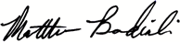
Matt Badiali, Editor
The S&A Resource Report

P.S. Claim 4 Risk-Free issues of The S&A Resource Report – in each issue you’ll discover the best ideas on how to make money in the highly lucrative resources sector. Each month I’ll share what I’ve learned in my investigations as I scour the world and talk to my rolodex of “insiders” in search of the best investment opportunities in the world of resources – like the small gold mining company that made a huge discover in the shadows of one of the most popular and famous landmarks in the world. The mine is ramping up gold production, insiders are loading up on company stock, and the share price of this less-than-$2 per share company could generate triple-digit gains over the coming months.

P.P.S. You’ll also receive 3 Free Research Reports – “Triple-Digit Profits from the Pharaoh’s Gold” and “The Canadian Silver Program” – PLUS I’ll include my exclusive research on how to profit from another potentially lucrative opportunity in “Mining the Riches of Canada’s Golden Triangle”
YES! Send Me 4 Risk-Free Issues of The S&A Resource Report Plus the FREE Research Reports for Just $39

[look for new testimonials in feedback]

[END]
Research Report #2: Mining the Riches of Canada’s Golden Triangle

Recently I traveled to a remote section of British Columbia known as the Golden Triangle to visit one of the largest gold deposit ever discovered in Canada. This is one of the greatest sources of untapped wealth in Canada and it’s about to open for business. My research has uncovered a potentially lucrative opportunity to invest in a company that owns two enormous projects in the heart of the Golden Triangle. I’ll share all the details in this Special Report.

http://cms.privatelabel.co.za/pls/cms/iac.page?p_t1=3085&p_t2=7932&p_t3=0&p_t4=0&p_dynamic=YP&p_content_id=182694&p_site_id=83
Centamin 2011 Annual Report – page 5 & Q42011 Results presentation page 29
150K+ in 2010 + 200K+ in 2011 (from Centamin 2011 Annual Report – p. 6) + 49K+ in Q12012 + 67K+ in Q22012 + 60K+ in Q32012
http://coolrain44.wordpress.com/2009/08/25/50-most-popular-tourist-attractions-in-the-world/
http://www.csmonitor.com/1999/1123/p7s2.html
http://cms.privatelabel.co.za/pls/cms/iac.page?p_t1=3085&p_t2=7932&p_t3=0&p_t4=0&p_dynamic=YP&p_content_id=182694&p_site_id=83
http://www.mineweb.com/mineweb/view/mineweb/en/page66?oid=85648&sn=Detail
Centamin 2011 Annual Report – page 5
http://weekly.ahram.org.eg/2001/559/ec2.htm
Centamin 2008 Annual Report – p. 42
http://weekly.ahram.org.eg/2001/559/ec2.htm
http://www.centamin.com/centamin/uploads/press/DFSAnnouncementFeb07.pdf
http://centamin.com/centamin/investors/news-media/news/optimised-open-pit-mine-plan
http://weekly.ahram.org.eg/2001/540/ec3.htm
15M oz x $1700/oz = $25.5B; value of CEE.TO ~$1.75B from Yahoo Finance (http://finance.yahoo.com/q?s=CEE.TO)
Annual Information Form 2010 – page 14
http://centamin.com/centamin/investors/news-media/news/optimised-open-pit-mine-plan
http://search.proquest.com/pqrlbusiness/docview/1002059121/138BEC79F9423FCDBA8/2?accountid=10750
June 2009 OIL
http://search.proquest.com/nationalnewspremier/docview/748324304/138BF341BBA294BCD3D/11?accountid=10750
http://www.stansberryresearch.com/secure/oil/issues/html/200903OIL_issue.asp
http://www.hotstocked.com/article/1918/jinshan-gold-mines-inc-pink-jinff-the-golden.html
http://www.stansberryresearch.com/secure/oil/reports/html/200907OIL_report_ChinaGold.asp
http://www.nrh.co.il/i/pdf/NRH_Research_2012%20World_Gold_Deposits.pdf (Centamin is #25 on p.5)
http://www.mbendi.com/indy/ming/gold/af/eg/p0005.htm
From Centamin investors presentation (last slide 25 of 25)
http://www.ide.go.jp/English/Data/Africa_file/Company/egypt05.html
http://www.cnbc.com/id/46322877/The_Best_Countries_for_Long_Term_Growth?slide=4
http://www.gmanetwork.com/news/story/270620/economy/finance/phl-to-be-6th-fastest-growing-economy-in-next-40-years-ndash-wealth-report
http://globalconnections.hsbc.com/news-insights/egypt-a-future-paved-with-gold
http://weekly.ahram.org.eg/2001/559/ec2.htm
http://www.centamin.com/centamin/operations/egypt/licence-information
https://en.wikipedia.org/wiki/Largest_gold_companies
http://www.newmont.com/north-america/nevada/gold-quarry
From Yahoo Finance; NEM share price on January 2, 1985 – 2.95; on February 21, 1990 – 31.06
From Matt’s presentation at the Spring Editor’s Conference
http://admin2.stansberryresearch.com/ADM/Master/Schedule?year=2012&month=10&rand=2.076143E%2B09

