Record-Setting Gold Deposit Discovered Near One of the
7 Wonders of the World

“This is one of the largest gold deposits found in the last decade.”
– Jonathan Guy, Gold Analyst, Royal Bank of Canada

It’s one of the largest gold deposits on the planet NOT owned by a major
mining firm - and it has already produced over 450,000 ounces of gold.

Early investors in the small $2.00 per share company that owns the rights to this
World-Class gold mine (plus 8 more) could quickly bank gains of 320% or more.

Dear Reader,

Recently, a major gold discovery was made in a location you’d never guess in a thousand years.

If it were buried beneath the Empire State Building… or the Eiffel Tower, it would probably be less surprising.

That’s because this massive discovery was made near an extremely popular tourist attraction. As a matter of fact, about 30 MILLION people have visited this place over the past 10 years and none of them realized how close they were to the largest gold discovery of the past decade.

“No one had thought to prospect for gold because there was no tradition of mining there,” says mining journalist, Michael Theodoulou.

That is, until a geologist with a small mining outfit, based out of London, England, realized the land near this instantly recognizable landmark could contain incredible amounts of gold and other precious minerals and began exploring the area. It turns out his instincts were correct.

How much gold has been discovered?

You might be surprised when you see…

Jonathan Guy, an Investment Analyst with the Royal Bank of Canada says “This is one of the largest gold deposits found in the last decade.”

Mining journalist Lawrence Williams call it, “The world’s largest new gold mine.”

(I’ll show you the surprising totals in a moment.)

As it stands right now, this is one of THE largest gold mines on the planet NOT owned by a major mining firm.

And here’s where it gets really good…

- One of the mining industry's leading audit firms, Roche Process Engineering, has independently reviewed and verified the size and recoverability of this massive gold deposit in a Definitive Feasibility Study. In plain English, that means there’s real gold – A LOT of real gold – in this deposit.
- The mine has already produced over 450,000 ounces of gold and is expected to ramp up to 500,000 ounces per year by 2016. That’s enough gold to make this one of the top producing gold mines in the world.
[insert image of NRH study of the top 50 producing gold mines in the world – Sukari Hills is #25]
- The total value of the gold in this enormous deposit (over 15 MILLION ounces and growing) is conservatively estimated at more than $24 BILLION – several times the value of the small company that made the discovery. The value of the deposit will be even higher if the price of gold continues to climb as most experts predict.
- And the best part might be that the government has already granted the small company that made the find exclusive rights to mine all the gold in a large area surrounding the discovery for 30 years (renewable for another 30 years) and this agreement has been signed into law.
What makes this situation even more remarkable is that practically no one is paying attention to this situation, except for a handful of the world's smartest geologists.

Shares of the small company sitting on this giant golden treasure are trading for practically nothing (about $2 per share) compared to the value of the precious metals it controls.

Remember, this mine is already producing hundreds of thousands of ounces of gold. It produced over 200,000 ounces of gold last year. It’s on pace to produce 250,000 ounces of the yellow metal this year. And production is expected to more than double by 2014.

And it’s sitting in the shadow of one of the world’s most highly recognized landmarks!

The important thing to remember here is that once the word really starts to spread, I expect this discovery to gain worldwide media attention. And due to a specific event that has recently taken place — this tiny stock could become VERY popular.

I’ve seldom seen such a one-way bet in my entire professional career.

With that said, I don't think this situation will remain a secret for much longer.

Where exactly has this incredible discovery taken place… how much gold did they find… and is this opportunity right for you as an investor?
Here’s the full story of…

One of the Largest (and Most Unusual)
Gold Discoveries of the Last Decade

Hi, my name is Matt Badiali.

I’m an investment analyst at a boutique investment research firm called Stansberry & Associates, headquartered in Baltimore, MD. My area of expertise is in the energy and precious metals sectors.

I’ve spent the better part of the last decade helping everyday folks learn how to generate above average returns in the natural resources markets.

One of the ways I’ve found to make a lot of money in resource stocks, for example, is to take advantage of big situations before the mainstream investment community becomes aware of them.

Let me show you some of the kinds of situations I’m talking about…

I introduced subscribers to an incredible opportunity to get in early on China's emerging precious metals industry. I saw an opportunity to double our money and I recommended buying shares of Silvercorp at $3.25 in June of 2009.

That was well before Investor’s Business Daily touted the stock in December 2010. If you waited for the mainstream press to tell you about Silvercorp you missed the boat.

A month after the article was published, in January 2011, I gave the sell signal when shares were trading for $11.66. That's a gain of 269% – more than double the initial investment.

There’s also the “Alaskan Gold” story. I recently investigated the discovery of the largest unmined gold deposit in the world. As it turned out, the company is run by a 40-year veteran of the mining industry with a long track record of success.
"On Northern Dynasty Minerals I made 167%
and on Parker Drilling Company 161%."
– Karl Blanchard, Austin, TX

In March of 2009, my recommendation was to buy shares of Northern Dynasty at $4.18. That was more than a full year before a story about “A Mind-Boggling Alaska Goldmine” hit the mainstream press in August 2010.
By the time that story was published, we were already up 60.8%. And share prices had risen to $17.64 when I gave the sell signal in February 2011 – a quick gain of 322%.
And finally, there’s the story of Jinshan Gold which owns one of China’s largest gold mines. More importantly, I discovered the company had the strong backing of the Chinese government – a government with a mandate to develop China’s vast mineral wealth. I recommended shares of Jinshan at $1.05 in July of 2009 – more than a year before one report labeled the company “the Golden Egg.”
By the time that article was printed shares had already skyrocketed to $4.50. You’d have missed most of the gains if you had waited for the story to hit the mainstream. Two months after the Jinshan story was out, in May 2010 – just 290 days after my initial recommendation – you could have sold those same shares for $4.61 and banked a 339% gain.
As you can see, I have a history of identifying great investment opportunities in precious metals early – before they become popular and their share prices soar.

And that brings me to the incredible discovery – in a VERY unusual location – I mentioned earlier.

So where exactly was this massive gold discovery made? And which of the 7 Wonders of the World sits nearby?

This major gold deposit is located…
“Egyptian gold is as plentiful as dust.”
– Mining Weekly⁷

435 miles south of Cairo, Egypt…
15 miles west of the shores of the Red Sea…
In the shadows of the Great Egyptian Pyramids…
In all, the massive gold strike covers 160 square kilometers in the eastern part of the Sahara Desert.
It’s said to be the same source of gold mined by ancient Pharaoh’s like King Tut and Cleopatra.
And as it turns out, the ancient Egyptians barely made a dent in the vast supply of gold.
After all, tremendous advancements in mining technology have been made since the days of the Pharaohs.
Indeed, while modern Egyptians were going about their daily lives and millions of tourists were flocking to major attractions like the Great Pyramids, the Sphinx, and taking cruises down the Nile…one of the largest gold mines in the world was practically right at their feet where it has sat basically untouched for thousands of years.
The estimated gold treasure in this deposit has skyrocketed from 2 million ounces in 2000 to over 15 million ounces today…and the estimate of the mine’s vast gold reserves continues to grow as exploration advances.
Here’s a graph showing the steady growth in the amount of gold reserves over the past decade.
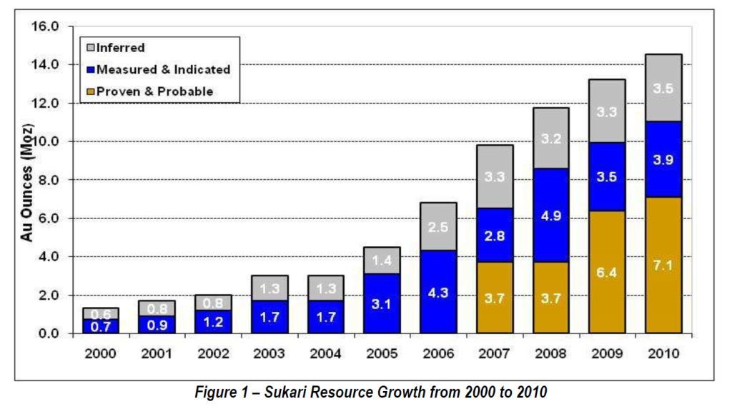
NEED TO MAKE THIS GRAPH LOOK BETTER…
USE SOLID BARS (NO DISTINCTION BETWEEN INFERRED, MEASURED, AND PROVEN

The size of this record-setting gold deposit keeps growing as exploration continues. The estimated gold reserves have soared from 1.3 million ounces in 2000 to over 13 million ounces today.
Is it a problem that this chart stops at 2010 and we are now well into 2012?

According to the latest figures, there are 15.4 million ounces of gold making it one of the largest gold resources – and the only producing gold deposit over 10 million ounces – not held by one of the world’s major gold producers
Why Should Investors Be Excited About the “Egyptian Gold” Story?
That’s a fair question considering what’s been happening in Egypt over the past few years. I’ll admit it – I was skeptical myself at first. But when you peel back the layers of the onion and take a deeper look at the situation, you may be surprised.
The first several reasons are obvious. I’ve already told you about the 15 million ounces of gold and the mine that has already produced over 450,000 ounces of gold and is on track to double production by 2016. This may be the largest producing gold mine not owned by a major gold producer.
What most people don’t realize is that Egypt’s economy is projected to be among the world’s top 10 fastest growing economies in the world over the next several decades by multiple sources. And mining could be the leading growth industry.
A director at the Egyptian Mineral Resources Authority makes it crystal clear when he says: “Egypt is full of mineral resources. The only choice for us is mining…”
Egyptian officials know the development of the mining industry could give a huge boost to their economy for many years to come. And government officials are excited about the possibilities of creating an industry that could generate more money than oil, tourism, and the Suez Canal combined.
Egypt’s gold mining industry could outstrip oil, tourism, and Suez Canal receipts combined.
Al-Ahram Weekly

So it comes as no surprise that the government has thrown its strong support behind the development of this massive gold mine (and the jobs and revenue that come with it).
They’ve even passed a law specifically granting exclusive mining rights to the small company that struck the gold. The exclusive rights are good for a period of 30 years and renewable for an additional 30 years. [Do we mention the government has a financial interest in the mine? ]
The government has also waived taxes for a 15-year period and provided fuel subsidies as further enticements to speed development of the mine. The stock price of this little-known mining company is set to soar due to the single event I referred to earlier in this presentation.
Don’t worry, you won’t need to send any money to Egypt take advantage of this opportunity. That’s because the company has offices in London and its stock is traded on both the Toronto and London stock exchanges. So you can easily pick up shares through online brokers like Scottrade, TD Ameritrade, E-Trade, and many other discount brokers.
But perhaps the biggest reason for investors to take notice is the event I’ve been referring to. This development is exciting because…
Similar Breakthroughs Have Created Gains of 953%,
1,530%, even 1,973% for Investors that Got in Early…
What is this event that has repeatedly produced triple and quadruple digit gains in mining stocks?
Let me give you some examples…

Newmont Jumped 953% After This Event...
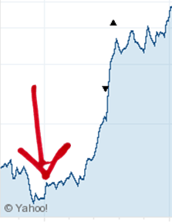
Today Newmont Mining is the 3rd largest gold miner in the world, but it wasn’t always that way. Newmont’s major growth spurt started in the 1980’s.
After a specific event that took place in 1985, the company’s stock price took off as you can see in the chart to the right. In January 1985 you could have bought a share of Newmont for $2.95. By February 1990, that same share was worth $31.06 – an increase of 953%.
When this event occurred in 2007, shares of China Gold International Resources jumped from $1.99 in July 2007 all the way up to $6.26 in April 2010 – a gain of 216%.
In 1985 (where the red arrow points), after specific event took place the stock price of Newmont Mining exploded. The same event is happening right now with a small mining stock I have uncovered.
That same event could generate triple digit gains (or more) the $2 stock of the small mining company I’m introducing today.
Goldcorp Soared 1,973% After This Happened…
The identical thing happened with gold mining juggernaut Goldcorp (the world’s 2nd largest gold mining company) in 2001.
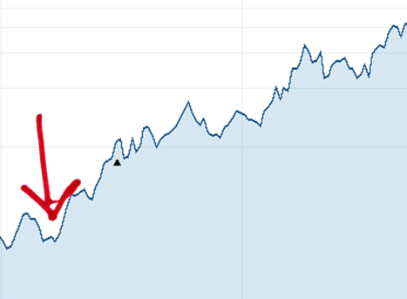
At the end of 2000, shares of Goldcorp were trading for $2.39. This event happened in early 2001, and by May 2006 the shares had jumped 1,530% to $38.95. If you held your shares until July 2008, your investment could have skyrocketed 1,973% to $49.55 per share.
The exact same catalyst – an event that has already happened – could send shares of this small mining company based in London, England, on a similar upward climb.
In early 2001 (where the red arrow points), something happened. After this event occurred, the share price of Goldcorp jumped 1,530% from $2.39 to $38.95. That exact event just took place in a small mining and its share price could rip higher hundreds of percent in the coming months.
I could show you several more examples but you get the point. After a specific event happened, these gold mining stocks soared.
So what is this event? What happened before these stocks exploded?
The illustration below will help…
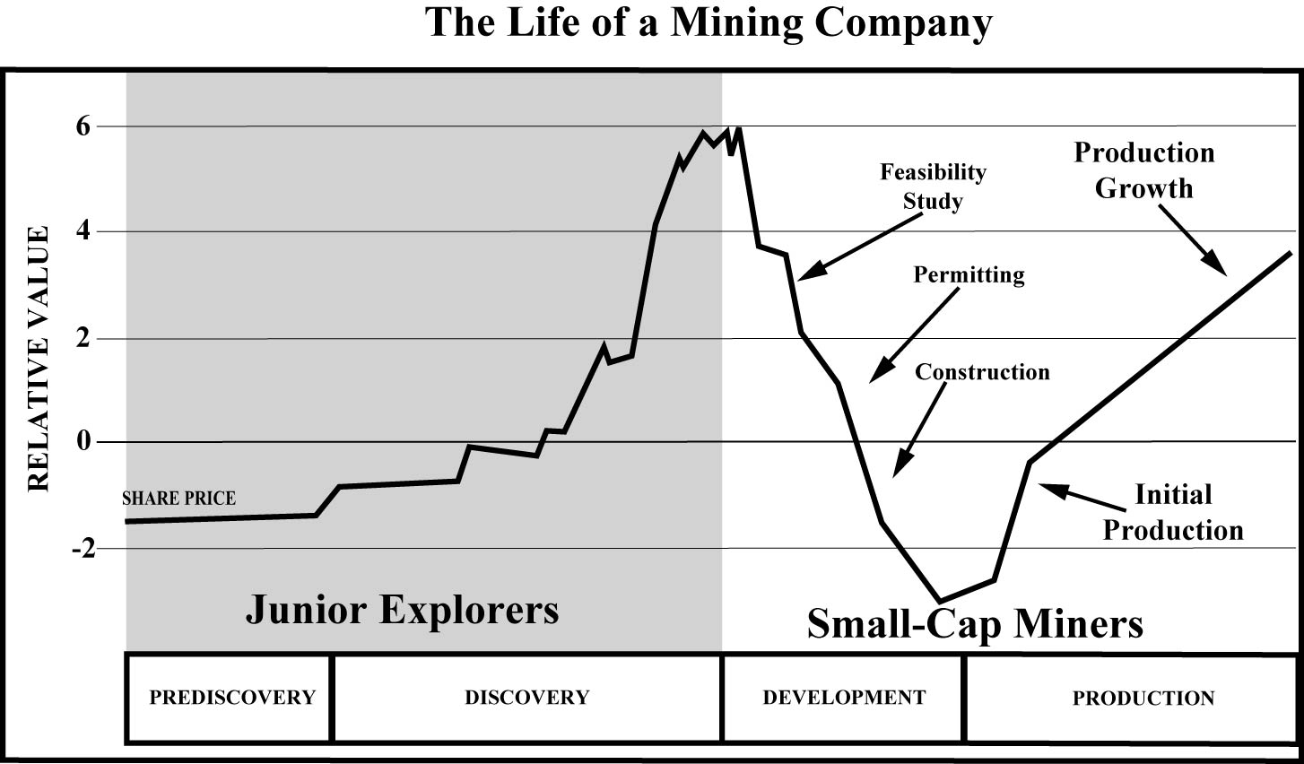

As this chart shows, the share prices of gold mining stocks can climb quickly after initial production begins. I’ve identified a small mining company that is now producing over 200,000 ounces of gold each year. The share price could soar as production ramps up to 500,000 ounces annually over the next few years.

This graph shows the life of a mining company. Specifically it shows how the share price tends to rise and fall over the different stages of mining. In many cases, the share price will jump when a discovery is made (a new gold discovery tends to excite investors).
But discovery is just the beginning. There’s no guarantee a gold discovery will lead to a successful mining operation. Before a single ounce of gold is produced, the site needs to be developed and the mine needs to be built.
This can take years and hundreds of millions of dollars – and a lot can go wrong. Further exploration can show there’s not as much gold as originally thought. It can be challenging to find the funding to build the mine, and there can be delays in construction due to weather or dealing with the permitting process.
This stage of a mine’s life can be financially challenging too. After all, millions of dollars are being spent on developing and building the mine but it’s not producing any gold so there are no profits to offset the large capital expenditures. Any bad news can send the share price tumbling and it’s not unusual for the share price to fall during this stage of a mine’s life.
But when a mine begins operating and starts producing gold and generating revenues, the stock price can soar. And it can happen quickly. That is the single event that can be the catalyst that generates triple-digit returns in a short period of time.
Early investors who get in when the mine starts producing real gold and before production ramps up can potentially make a fortune. In each of the three examples above, the catalyst or event that happened was that the mines started to produced real, hold-in-your hand gold. After that, the stock prices shot up as the demand for shares of these gold mining companies increased.
And that’s exactly where we find ourselves today with this massive gold mine in the shadows of the Great Pyramids of Egypt. The gold was discovered, the site was developed, the mine was built, and now it’s producing gold – A LOT of gold – over 200,000 ounces last year. And production is projected to ramp up to 500,000 ounces annually over the next few years.
This could be an opportunity to get in early and set yourself up for triple-digit gains – maybe even more if the price of gold continues its upward trend.
Add more on Centamin? Recent insider buying? Financial strength?
All the details are in my Special Report: The Treasure of the Turin Papyrus

[END]
Add 2nd and 3rd opportunities.

http://cms.privatelabel.co.za/pls/cms/iac.page?p_t1=3085&p_t2=7932&p_t3=0&p_t4=0&p_dynamic=YP&p_content_id=182694&p_site_id=83
Centamin 2011 Annual Report – page 5 & Q42011 Results presentation page 29
150K+ in 2010 + 200K+ in 2011 (from Centamin 2011 Annual Report – p. 6) + 49K+ in Q12012 + 67K+ in Q22012
http://coolrain44.wordpress.com/2009/08/25/50-most-popular-tourist-attractions-in-the-world/
http://www.csmonitor.com/1999/1123/p7s2.html
http://cms.privatelabel.co.za/pls/cms/iac.page?p_t1=3085&p_t2=7932&p_t3=0&p_t4=0&p_dynamic=YP&p_content_id=182694&p_site_id=83
http://www.mineweb.com/mineweb/view/mineweb/en/page66?oid=85648&sn=Detail
Centamin 2011 Annual Report – page 5
http://weekly.ahram.org.eg/2001/559/ec2.htm
Centamin 2008 Annual Report – p. 42
http://weekly.ahram.org.eg/2001/559/ec2.htm
http://www.centamin.com/centamin/uploads/press/DFSAnnouncementFeb07.pdf
http://centamin.com/centamin/investors/news-media/news/optimised-open-pit-mine-plan
http://weekly.ahram.org.eg/2001/540/ec3.htm
15M oz x $1600/oz = $24B; value of CEE.TO ~$1B from Yahoo Finance (http://finance.yahoo.com/q?s=CEE.TO)
Annual Information Form 2010 – page 14
http://centamin.com/centamin/investors/news-media/news/optimised-open-pit-mine-plan
http://search.proquest.com/pqrlbusiness/docview/1002059121/138BEC79F9423FCDBA8/2?accountid=10750
June 2009 OIL
http://search.proquest.com/nationalnewspremier/docview/748324304/138BF341BBA294BCD3D/11?accountid=10750
http://www.stansberryresearch.com/secure/oil/issues/html/200903OIL_issue.asp
http://www.hotstocked.com/article/1918/jinshan-gold-mines-inc-pink-jinff-the-golden.html
http://www.stansberryresearch.com/secure/oil/reports/html/200907OIL_report_ChinaGold.asp
http://www.nrh.co.il/i/pdf/NRH_Research_2012%20World_Gold_Deposits.pdf (Centamin is #25 on p.5)
http://www.mbendi.com/indy/ming/gold/af/eg/p0005.htm
From Centamin investors presentation (last slide 25 of 25)
http://www.ide.go.jp/English/Data/Africa_file/Company/egypt05.html
http://www.cnbc.com/id/46322877/The_Best_Countries_for_Long_Term_Growth?slide=4
http://www.gmanetwork.com/news/story/270620/economy/finance/phl-to-be-6th-fastest-growing-economy-in-next-40-years-ndash-wealth-report
http://globalconnections.hsbc.com/news-insights/egypt-a-future-paved-with-gold
http://weekly.ahram.org.eg/2001/559/ec2.htm
https://en.wikipedia.org/wiki/Largest_gold_companies
http://www.newmont.com/north-america/nevada/gold-quarry
From Yahoo Finance; NEM share price on January 2, 1985 – 2.95; on February 21, 1990 – 31.06
http://www.stockopedia.co.uk/share-prices/centamin-LON:CEY/directors-dealings/
http://www.theglobeandmail.com/globe-investor/investment-ideas/centamin-directors-buy-after-earnings-report/article4498628/

