CASE STUDY:
[insert Shed Pounds image: product image, banner, etc… not a book though – books are only worth $20! I would show the whole package of “stuff” you get so it looks like a lot of information]

PLEASE READ THIS FIRST:
What you’re about to read is a case study on the effectiveness of “Shed Pounds to Save Strokes” – a golf-specific program of diet and exercise designed to help golfers shed pounds, shred body fat, and improve their endurance.
I wanted to prove the program worked so I put it to the test. In addition, I was leaving on a two-week tour of Thailand (including some beaches) and wanted to whip myself into “beach shape.” And for that reason, I refer to this case study as the “Thai Beach Body Challenge.”
In addition, I figured if I was on a mission to shed pounds and shred body fat, then why not improve my golf game as the same time? I’ll share my successes, my failures, my diet, my exercise, and much more in the pages of this case study. However, I can tell you I was very pleased with the results.
After just 28 days, I had successfully accomplished all of the above. And to my pleasant surprise, I discovered an additional benefit – power and distance. I’m hitting longer drives more consistently than ever and I’ve added distance to my irons too.
I kept a “success journal” of my diet, exercise, and thoughts during my “Thai Beach Body Challenge.” That journal has been edited into the case study you’re reading now.
Remember, I wrote in my journal daily as I was going though the program so there may be some gaps. For example, I tested fasting (with surprising results). I wrote about fasting one day, then didn’t write about it again until I had tested it for several days so I could share the results.
I’ve also added some photos and stories on my adventures in Thailand – including a round of golf.I hope you find it informative and entertaining. And most of all, I hope it inspires you to put “Shed Pounds to Shave Strokes” to your own personal test because, after seeing what this program did for me in such a short period of time, I have no doubt whatsoever that you can see similar results and make 2014 the year you transform your physique and improve your golf game too!
All it takes is a plan and your commitment to stick to the plan. With that, the positive results are almost assured. The proven plan is “Shed Pounds to Shave Strokes.” I’ll prove that to you in this case study.
The only question is this: Are you committed to shedding pounds, shredding body fat, increasing your endurance and stamina, and improving your golf game? There’s also a good chance you’ll add muscle to your frame, and power and distance to your golf game.
Don’t be surprised if your improved physique starts attraction more attention from the ladies and if your playing partners start making comments about how much farther your hitting the golf ball!
The first step to making 2014 a transformational year starts NOW! Let’s get started!
[can we make this not fit on one page?]
Shed Pounds to Save Strokes is a simple, scientifically tested and proven program for shedding excess weight, melting body fat, adding power and distance to your golf game, and shaving strokes of your handicap….
But does it really work?
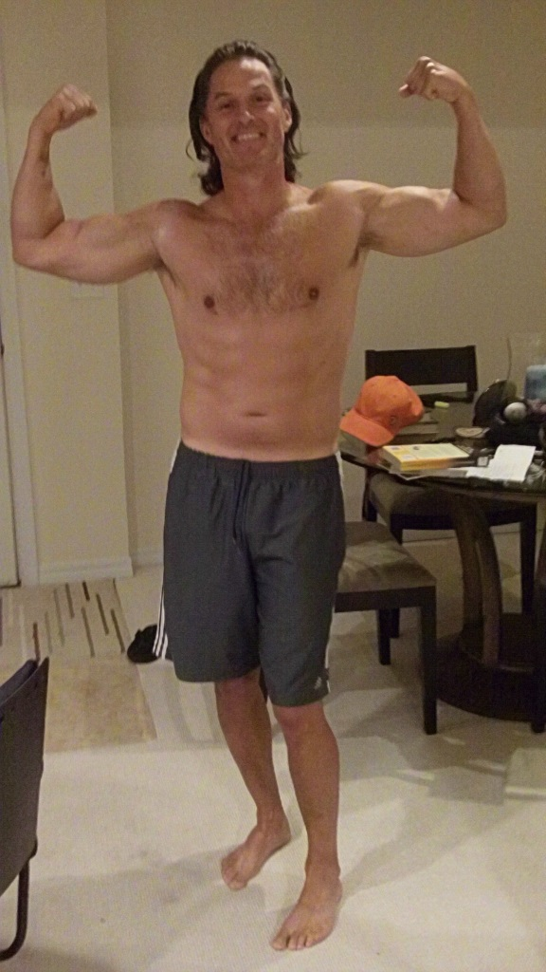
My name is Robert Phillips and recently I put this workout program to the test. And in this Case Study, I’ll explain the amazing transformation that took place…but if a picture is worth 1,000 words, here the short story in a few thousand words with my “before” and “after” photos:
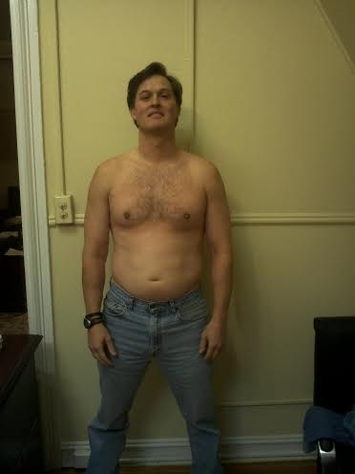

How did a regular guy in his 40’s quickly transform himself from “fat ass” to “high school thin” with muscles
(and even a hint of six-pack abs!) that turn ladies heads and give him the power to hit more 300+ yard drives than ever before? Keep reading to discover the simple secret. (Hint: It’s more than just the hair!)
Note for Chris: Do we need an explanation/disclaimer about these before and after photos? The “after” photo was taken a few days before I left for Thailand but “before” photo is from January 2012 – not from when I began the “Thai Beach Body Challenge.” – Anyone with a brain knows you can’t make a transformation that drastic in 28 days! But on the other hand, it does show a BIG transformation. I lean toward no explanation. We can answer questions if they come up. What do you think?
Note 2 for Chris: We might want to reduce the size of these photos – the file size. You know I’m no techie but a couple dozen large photos might make the pdf huge and it may take a long time to download. OR maybe I’m completely wrong and it doesn’t matter. I’m not sure – just making the point that it might make a difference. UPDATE: We definitely need to reduce the size of the images. The files are so huge I can’t even attach them to email!!
And my physical transformation was just the beginning! I noticed myself more consistently pounding the ball further off the tee and with my irons. If you’d like to see a similar transformation and make 2014 the year you get “high school skinny,” add power and distance, and lower your handicap, all at the same time with one simple program, then let’s get started!
Background
Here’s the story:
In late November 2013, I took a two-week trip to Thailand. I went to Bangkok, Chiang Mai, and Phuket. It was AWESOME! I definitely plan to go back in the not-too-distant future.
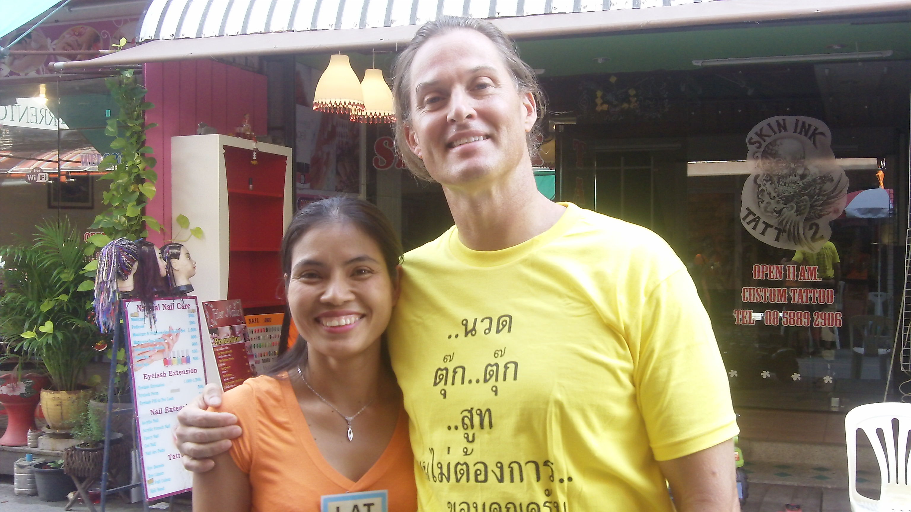
If you haven’t been I highly recommend it. The people are extremely happy and friendly. And it’s relatively inexpensive.
For example, my friend Lat (that’s Lat and I in the photo to the right) gave me a full one-hour body massage with oil. It was so relaxing that I actually fell asleep! And it cost me a whopping 300 THB (THB is short for Thai bahts). That’s less than $10 US dollars. And of course I have her a $10 tip because she deserved it!
What in the world does my t-shirt say? It’s written in Thai and I found it hilarious. I’ll explain later in this report…
I also played some golf, but more on that later. If you decide to visit Thailand though, here’s an idea to consider: DON’T BRING YOUR WIFE OR GIRLFRIEND! Moving on…
In the pages of this case study, I’ll show you how to:
- SHED excess pounds
- TORCH excess body fat
- IMPROVE your endurance and stamina
- Add POWER and DISTANCE to your golf game
- SHAVE strokes off your score
- LOWER your handicap
- And make 2014 your best year ever –
for both your physique AND your golf game!
Ultimately, I torched off 12.5% of my body fat in just 28 days. And at 47 years young, I’m hitting more 300+ yard drives than ever before. And there’s no reason you can’t get similar – or perhaps even better results – as I’ll explain later.

And the best part is, you can do it all at the same time by following one simple program: Shed Pounds to Shave Strokes. And you can probably accomplish your goals more quickly than you imagined possible.
You may be wondering why I wanted to whip myself into peak physical condition (aka “beach shape”) before my trip to Thailand. That’s a good question and here’s the simple answer. Several days of my trip were spent on the beaches of Patong in Phuket, Thailand. It’s beautiful place to spend the day.
Patong Beach in Phuket, Thailand


And at night, Patong is a crazy place – especially the famous Bangla Road with its seemingly endless gauntlet of clubs and bars. The streets are packed with “interesting” people too. If you don’t like “people watching” or the fast-paced nightlife, then stay away from Bangla Road! Even I’ll admit I wouldn’t want to go there every night but it certainly was fun for a few nights.
The entrance to Bangla Road in Phuket, Thailand
We found a great spot right in the middle of all the action on Bangla Road called the Blue Lotus. We grabbed a front row seat, drank several mojitos (the Singha beers were good too!), and watched the endless parade of people walk by. [formatting note: 1. I’m having some trouble with images and captions moving around. 2. Let’s reformat after the final edit. For example the above photo & caption will be fine when we remove my notes.]
Hanging out with Mia at the Blue Lotus on Bangla Road
(See! I’m not kidding when I say the ladies will like your new, thinner, more muscular physique!)
There also happened to be a “lady boy” bar across the street so we watched the “lady boys” recruit people to their club to watch the show. It was interesting and entertaining to say the least! (Look up “Thai lady boys” on You Tube!)
As you can probably see, after visiting, I’m now a big fan of Thailand. I’ll share more photos and stories later – specifically about my golfing experience and how I bombed a 300 yard drive that made the Thai foursome in front of me scatter like ants! It was an accident of course! I’ll give you all the details – including my female caddie’s reaction – later in this report.
However, this isn’t a case study about Thailand. It’s about shedding pounds, shredding body fat, adding power and distance to your golf game, shaving strokes off your score, lowering your handicap, and making 2014 the best golf year of your life!
So let’s dive in…
On October 23, 2013, I made a decision to get into better shape. You could soon be making a similar decision that could set 2014 up to be a FANTASTIC year!
Specifically, I committed myself to shedding pounds and shredding body fat. At that point, I had 28 days to whip myself into shape before my flight to Bangkok. I started referring to these 28 days as the “Thai Beach Body Challenge.”
And based on the results I’m about to share, I promise that if you make that same decision and commitment to yourself right now, today, that in just 28 days, you’ll be glad you did because…
You WILL shed pounds…
And
You WILL shred body fat!
Here’s how it began…
The Starting point
The first thing I did was take my measurements. After all, you can’t measure your results without a starting point. So I stepped on my scale and recorded my weight and my body fat percentage.
The scale I used is from Escali and it uses bioimpedance to calculate body fat. I couldn’t explain the science between bioimpedance if you asked me to so I’m not even going to try. And besides this about golf and lowering your scores by getting into better physical condition anyway! Not about the boring science of bioimpedance!
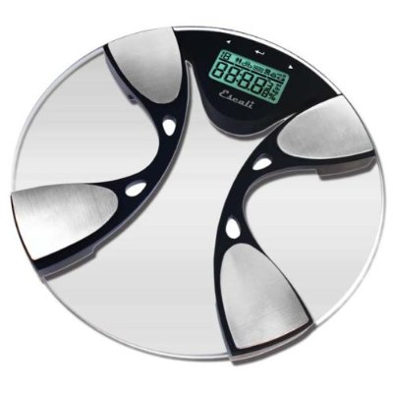
But I do know bioimpedance is not always completely accurate so no need for the brainiacs out there to remind me. All I’ll say is that I’ve been using this scale for several years now and despite any shortcomings, it definitely helps because I can see the trend of body fat % rising or falling.
To measure and track my weight and body fat I used this scale by Escali (Model BFBW200). You can find it on Amazon for about $45.
And the results speak for themselves. I was at about 20% body fat when I got the scale and through diet and exercise, my body fat has been as low as 12.6%. That means I’ve torched roughly 35% of the fat off my body. Not bad!
Tracking your body fat percentage is not mandatory – especially if your primary concern is losing weight. Personally, body fat is the more important number to me so I like to keep track of it. It’s really an individual decision.

If you’re interested, the scale is very affordable at about $45. I ordered mine on Amazon. There are several Escali scales. I have the Escali BFBW200 Escali Body Fat / Water Bathroom Scale.

So here was my starting point

Weight: 175

Body Fat: 15.8%
That’s not bad at all – especially for a 47 year-old guy like me – but I knew I could do better. And my goal was to get into the best “beach shape” possible in 28 days.
Having specific goals (and putting them in writing) is proven to work. People who have specific goals and put them in writing are more likely to achieve those goals.
These are the goals I put in writing:
1) Prove that “Shed Pounds to Save Strokes” really works…
First and foremost, I took on this challenge to help you improve YOUR overall fitness level and golf game. After all, if I use myself as the guinea pig, put this program to the test and prove it works, then that leaves no excuse for you not to try the program and expect similar results, right? Especially if you’re serious about shredding body fat, shedding pounds, building muscle, and lowering your golf scores. How serious are you?
2) Reduce body fat
I’ll naturally lose weight as I trim body fat but the more important number to me is the body fat percentage. Heck, I would prefer to put on some muscle and reduce body fat. It’s possible to gain weight and reduce body fat because muscle weighs more than fat.
NOTE: We’re all different, with different bodies and different goals. If you’re like me and you’re already relatively thin and in relatively good shape and you’re looking for a way to lose those last few stubborn pounds of body fat, add some muscle, and uncover your six-pack abs, keep reading because I’ll share specific tips for you to do just that!
I’ll put a specific goal in writing (a key to achieving goals) and I’ll put in terms of good, better, and best. Good would be a body fat % below 15%. That should be a piece of cake.
Better would be a body fat % below 14%. That’s reasonable. And best would be a body fat % in the 12’s (i.e. below 13%). That will be a challenge so I consider it a “stretch goal” but I’ve been as low as 12.6% so it is possible.
Since my primary goal is losing body fat, I won’t list a weight loss goal. You may not care about body fat. Your goal may be to lose 10, 15, or 20 pounds. It’s a personal decision.
3) Break 90 at Mayacoo Lakes!!
Let me be clear here. I break 90 on a regular basis. I’ve just never broken 90 at Mayacoo Lakes. It’s a bear of course (pardon the pun as the “Golden Bear” Jack Nicklaus is the course designer). It has a slope of 141 (from the orange tees) which makes it possibly the most challenging course I’ve ever played.
In other words, this is not your normal muni course where it’s almost impossible to lose a ball and easy to shoot low scores. I regularly shoot in the low 80s at muni courses and have even shot in the 70s several times.
Mayacoo Lakes hosts the Monday qualifier for the annual Honda Classic held at nearby PGA National so it’s a “PGA level” golf course. You can check it out for yourself at Mayacoo.com.
I’m sharing my goals and this case study for several reasons.
One is to hold myself accountable. If I fail, I fail on a large scale. That’s a good motivator and a great reason not to fail!
Two, I’m hopeful my success in shedding pounds and shredding fat while at the same time adding distance to my golf game will inspire others – like YOU! – to do the same.
MY PLAN
Putting your goals in writing is important. The next step is to come up with a plan and put it in writing too.
Here’s my plan to reduce my body fat% and achieve my goal. It’s simple. If you want to lose weight (or body fat), you need to decrease caloric intake and increase caloric output. In other words, eat less and exercise more.
And that’s what I did. I’ll share more about what I ate and my exercise program so stay tuned. However, I also discovered some subtle twists you’ll be interested to know if your goal is more focused on reducing body fat than on losing weight.
Reducing Caloric Intake (the real challenge)
The first part of the challenge is to reduce caloric intake. I’m not into fasting. I’ve tried it before and I’m OK until about 6PM or so and then I’m starving. I listen to my body. If I’m starving, I need to eat.
However, eating is not the real problem. The real challenge is what you eat. Eating as many vegetables as you want is not going to do much harm, if any at all. They’re low in calories and they fill you up. On the other hand, eating ice cream, potato chips, cookies, or other crap is not going to help you lose body fat.
I generally eat quite healthy to begin with. I’m just going to eat less. And I’m also going to have to cut out (or at least reduce) some of my biggest vices for the next few weeks.
Here they are:
1) Red Wine
I enjoy a glass of red wine (and sometimes the whole bottle!) once or twice a week. I’m not certain if I will eliminate red wine or not. We’ll see. (Update: I did not eliminate red wine entirely.) But if I do have some red wine, I’ll try drinking a glass instead of a bottle. By the way, it’s been well-documented that a glass of red wine is actually good for your health (look up resveratrol if you don’t believe it).
I’m no dietician, but I’ve often wondered: If a glass of red wine is good for you, is a bottle better? Unfortunately, to this point I have found no scientific evidence to prove my assertion to be true (and I doubt I ever will) so I’ll leave that decision up to you!
In general, alcohol is high in calories and worse, they are empty calories – meaning there is little nutritional value. So if you’re trying to lose weight or body fat, avoiding alcohol helps tremendously.
2) Popcorn
I love salty snacks. I’ve pretty much cut out potato chips, Fritos, and any other processed salty snacks you could think of – but popcorn is my favorite and once a week or so (usually while I’m watching football or golf) I’ll pop a big bowl and eat the whole thing!
I hate microwave popcorn. In fact, I don’t live microwave ovens period! I stopped using them years ago over health concerns. There’s research that suggests eating food prepared are reheated in a microwave is hazardous to your health.
However, this isn’t a report on the health risks of microwaves. I’ll leave it up to you to research the subject and make your own decision.
Back to the good stuff – popcorn! Having grown up in Valparaiso, Indiana, (home of Orville Redenbacher) I’m a traditionalist. I pop my corn in peanut oil or coconut oil (healthier alternatives to corn oil). And I load it up with salt. Maybe a little butter but not much.
That’s my reward for eating well and exercising during the week – but I made an effort to cut out the popcorn (or at least reduce it) during the “Thai Beach Body Challenge.”
3) Friends with no “caloric conscience”
This is a big one. You know what I’m talking about. I’m sure you have friends who are not as serious as you are about fitness and eating healthy. They eat all kinds of crap like creamy potatoes, macaroni and cheese, chicken wings, lots of fatty meats, and on and on.
I’ll be honest. I eat well but I don’t have nearly the “willpower” some people think I do. I don’t eat that crap because I don’t buy it. And therefore it’s not around to eat. However, when I hang out with friends who have no “caloric conscience” (in other words, they eat whatever they want without regard for the dietary and weight gaining consequences) I sometimes cave.
But not during the “Thai Beach Body Challenge.” I made a pledge to avoid this temptation for 4 weeks. You can do just about anything for a measly 28 days, right?
(Spoiler Alert: I caved near the end of the challenge – I’ll tell you the story later so keep reading. Nobody’s perfect and even though I “cheated” a bit, I still had enough discipline in my diet and exercise to “win” the challenge because I shed pounds and shredded body fat.)
Ask yourself these simple questions: What are your vices? What can you cut out for the next several weeks to lose some weight or body fat?
day 1 workout
I followed the workouts in Chris Henning’s “Shed Pounds to Save Strokes,” but at the time of my “Thai Beach Body Challenge,” I was also finishing up a 10 week body weight workout program.
I had just completed week 9 the day I started Chris’ program so I doubled up – with week 10 of the bodyweight program plus week 1 of Shed Pounds.
Is that too much? Possibly. But I’m in good shape so I know I can handle it and I hate quitting. I was 9 weeks into the 10 week program and I wasn’t about to quit!
At the same time I wanted to give Shed Pounds a full 4 weeks to work it’s magic. So mostly due to timing, I worked out extra hard the first week.
If you like bodyweight workouts, you can get the program I’m following in a book by Mark Lauren called: You Are Your Own Gym: The Bible of Bodyweight Exercises. It’s available on Amazon.
The best part is you can do these workouts at home. I’m not a fan of crowded gyms, monthly fees, long-term contracts, driving to and from the gym, or any of that. You can certainly do this at a gym but I prefer working out at home.
So here’s my Day 1 workout:
It’s a circuit of 3 exercises that you repeat as many times as possible in 20 minutes. This is called “stappers.” This workout is as challenging as you make it! The good news is that you’re done in 20 minutes.
Here are the exercises:
Exercise #1: Pistols (or one-legged squats) – substitute two-legged squats if necessary
Here is Mark Lauren’s video showing several variations of the exercise:
https://www.youtube.com/watch?v=AHyOk0TuXcc
Exercise #2: Box Jumps
Here’s a video on box jumps
https://www.youtube.com/watch?v=wteOBt46i78
And if you’re really ambitious, here’s Mark Lauren doing a “Bar Hop”
https://www.youtube.com/watch?v=nFy-rKZfSd4
Exercise #3: Dive Bombers
Do them with this form: https://www.youtube.com/watch?v=LMSV1icfFvc
Or here’s an easier version from Mark Lauren (Half Dive Bombers):
https://www.youtube.com/watch?v=ZIO--fYzl40
Exercise #4: Let Me Ups (or Inverted Rows)
https://www.youtube.com/watch?v=RX6NO50G-Uc
If you’re at the gym, you can do them like this:
https://www.youtube.com/watch?v=Y9lujivogoE
You can do them with an overhand grip or an underhand grip (I alternate) and you can bend your knees to make the exercise easier.
Yeah, I know I said it was 3 exercises and then I gave you 4 but there’s a reason.
Let me explain.
Here’s the circuit:
1. 12 pistols (one-legged squats – 12 with each leg) OR 12 box jumps (I alternate)
2. 6 Dive Bombers
3. 8 Let Me Ups (I alternate between overhand and underhand grip)
So here are my first 2 circuits:
Circuit #1
12 Pistols (12 with each leg for a total of 24)
6 Dive Bombers
8 Let Me Ups (with overhand grip)
Circuit #2
12 Box Jumps
6 Dive Bombers
8 Let Me Ups (with underhanded grip)
Then I repeat those circuits as many times as I can in 20 minutes.
You’ll be worn out if you push yourself! Trust me on this…
Note for Chris: We need to add the disclaimer about consulting a physician before beginning any exercise program. IMPORTANT NOTE: Please consult your physician before beginning any diet or exercise program – including Shed Pounds to Shave Strokes
the fitness industry’s “dirty little secret”
I’m on a mission to help you shed pounds, shred body fat, and shave strokes off your golf scores. So I have to clue you in to a “dirty little secret.”
When starting on a program like this, most people put the majority of the focus on the exercise part of the program. Diet takes a back seat.
Apparently, the popular thinking is that exercise is more important than diet. But that’s WRONG! Trust me on this. I know because for years I thought the same thing.
That was before my friend and fitness expert Craig Ballantyne clued me in on the truth: “Diet is more important than exercise.”
Many people are surprised – even SHOCKED – to discover this truth but as Craig says, you can’t out train a bad diet. I know from personal experience Craig speaks the truth. I was working out like crazy and not getting the results I wanted.
And as soon as Craig clued me in to this “dirty little secret” of the fitness industry, I changed my diet and started seeing results. I lost 20 pounds and reduced my body fat from about 20% to 15%.
Now you know the truth – that diet is more important than exercise. Ignore this truth at your own risk.
OK, so here’s my diet. But before I go on, just like I don’t believe in many “one size fits all” solutions in golf, I don’t believe in “one size fits all” diet solutions either. You just have to experiment and see what works for you.
I’ve tried fasting for example and I don’t like it. I’m usually starving by around 6PM. And I don’t believe in starving myself. If my body is telling me I’m hungry, then I need to eat something!
But others swear by fasting or intermittent fasting – which is basically fasting from say 6PM at night until noon the next day. That’s not so bad, but still my general rule is that I eat when my body tells me it’s hungry.
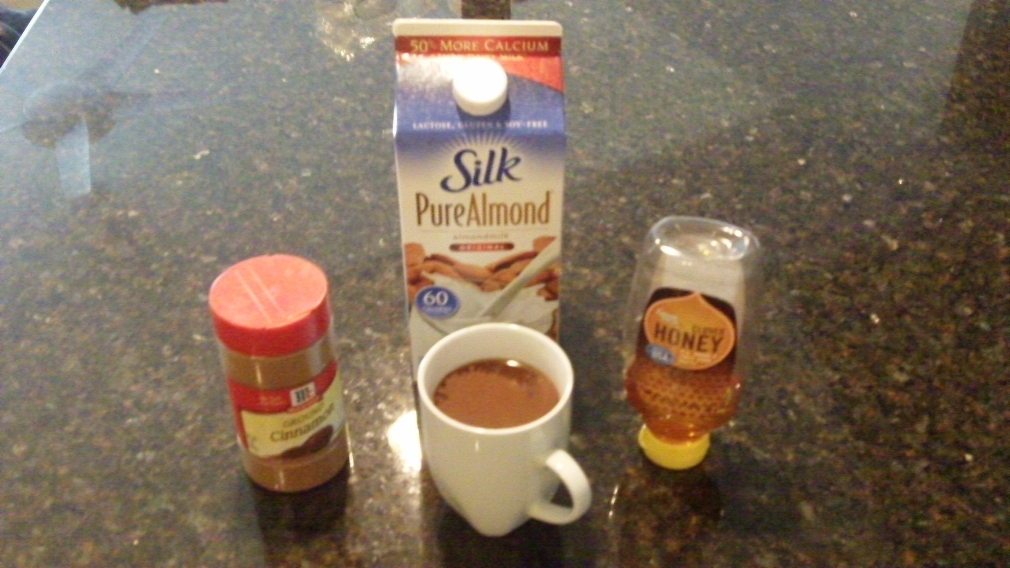
breakfast
I like 2 cups of coffee every morning. Coffee is controversial. Some argue caffeine is bad for you. Some say coffee is loaded with anti-oxidants. I’m not in the medical profession so I don’t know. But I don’t see anything wrong with 2 cups of coffee.
A cup of coffee is fine – but don’t ruin it by loading it up with artificial sweeteners and creamers!!
What’s wrong is loading the coffee up with extra calories like cream and sugar or the flavored creamers that are so popular. I don’t use any of that stuff.
I add some honey to sweeten the coffee. I use almond milk as creamer. And I sprinkle in some cinnamon. It’s delicious! And cinnamon has been shown to regulate your blood sugar levels.
I might also have a cup of green tea. And for every cup of coffee I drink, I also drink a cup of water. I like to put lemon in my water – just the “Real Lemon” juice you can find at any store.
I started adding lemon or lime juice for the added taste. I didn’t realize until later that there may be health benefits to adding a little lemon to your water. Research suggests it helps with your bile – which sounds gross but apparently is important – and has been shown to have other health benefits too.
If I’m hungry I’ll eat breakfast. If not I’ll skip breakfast.
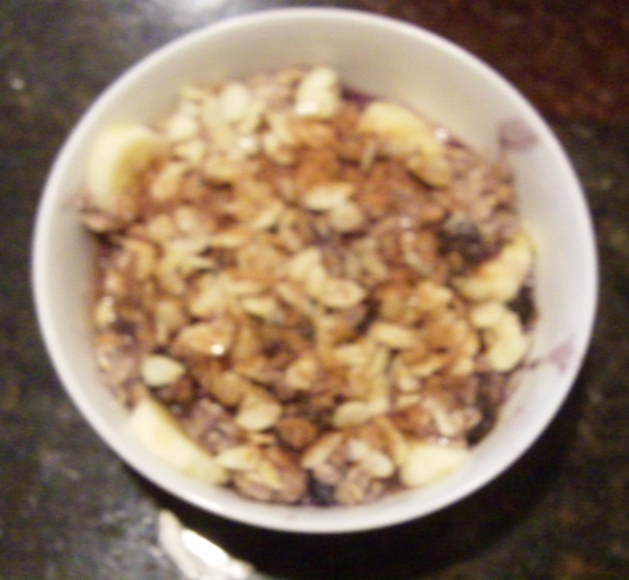
I’m a creature of habit. I tend to eat the same things over and over again. For breakfast, I’ll either have fruit and oatmeal or vegetables and eggs.
I don’t like instant oatmeal because it’s processed. I prefer real oatmeal. It only takes 5 minutes to cook and it’s less processed. I’ll add some honey, a banana, blueberries, sometimes a scoop of chocolate protein powder, sometimes some almond milk, and I’ll top it off by sprinkling some slivered almonds and cinnamon. Plain oatmeal is pretty bland but I find this oatmeal pretty darn good.
Oatmeal with fruit, cinnamon, nuts, and almond milk
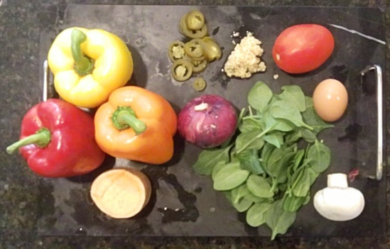
If I’m in the mood for eggs, I’ll chop up as many vegetables as I have: spinach, onions, mushrooms, green, yellow, red, and orange peppers, broccoli, etc. I’ll add olives for some healthy fat. I’ll put it in a pan with some coconut oil, crack two eggs and scramble it all together. It’s pretty darn colorful and tasty if you ask me.
Breakfast! Before I chop up the vegetables!
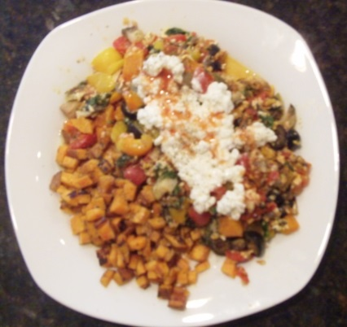
Recently I experimented with something that may sound strange but I love it. I add a few scoops of cottage cheese after I’ve cooked the eggs and mix it in. It’s cheese for crying out loud! Cheddar cheese, swiss cheese, mozzarella cheese – so what’s wrong with adding some cottage cheese? Nothing I say! And sometimes I’ll add some salsa too! Mmmmm!
I also like to cut up half a sweet potato and cook it in coconut oil. Sweet potato hash browns I suppose you could call them.
Scrambled eggs (usually 2) with as many colorful vegetables as I can chop up – topped with cottage cheese and hot sauce with a side of sweet potato hash browns. Mmmm!!
That is my normal, everyday breakfast whether I’m trying to shred body fat or not. However, during my “Thai Body Beach Challenge,” I just ate a little less. I used one egg instead of two. However, I chopped up just as many vegetables if not more. They’re nutritious, filling, and low in calories. Perfect for shedding pounds and shredding body fat!
Lunch, dinner, & snacks
So far I’ve given you a challenging bodyweight workout and shared my ideas on breakfast. Remember, diet is more important than exercise. You can’t out train a bad diet. So it’s of critical importance to focus on diet just as much as exercise if you’re serious about shedding pounds and shredding body fat.
Now let’s move on to lunch, dinner, and snacks…
My lunch and dinner diet consists primarily of salad. The way I eat is opposite of the way most people eat. Most people focus on the meat and sprinkle in some vegetables. I focus on the salad and sprinkle on some meat.
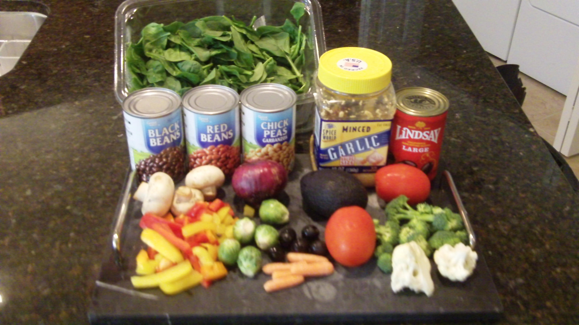
Once a week or so I make two huge bowls of salad that last me several days. Just as with my breakfast vegetables, I love color so I chop up every color I can get my hands on. It starts with spinach. Spinach is a super food packed with nutrition. Iceberg lettuce is basically useless as far as nutrition is concerned.
Then I chop up green, red, yellow, and orange peppers, tomatoes, onions, broccoli, cauliflower, carrots, brussel sprouts, and mushrooms. I add garlic, sunflower seeds, assorted beans, and mix it all together into a salad.
The building blocks of a great salad – spinach, colorful vegetables, beans, garlic, olives, etc.
Chop them up into a delicious and nutritious salad.
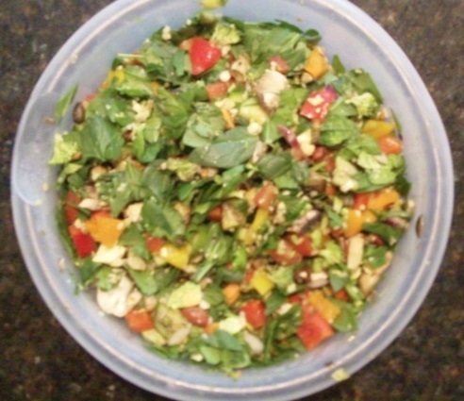
Then I’ll eat it when I’m hungry – for lunch, dinner, and snacks. It’s very versatile. Sometimes I’ll add tuna. Other times chicken. Sometimes salmon. And a few slices of pineapple is a nice, refreshing change of pace now and then.
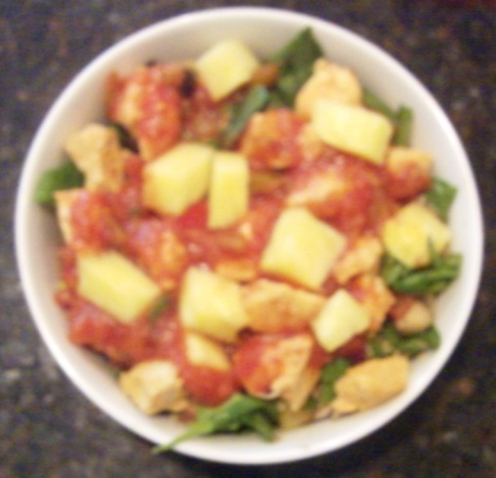
I never use the typical store bought salad dressings because they’re processed and loaded with calories.
When you chop it all up, you have a big salad
in a big bowl that will feed you for several days.

Instead I’ll use balsamic vinegar, salsa, or ranch dressing I make by sprinkling the powdered ranch dressing on cottage cheese. I use a variety of things to spice it up so I don’t eat the same salad every time. That would be boring!
This is a salad from the big bowl. I added salmon, pineapple, and used salsa for the dressing. The meat could have just as easily been chicken.
My free snack food should I get the late night munchies is veggies and ranch dressing. Usually broccoli, cauliflower, carrots, or tomatoes. And again I make the ranch dressing by sprinkling the powdered Hidden Valley Ranch on cottage cheese and mixing it together – no high calorie buttermilk or mayonnaise for this guy!
And of course I try to drink a lot of water. And I pour lemon juice in it to give it some taste. Sometimes I add a smoothie to the mix too.
I’m not saying you have to eat like I do. It’s not for everybody but it works for me. It’s hard to get fat eating as many fruits and vegetables as I do.
I’m no vegan or vegetarian nor do I want to be. I like meat and eat it every day. I just eat it sparingly. And I rarely eat red meat – mostly chicken and fish. Eggs and cottage cheese are also primary sources of protein for me.
I don’t count calories either. I’ve done it before and it’s a hassle. I like to keep things simple. I eat when I’m hungry and I only eat until I’m no longer hungry – not until I’m full.
If my dietary plan sounds good to you, then why not give it a try? And if it doesn’t sound so good, that’s fine too. But you need to find a dietary plan that both meets your unique tastes and promotes shedding body fat.
I won’t have much more to say on diet. You already know what I eat and I’m a creature of habit. I mix things up enough that I don’t get bored with eating so much salad.
Day 2 cheating controversy?
Day 2 of the “Thai Beach Body Challenge” was a light day. You could try yoga, walking, or something else not quite as brutal as the bodyweight workout.
My hamstrings had been a bit tight lately so I decided to give yoga a try. I know next to nothing about yoga so I searched YouTube and found a 20-minute beginner yoga video. Perfect!
You’ll find the video here: https://www.youtube.com/watch?v=gCYCKO4XX9U
[if we want more control of these links we can use redirects – something like shedpoundstosavestrokes.com/yoga – or something similar]
It was so simple I think I could do it on my own. And I have to say my legs feel much better today after the stretching from yoga. This yoga workout is pretty easy – although if your muscles are tight, you’ll definitely feel the stretch.
I’ll definitely be doing this again – perhaps every other day during my “Thai Beach Body Challenge.” The video calls for a yoga band as part of the leg stretching. You can also use a belt. I used a towel and it worked just fine.
And I don’t even own a yoga mat. I just used a soft rug.
UPDATE: I have now added this yoga workout to my routine. I do it several times a week. It only takes 6 to 12 minutes. I set my GymBoss for 12 30 or 60-second intervals (because there are 12 stretches). I’m done and feeling relaxed and stretched in just a few minutes.
After yoga, I had some oatmeal for breakfast using the recipe I described earlier: regular oatmeal (not instant!), fruit, a scoop of protein power, cinnamon, slivered almonds, and honey.
Then I went off to a professional/networking event to see some colleagues. I knew it would be a challenging day to eat healthy but the temptations to cheat started early – at lunch.
A friend and I met some people and walked down the street to a pizza joint – ughh!! Don’t get me wrong, I love pizza – but not during the “Thai Beach Body Challenge!” I swore off all that stuff for just a few weeks and that was only yesterday!!
Fortunately my friend also eats healthy and she saved me. I had told her about my goal to get in “beach shape” and she helped me out! So don’t be afraid to share your goals with friends who will hold you accountable. It turned out to be a lifesaver in this case!
We went to a different restaurant and I had a grilled salmon salad. It was very good. It had some cheese on it that I could have skipped but hey, it’s better than eating pizza!!
Then back to the event where I drank a lot of water and avoided having even a single glass of beer or wine during “happy hour.” So far, so good….
Then dinner. My friend and I met a colleague for dinner and he had a beer so I caved and had a beer too!!! Only one though. And for dinner I had a grilled chicken sandwich with sweet potato fries. Not perfect, but all in all not too bad.
It came with a slab of bacon that I could have skipped but I didn’t. I offered my sweet potato fries to the others and they ate about a third of them so that helped. And I also didn’t eat the bun that came with the sandwich. I rarely eat white flour. It’s one of the worst processed foods.
If the night had ended then I would have been satisfied with my eating and drinking decisions for the day…but it didn’t. We went to a wine bar to meet some other friends. And as I’ve mentioned, I like wine so I had two glasses.
Here’s my opinion. I’m neither an Olympic nor a professional athlete – far from it. So I see no need to be maniacal about my diet. I choose not to let it interfere with my regular everyday life and my social life. I see no problem in having a few social drinks (like one or two) – as long as it stops there.
It’s only a problem when 2 cocktails turn into 5 or 6. That’s a lot of empty calories to burn off. And besides this was actually a very cool new wine bar and I chose not to deprive myself of the experience.
After that I went home. By the way, my friend and I walked both to the bar and back to the car – which is probably about 2 miles in total – so I’m certain the walk burned off a drink or two.
All in all, I wasn’t disappointed with my decisions for the day. Sure I could have done better but nobody is perfect, right? And besides, all that matters is the final result. You’ll soon see where my weight and body fat % finished up when the challenge ended.
day 3 workout
Day 3 fell on a Saturday but it’s not a day off for people who are serious about shedding pounds and shredding body fat like us, right? There also happened to be a big party tonight downtown and within walking distance – something to do with Halloween? Did I cave and cheat again? Keep reading to find out.
The day started out great. I woke up at 6:30, had 2 cups of coffee (with almond milk, honey, and cinnamon – none of that high calorie, sugary, processed, flavored creamer for me!) and a tall glass of water with some lemon juice added for flavor.
By 8AM, I was at the gym. I don’t normally go to gyms but I’m making an exception for this challenge for several reasons:
1) The gym was in my condo building so I don’t need to drive and battle traffic
2) The gym is generally not very crowded (I hate battling the “squatters” at the gym – you know, the people that squat on a machine, pull out their smart phones, and act like they’re sitting on the sofa in their living room! They drive me crazy! )
3) I’m following Chris Henning’s “Shed Pounds to Save Strokes” Program which calls for some weight training so I need to go to a gym. (normally I prefer bodyweight exercises because I can do them from anywhere with no need for a gym.)
And wouldn’t you know it, as soon as I walked into the gym, I discovered not one, but two squatters – and of course they were sitting and talking on the only two pieces of equipment I needed! Why does it always seem to work out this way?
Anyway, I politely asked if they were using the bench (obviously they were not!) and they gave it up. They even left the gym. I guess I scared them away. Good!!
After a short warm-up as described in “Shed Pounds to Shave Strokes” I was ready for the main workout.
Here’s the warm-up:
Go through the following with no rest between exercises. If you have a clock with a timer, you can use it to know when to switch to the next exercise.

Torso Twists: 60 seconds
Side Bends: 60 seconds
Inchworms: 60 seconds
Superman Reaches: 30 seconds
Bodyweight Squats: 60 seconds
Straight Up Sit up: 30 seconds
All of these exercises are described in detail with photos in “Shed Strokes to Save Pounds” so in the interest of saving time and space I’m not going to describe them here. [should we make each mention of SPSS a clickable link?]
UPDATE: There are now videos of EVERY single exercise in the “Shed Pounds to Save Strokes” program so there are no excuses. It’s easy to follow along.
I used a GymBoss to time each exercise in the warm up. I love the GymBoss. I use it in most of my workouts. You can find them on Amazon for about $20.
After a one minute rest, move on to the main workout.
This workout involved supersets. That simply means doing one exercise followed immediately by a second exercise. Then you rest one-minute and repeat the superset two more times for a total of three sets. Pretty simple and straightforward.
Here are the supersets:
Superset #1
1A) Dumbell Bench Press (12 reps)
1B) Rows (12 reps with each arm)
Superset #2
2A) Dumbell Squats (12 reps)
2B) One legged dumbbell curls (8 reps with each arm)
Standing on one leg helps develop balance and stability – two qualities that are absolutely essential to a good golf swing.
Superset #3
3A) Stability Ball Leg Curls (8 reps) – you can also do these on a chair
3B) Plank on elbows (45 seconds)
It should take you about 20 minutes to do 3 sets of each Superset. For the plank on elbows I used my GymBoss.
Then you move on to the interval workout – but first I added a little extra!
You may think I’m a sadist or a masochist (I’m actually neither – I’m just serious about shredding body fat) but I added a “finisher” to this workout. It’s just a little extra superset to help you burn more calories and fat.
Here’s my “Finisher Superset”
A) 6 pull-ups
B) 50 ski abs or in & outs
Rest 30 seconds and repeat twice for a total of 3 sets.
Here’s a video showing how to do ski abs and in & outs.
https://www.youtube.com/watch?v=xwCrb-QmSKQ
Now you’re ready for the cardio workout. But NOT the boring cardio workout you’re probably used to – the kind where you go at the same pace for 20 or 30 minutes. No siree! We’re stepping it up a notch – actually several notches.
This is high-intensity interval training. You can use a treadmill, a bike (either stationary or real), stairs (or a stair master), an elliptical machine, a rowing machine, a track, etc.
I prefer a track but I used the treadmill in the gym. Start with a 4 minute warm-up. Start easy and progressively add resistance (speed, incline, etc.) to gradually make it harder. You should reach an effort level of about 3 out of 10 by the fourth minute.
After the warm up, it’s time to get serious with the intervals – this is what burns the fat! Go hard for 30 seconds (an effort level of about 7 on a scale of 10), followed by a 90 second period of “active rest” (at an effort level of about 3 on scale of 10).
Repeat this for a total of 6 interval circuits.
Then “cool down” for 5 minutes, gradually decreasing your effort level down to nothing after 5 minutes.
The cardio part of the workout should take about 20 minutes.
And there you have it – a simple workout you can do in about 45 minutes. If it’s the weekend as it was the day I did it, you could exercise in the morning and be done by 9AM Saturday morning and have the rest of the day to watch football, go to the pool, play golf, relax, or whatever else you want to do.
So did I cave in, go to the party, and cheat again?
NO! I didn’t!
There were a couple of good college football games on TV that night so I figured unless someone called and wanted to go out, then I was content to relax, watch some good sports, go to bed early, and wake up rested and ready to tackle Sunday.
And that’s exactly what happened. I also resisted the dual temptations of popping a big bowl of popcorn and/or drinking a bottle of wine – which is something I would normally do on a Saturday night.
Believe me, I sure would have enjoyed some salty snacks and some red wine but – Saturday night at least – I was able to put my long-term goal in front of my short-term desires. Willpower!
I can’t give myself a perfect score because I did cheat a little on Friday night but all in all I’m satisfied with my decisions and my discretion on the most difficult times to stick to a diet and exercise plan – the weekend!
Yoga: can it really improve your golf game?
Remember, on the off-days in between rigorous workouts, it’s recommended that you do something light. You could go for a walk, a bike ride, do some foam rolling, stretch, etc.
Another possibility is yoga. And here’s a common question about yoga:
Can doing yoga really improve your golf game?
Consider these facts:
FACT: Many swing flaws occur as a result of lack of flexibility.
FACT: Yoga increases your flexibility and range of motion. And that reduces the risk of injury AND could increase distance.
FACT: Many golfers don’t have as much power as they could because they lack core strength.
FACT: Good balance is a key factor in playing good golf.
FACT: Yoga increases core strength and improves balance.
So can Yoga could improve your golf game?
While I can’t guarantee yoga WILL improve your golf game, I can say if you do it regularly, it will improve your core strength, flexibility and range of motion. This WILL reduce your risk of injury and it COULD improve your power and distance.
If your swing is fundamentally sound, yoga should increase your distance. Whether or not it will improve your game is another question. It depends on your definition of “improve.”
If “improve” means hitting the ball farther, then yoga could improve your golf game. You could be hitting an 8-iron from 150 yards out instead of a 7-iron. And with a shorter iron, you should be more accurate and hit more greens.
If “improve” means lowering your score, then even though a regular yoga routine could increase your power and distance, your score is largely dependent on your short game – pitching, chipping, and putting.
And if you’re hitting the ball farther and hitting more greens but still three-putting then you may not lower your score.
While I can’t guarantee doing yoga will lower your scores, doing yoga properly and consistently will increase your core strength, flexibility, and range of motion. And that certainly can’t hurt your golf game.
BOTTOM LINE: There’s a high probability adding a regular yoga routine will improve your golf game.
So while all the talk about yoga?
Because today was yoga day as part of my “Thai Beach Body Challenge.” This was my second yoga day and I have to admit I’ve been pleasantly surprised. I’ve taken a few yoga classes before and I didn’t particularly care for them.
A few days ago I shared a beginner yoga video I found on YouTube:
https://www.youtube.com/watch?v=gCYCKO4XX9U
It was GREAT for my tight hamstrings…plus since it’s on YouTube I did it at home so it’s very convenient.
Today I searched YouTube for a yoga video specific to golf and I found this one:
https://www.youtube.com/watch?v=qpqNbltgFW4
It was pretty good and it did have some good hip stretches and some stretches you can do at the golf course to get loose before your round.
However, after I did it, I went back and did the other video too! Both videos are 20 minutes – about my limit on videos – so I did a total of 40 minutes of yoga today.
Like I said I can’t guarantee yoga will lower your golf scores; however, I think there’s a very high probability it will improve your golf game and your overall health and flexibility.
Give the videos a try. Considering the short 20-minute yoga sessions can be done at home, there are few excuses not to give yoga try.
My embarrassing admission (don’t make this big mistake!)
I’m going back to diet for a minute because I believe one of the BIGGEST MISTAKES people make is focusing too much on exercise and not enough on diet.
As my friend and fitness expert Craig Ballantyne says: “Diet is more important than exercise.” He also says you can’t out train a bad diet.
Not until I heeded Craig’s advice a few years ago did I start seeing the results I wanted. I was stuck in the mindset that I could out train my diet – and it wasn’t even a bad diet. I thought diet didn’t matter much.
Boy was I WRONG!
Craig’s message struck a chord with me and I even posted that message on my refrigerator so that every time I went to get something to eat out of the old icebox, there was a reminder that diet is more important than exercise.
I dropped 20 pounds from about 195 lbs to about 175 lbs. And I dropped from 20% body fat to 15% body fat. And I’ve stayed at that level for several years now.
OK, enough with the lecture. You either get the point or you don’t believe it.
You may be wondering why I called it: the fitness industry’s “dirty little secret.” Here’s the simple answer…
You see, the fitness industry wants you to think exercise is more important than diet because that’s where they make their money – by selling you more exercise programs and machines.
That’s only the beginning though. The fitness industry also knows that as soon as you see results – in other words as soon as you lose the 5, 10, or 20 pounds you wanted to lose, then you won’t need them anymore.
And of course, that means you’re less likely to buy more exercise programs, books, magazine subscriptions, the latest fitness gadgets you see on TV, etc.
However, the truth is that you could lose that 5, 10, or 20 pounds simply by changing your diet. You may not even need exercise to achieve your weight loss goals. That’s why the fitness industry doesn’t want you to know the truth: that diet is more important than exercise.
Now, to be fair, diet alone may be enough to lose weight, however, you’ll still need to exercise to improve overall health, strength, and flexibility as part of a well-rounded fitness program.
And of course, there’s also the synergistic effect of proper diet coupled with an effective exercise routine. The simple equation for losing weight is to reduce caloric intake and/or increase caloric output.
You can change your diet to reduce caloric intake. You can increase your exercise to increase caloric output. And when you do both together, you should see results faster than focusing on just one aspect of the equation.
The ideal solution depends on your personal situation and your goals. If you’re 20 pounds overweight (or more), you really could drop the excess baggage with simple changes to your diet.
It gets a lot more challenging when you get down to about 15% body fat (for males) and you want to drop that last 5 to 10 pounds of fat and get down to 10% to 12% body fat.
That’s where I am. And that’s why I need BOTH diet and exercise. So if you’re like me – someone who’s not overweight to begin with but wants to lose those last few stubborn pounds of fat, then you should focus on both diet and exercise.
I’ll reveal how to achieve a HUGE caloric deficit and literally “trick” your body into a fat-burning frenzy later in this report so keep reading…
And specific to golf, you need a program like “Shed Pounds to Shave Strokes” to help you improve the strength and flexibility of your golf muscles.
I’ve already described what I’ve been eating and shown photos so I’m not going to repeat it. Feel free to go back and review it.
I’m not saying you have to eat what I eat. That’s a choice for you to make but you’re not going to shed pounds and shred body fat with a diet full of pizza, pasta, bread, beer, and a bunch of other crap.
That stuff may taste better but to be honest I think my food tastes great! And as my friend Aaron says: “Nothing tastes as good as thin feels.” I agree 100%!
I’ve also made it a point to drinking more water…if I feel a bit hungry, I drink water. It works. Now let’s get back to exercise with…
Shed Pounds at Home with this workout
So far, so good with “Shed Pounds to Shave Strokes.” I’ll share a progress report soon so keep reading to discover how many pounds I’ve shed and how much body fat I’ve shredded.
Now, on to the workout. This was Intermediate Workout B – but with a twist. As I mentioned earlier, I don’t like gyms – (crowds, monthly fees, squatters, travel, etc.). I don’t like any of it. So I prefer to workout at home and avoid all the hassle.
With that in mind, I adapted this work out a bit and changed it into a home workout. First was the warm-up which I’ve covered previously so I won’t repeat it here.
Next are the Supersets. Superset means two exercises done back to back with no rest in between. Then rest 1 minute and repeat twice for a total of 3 cycles through each superset.
Superset #1
1A) dumbbell step-up to balance (12 reps each leg)
1B) dumbbell wood chop (8 reps per side)
Superset #2
2A) Walkout Push-ups (15 reps)
2B) Cross Crawl (15 reps)
Superset #3
3A) Floor Cobra (15 reps)
3B) Side Plank (45 seconds per side)
Some of these exercises are difficult to explain in words but remember, we have videos of every exercise in “Shed Pounds to Save Strokes” program so you’ll know exactly how to properly perform each exercise.
Superset #1 is the only one that requires dumbbells. Other than that, you really can do the whole workout at home as I’ll show you.
I did not use dumbbells for the step-up to balance repetitions but I could have used bags or boxes with handles or backpacks with handles that I filled up with stuff like books to give it some weight.
If you were at the gym, this involves stepping up onto a bench, then stepping down. Pretty simple. Do 12 reps leading with one leg, then 12 reps leading with the other leg.
I found a tall chair with a seat about midway up my thigh. Then I simply stepped up and down 12 times, left foot first. Then repeated 12 times stepping with the right foot first.
NOTE: Make sure the chair can support your weight! I’m not responsible if you fall through the chair and break it!
Next is the woodchop. You can find a video of this exercise on YouTube. It’s simple but difficult to describe in words so I won’t even try. In place of a dumbbell, I found a 20 pound box I could easily hold with 2 hands. Then I did 8 reps in one direction followed by eight reps in the other direction.
Rest 1 minute. Repeat. Rest 1 minute. Repeat. For a total of 3 supersets.
Then it’s on to Superset #2. No dumbbells required for this one so it’s easy to do at home. 3 sets with one minute of rest in between. You can find videos of these moves on YouTube.
And finally Superset #3. Again no dumbbells required so simple to do this at home. And again, you can find videos of these exercises on YouTube.
Then we move on to the cardio segment of the workout. A bit later, I’ll share the exact cardio program I use on the treadmill at the gym. Today, I did the workout at home.
First I set my GymBoss timer to 42 thirty-second intervals (you can find a GymBoss for about $20 on Amazon or use a different timer.) Then came the 4-minute warm-up or 8 30-second intervals.
I just switched the warm-up exercise every 30 seconds. I ran in place, did high knees, jumping jacks, butt kicks, mummy kicks, etc. Any cardio exercise will do.
Next is the 6 cycles of 30 seconds of intense cardio (an effort level of 7 on a scale of 10) followed by 90 seconds of “active rest” (an effort level of 3 on a scale of 10).
For the intense cardio, I jumped rope. I got in 60 to 70 reps in 30 seconds so that’s easily an effort level of at least 7 on a scale of 10. If you don’t have a jump rope, you could substitute “power jumps.” Jump as high as you can (i.e. with power) and lift your knees to your waist, then land softly.
If you can get 20+ “power jumps” in during the 30 second interval, I’d say that qualifies as intense cardio.
For active rest, I just repeated the warm-up exercises changing every 30 seconds (the GymBoss beeps every 30 seconds so it’s easy to keep track of the time).
One cycle is 30 seconds of intense cardio followed by 90 seconds of “active rest.” Repeat this for 6 cycles – a total of 12 minutes.
Then “cool down” for 5 minutes. Again I just did the warm up exercises switching it up every 30 seconds when the GymBoss beeped.
Trust me. When I finished this workout, I felt it – especially in my legs.
Give it a try and let me know what you think.
Week #1 results
It’s now been one week since I started the “Thai Beach Body Challenge” – my quest to shed pounds, shred fat, improve my golf game, and more specifically to break 90 at the “PGA difficult” Mayacoo Lakes golf course.
I’ve shared my diet and exercise for the week since I started the challenge so let’s take a look at the early results and see if the plan is working.
Remember, here’s where I started:
Weight: 175 lbs
Body Fat: 15.8%
Those are figures from the scale I’m using – the Escali scale I described earlier. The scale is available on Amazon for about $45.
Here are my measurements one week later:
Weight: 172 lbs
Body Fat: 15.2%
Good news! In one week, I shed pounds and shredded body fat just as I intended. I’ve shed about 3 pounds and shredded my body fat by over half a percent. Those are positive results.
If I can keep up this pace, I’ll end the challenge in what I’d consider that to be good “beach shape” – at least for me. It’s great to see positive progress. It reinforces your efforts and makes you want to keep on going.
However, keeping up this pace is going to be tough – not because I’ll lose motivation and willpower. I won’t. But as you get down to 15% body fat and lower, it gets more difficult to shred those final pesky pounds of body fat – especially if you’re over 30 as I am.
But it’s certainly possible. I’ve been down at low as 12.6% body fat so I know it’s possible and I’ll keep doing my best.
As I mentioned earlier, a proven strategy for achieving goals to is to put them in writing and share them others so I’ll do that right now. The next time I report results I will weigh less than 170 lbs and my body fat will be under 15%.
I’ve also decided to throw a new challenge at myself. I’m going to fast tomorrow. I’m not normally a big fan of fasting as I’ve shared previously but I’m going to give it a shot and see what happens.
Today is a yoga day and I’ve shared my yoga routine so I won’t repeat it here. And for my diet, I haven’t deviated from the breakfasts and salads I’ve already shared. Please go back and review previous sections if you need details.
Fast results? (controversial)
The early results are in and so far “Shed Pounds to Shave Strokes” is delivering as promised. I’m already shedding pounds and shredding body fat.
Today I’m on to Intermediate Workout C – a superset consisting of 8 exercises.
1) Prisoner squats (20 reps)
2) Decline push-ups (15 reps)
3) Side plank (30 seconds each side – left & right)
4) Hip extension
5) Ball Cobra
6) Wall squat (45 seconds)
7) Horse reach (12 reps each side)
8) Squat thrusts (8 reps)
Then rest for one minute. Repeat two more times for a total of 3 supersets.
The exercises are described in words and photos and shown in videos in “Shed Pounds to Save Strokes.”
I modified the workout slightly so I could do it in the “party condo” I’m staying at for now. (I don’t like gyms!) Most of these exercises can be done at home anyway.
For decline push-ups, I used a chair to elevate my feet. For hip extensions, I used the same chair instead of a stability ball. For the ball cobras, I used an ottoman (probably not recommended but it worked for me).
After the workout, I did a 20-minute high intensity interval cardio workout. This time on the treadmill.
Now back to “Fast results?” I’m adding a new twist today. I’m fasting. Fasting is a controversial topic. Some swear by it while other think it’s a terrible idea.
I’m generally not a big fan of it but I’m curious about a few things. One, to see if I’ll make it the whole day without eating. If I’m starving I’ll eat something because I listen to my body and if it’s screaming for nutrition, I will eat something.
The other reason is to see what kind of results fasting produces – assuming I actually stick to the fast for the entire day. I’m not literally eating and drinking nothing. I had my normal 2 cups of coffee with almond milk, honey, and cinnamon before my workout this morning.
For the rest of the day I don’t plan to eat anything. I will be supplementing with protein though. This is because I want my body to attack stored fat for energy not muscle. That way I should lose some body fat.
Specifically I’m taking two forms of branch chained amino acids or BCAAs. These are the building blocks of protein and a very pure form of protein.
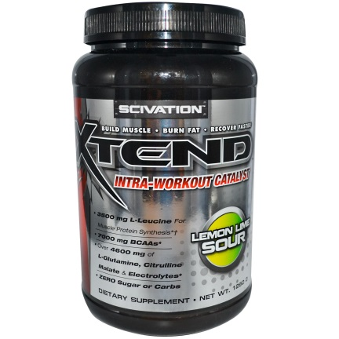
Note: I am NOT a registered dietician, nutritionist, or anything remotely close. I’m just a regular guy who’s been health-conscious for over two decades and seen positive results from what I’ve studied, learned, and implemented over the years. It is recommended that you consult a physician before beginning a diet or exercise program – specifically fasting in this case.
I have a jar of Xtned by Scivation. You can find it on Amazon in many flavors. I have the lemon lime sour flavor. You mix it with water and it tastes similar to Gatorade as far as I’m concerned. But it’s very low in calories (5 calories per serving with no sugar and no carbs) and it’s packed with BCAAs.
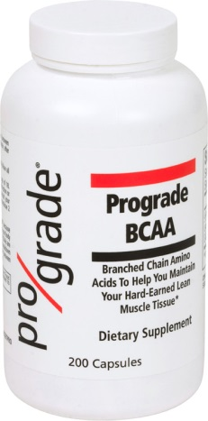
The other BCAA supplement I have is from ProGrade. I remember I got several bottles of this a few years ago when I did Joel Marion’s Xtreme Fat Loss Diet Program [affiliate link?]
How to achieve “super health”
While my fasting experiment is in progress, let’s talk about “super health.” It’s a term I read about somewhere many years ago to describe people who almost always feel great and rarely get sick. That describes me over the last 10+ years so I feel qualified to talk about it.
Before I type another word:
WARNING: I am NOT a doctor, surgeon, dietician, nutritionist, or certified in anything remotely related to health. Please consult a physician before beginning any diet or exercise program.
OK, now with that disclaimer out of the way, I can also say that I’ve been a serious student of health and fitness for 20+ years – mostly for my own health. And I’ve lived in a state of “super health” for the vast majority of that time.
I’m 47 today. Until recently I hadn’t even seen a doctor in over 10 years. And the only reason I saw the doctor was because I recently left my job and when I discovered my health insurance included an annual physical exam I figured I might as well take advantage of it to see if I was as healthy as I felt.
As usual, the doctor ran all the tests and told me to “keep doing whatever I’m doing” because I’m in great health. That’s basically what every doctor I’ve seen in the last 20+ years has told me – both of them!!
Other than that, there’s been no need to see a doctor because I don’t get sick (knock on wood). I may have had a cold or the flu twice that I can recall but no need to see a doctor for that, right? My mother is a nurse so I just took whatever she gave me, rested, and I was back to feeling great in a day or two.
The more common malady has been self-imposed – dehydration caused by excessive alcohol consumption. The more common term is a hangover. But even those are few and far between these days. Apparently I’ve gotten older and outgrown the party days of my youth! Not such a bad thing I guess.
I attribute this state of “super health” to my serious attention and dedication to diet and exercise – to studying it and constantly learning. You see, I discovered early on (by the time I was in my early 20s) that virtually every male in my family had heart problems – including heart attacks and heart surgery.
I didn’t want anything to do with that so I took action early to prevent it from becoming a reality for me. As it turns out, my uncles and grandfather worked in steel mills (with asbestos), smoked, drank too much, ate unhealthy diets with too much red meat, didn’t exercise enough, and I believe had a fair amount of stress in their lives.
I have none of that. My diet is heavy on vegetables and lean meat (chicken and fish) and low on junk food, fast food, red meat, and most of the other common culprits of heart and health problems.
My weaknesses are red wine and salty snacks but I even have those vices under control – especially the salty snacks. I have to admit to drinking too much red wine on occasion – but hey, nobody’s perfect right?
I’ve shared my diet throughout this report and you can go back and see the details including photos but I’ll give a brief recap here.
I’m a creature of habit. I tend to eat and drink the same things over and over again.
For breakfast it’s either vegetables and eggs or fruit and oatmeal. I also have 2 cups of coffee most mornings but I don’t use sugar or those sugary processed creamers. I use honey, almond milk, and sprinkle cinnamon on it too (cinnamon helps control your blood sugar).
For lunch and dinner, I do the opposite of what most Westerners do. Most Americans and Europeans start with meat and sprinkle in some vegetables. I start with salad and sprinkle in some meat.
It may sound boring but I don’t find it boring. I make a huge bowl of salad that lasts a week. I love color so I use just about every vegetable you can imagine including:
- Spinach (a healthier alternative to lettuce)
- tomatoes
- mushrooms
- peppers (green, red, yellow, and orange)
- cucumber
- broccoli, cauliflower, and brussel sprouts (cruciferous vegetables are “miracle foods”)
- beans (2 cans of assorted beans like kidney, black, garbanzo, etc.)
- for healthy fats I’ll add avocado and pine nuts and sunflower seeds and also olives
I may even be forgetting some ingredients but when I’m done I have a very colorful and big bowl of salad. If you don’t like some of those vegetables, then just don’t use them. Simple.
Then I’ll add meat – usually either chicken, tuna, or salmon. And for dressing I’ll use salsa, balsalmic vinegar, or ranch – but not the kind of ranch you buy in the store. I make my own by mixing powdered ranch dressing with cottage cheese. I like it.
With few exceptions, I don’t drink calories. I drink coffee, green tea, and water. I’ll add lemon to my water. I rarely drink soda – probably less than a six-pack per year.
That’s my basic diet and I’m very good at sticking to it the vast majority of the time. I don’t have great willpower. I love salty snacks and other junk foods. My secret is that I don’t buy them. I can’t eat them if they’re not around, right?
For snacks I favor vegetables and the ranch dressing I described earlier (powdered ranch dressing mixed with cottage cheese – not sour cream or buttermilk! Way too much fat!).
But contrary to what you may think, I’m far from perfect. I think it’s insane and downright inhuman to eat perfectly 100% of the time. I cheat liberally.
Left on my own, I will eat as I’ve described but I’m not always on my own. I do have a social life. I love Mexican and pizza. And I’ll eat it on the weekend when I’m out with friends. And I’ll wash it down with beer or wine too!
At home, I rarely drink beer but I will drink red wine regularly and I’ll pop a big bowl of popcorn usually every weekend (but not during my “Thai Beach Body Challenge!”).
In addition to the diet, I exercise regularly. I don’t like gyms. I prefer bodyweight exercises that I can do at home while watching Sportscenter or The Golf Channel. I’ve shared many of these workouts during the course of this challenge. And I also do high intensity interval cardio training about 3 times per week.
My exercise regimen is nothing maniacal. In fact, I really don’t like to work out for more than 20 minutes at a time and I rarely do. But I consistently work out six days a week and take Sunday off. And even on Sunday I’ll often go for a long walk.
So what does any of this have to do with golf?
Well, I can play 36 holes with no fatigue at all. In fact, I’m often disappointed we can’t play longer due to darkness. So this diet and exercise regimen is good for endurance.
And I don’t get golf injuries either. Occasionally I’m sore but not very often. I definitely don’t suffer from chronic fatigue, muscle soreness, pulled or strained muscles or any of that.
I’m not saying you should follow this plan exactly. I’ve often said I generally don’t believe in one-size-fits-all solutions. You need to experiment and find out what works for you. And make it something you can stick too!
My goal is to be as fit and energetic as Gary Player when I’m 80!
Now let’s move on to a…
Killer leg workout
Today I did a great leg workout. And the best part is it’s a bodyweight workout you can do from the comfort of your own home.
So far so good for the “Thai Beach Body Challenge.” In 8 days I’ve shed nearly 5 pounds and shredded several pounds of body fat too. I’ll be sharing more results as well as my diet and exercise so keep reading.
I welcome you to take this challenge yourself. I’m following Chris Henning’s “Shed Pounds to Shave Strokes” program [link to SPSS]. I’m putting it to the test to prove it works.
But today I’ve deviated a bit. As I shared earlier, I also happen to be finishing up the last week of a 10-week bodyweight program. I LOVE it! I was surprised to discover how challenging bodyweight workouts can be.
And as someone who doesn’t care for the hassles of gyms (squatters, membership fees, travel, etc.) I love the fact that I can do these workouts at home while I’m watching SportsCenter or the Golf Channel or whatever else I’m watching.
You can find these workouts in a book by Mark Laruen called “You are Your Own Gym: The Bible of Bodyweight Exercises.” You can find it on Amazon.
Today’s workout is a leg workout that’s sure to leave your legs burning like you never knew a bodyweight workout could. There are four simple exercises.
- 1-legged squats (or “pistols”)
- Bulgarian split squats (with 4 – 6 second pause)
- Side lunges (with 4 – 6 second pause)
- 1-legged hip extensions
You can find videos of all these exercises on YouTube and they are not difficult. Well, the one-legged squat is difficult.
Mark Lauren himself shows how to start with a two-legged squat and progress to a one-legged squat (commonly called a “pistol”). You can watch the video here:
https://www.youtube.com/watch?v=AHyOk0TuXcc
You may see people using stability balls for Bulgarian split squats and/or one-legged hip extensions. If you don’t have a stability ball, you can do what I do and use a chair. It works just fine.
So here’s the killer leg workout. It’s an Interval workout. 3 sets of each exercise. Perform 6 to 12 reps each set and take a short break of 30 to 60 seconds between sets (or longer if you need more recovery time).
Exercise #1: one-legged squats (6 - 12 reps each leg)
Exercise #2: Bulgarian split-squats (6 – 12 reps each leg)
With a 4 to 6 second pause at the bottom (this is what will make your legs SCREAM!)
Exercise #3: Side lunges (6 – 12 reps each leg)
Again, with a 4 to 6 second pause at the bottom so you’ll really feel the BURN!
Exercise #4: one-legged hip extensions (6 – 12 reps each leg)
You’ll really feel this in your hamstrings.
You can stop there… OR if you want extra credit, I added a “finisher” to this workout.
1) Wall Squat (30 seconds)
2) Power Jacks (30 seconds) – jumping jacks with a squat
3) Rest (30 seconds)
Repeat twice for a total of 3 sets
The “finisher is optional.” It’s only for people who are really serious about shedding pounds and shredding body fat.
After this I also did some yoga to stretch out the legs. I love the beginner yoga video I shared in a previous message. You’ll find it here:
https://www.youtube.com/watch?v=gCYCKO4XX9U
The workout AND the yoga stretching combined should take you 45 minutes or less. And you can do it all from the comfort of your own home while you’re watching the news on TV.
Does fasting really work (surprising test results)
For the past two days, as part of the “Thai Beach Body Challenge” to shed pounds, shred body fat, and get into “beach shape” for a trip to Thailand, I experimented with fasting.
I’m not a big fan of fasting – at least not traditional 24 hour fasting – because I get very hungry after about 18 hours. The few times I’ve tried it, I’ve found the last 3 or 4 hours before bedtime to be extremely difficult. And I also don’t believe in starving myself. If my body is hungry it needs food and I should eat.
I supplemented with a low-calorie branch-chain amino acid (BCAA) drink powder (5 calories per glass when you mix it with water) and also some BCAA capsules. I shared the brands earlier.
That definitely helped with the hunger pains. And I would recommend some sort of protein supplementation when you’re fasting because you want the body to attack stored fat for energy – not muscle.
Remember as I’ve said repeatedly, I’m not a doctor, dietician, nutritionist, or anything close – so please consult a physician before beginning any diet or exercise program – including fasting.
Now back to the fasting. I actually caved at about 2PM the first day and had a salad and at about 3PM the next day and had a salad. I also ate a small meal for dinner and had my free snack before bed (vegetables and cottage cheese with powdered ranch dressing).
So what I ended up doing was actually “intermittent fasting.” I can handle intermittent fasting but I still wouldn’t want to do it every day. I actually do it naturally. Sometimes I’m just not hungry for breakfast and I don’t end up eating until noon. That’s fine with me because it’s natural. I just don’t like fasting and feeling hungry and that’s my biggest beef with fasting.
But I do have to admit that according to the scale, fasting did produce results. I dropped below 170 pounds and below 15% body fat during the fasting. We’ll just have to see if the fat stays off when I stop fasting tomorrow.
Now let’s move on to another…
hardcore workout
Today I was back to an Intermediate workout in Chris Henning’s “Shed Pounds to Save Strokes” program. I followed the program in my quest to shed pounds, shred body fat, break 90 at the challenging Mayacoo Lakes golf course, and get into “beach shape” for a trip to Thailand.
This is Intermediate Workout A, but with my own added twist. I added a few exercises and substituted a few too. I wanted to focus on upper body so I dropped the leg exercises. I also added some upper body dumbbell (DB) exercises.
I started with the warm-up to loosen up the muscles. I covered the warm-up earlier. You’re welcome to go back and review it if you’d like. After the warm-up, I dove into the 3 supersets.
Superset #1
1A) DB bench press (12)
2A) DB flies (12)
3A) DB rows (12)
rest 1 minute, repeat twice for a total of 3 supersets
Superset #2
1B) DB military press (12)
2B) Single leg DB curls (8 each arm)
3B) DB hammer curls (10 each arm)
rest 1 minute, repeat twice for a total of 3 supersets
Superset #3
1C) side plank (30 seconds)
2C) side plank (30 seconds – on other side)
3C) plank (30 seconds)
rest 30 seconds, repeat twice for a total of 3 supersets
That alone was a good workout but I wanted to do a little extra so I added a “finisher.”
Finisher Superset
6 pull-ups
50 ski abs or in & outs
rest 30 seconds, repeat twice for a total of 3 supersets
I have to admit I was beat after this workout and I did not feel like doing the cardio workout. I wonder if it had anything to do with losing energy from fasting. Who knows?
In any event, as much as I didn’t want to get on that treadmill and put myself through the high intensity cardio interval workout, I did it because I’m serious about winning this challenge.
I love Dom Capers’ quote. Dom was a football coach in the NFL (maybe he still is). His quote is: “Discipline is doing what needs to be done, even if you don’t want to do it.”
The next time you don’t feel like working out or don’t feel like finishing a work out, ask yourself how serious you are about achieving your goals. Successful people have discipline and they do what needs to be done even when they don’t feel like doing it.
Next, I’m going to share a little twist I’ve decided to throw in to confuse the body and why it’s a good idea to confuse the body in the first place.
Fat loss demystified (shred fat by cheating)
At this point, I’ve been at my quest to prove “Shed Pounds to Save Strokes” works for 10 days. So far so good. I’ve shed pounds and shredded body fat by following the workouts and eating a sensible diet.
I’ve even gone an extra step by cutting back on two of my vices or guilty pleasures – red wine and salty snacks (popcorn is my favorite).
But I’ve declared today “cheat day.” It’s Saturday and it’s time to cheat – but it’s cheating with a purpose.
I’ll give you the usual disclaimer that I’m not a doctor, dietician, nutritionist, or anything else of the sort. I’m just a regular guy who’s dedicated himself to learning as much as possible about diet and exercise.
And one thing I’ve learned is that you need to throw the body a curve ball now and then. You see, when you start restricting calorie intake (like I did with my intermittent fasting experiment earlier this week), your body notices and adjusts.
Your body knows you’re consuming fewer calories and it goes into starvation mode to conserve calories. That means your metabolism slows dramatically. As a result, you burn less calories and less fat.
The solution is to shock the system and throw the body a curveball by “cheating” for a meal or a day. Temporarily increasing caloric intake is an effort to “fool” or “trick” the body out of starvation mode and back into high metabolism, fat burning mode.
From personal experience, I can tell you it works. I can’t explain the science behind it but it has something to do with leptin levels. Again, I’m not a dietician or a nutritionist – just a regular guy who has educated himself on the topic. I’ll share a little high-level information but if you want to understand the details and the science, I’m not the guy for that. I’m sure you can find more information online.
Leptin is a hormone that makes you feel full. Dieting lowers your leptin levels. If leptin is the hormone that sends the “full” signal and dieting lowers leptin levels, it only makes sense that you’d feel hungry when you’re dieting.
A sudden surge of calories increases leptin levels back to normal and turns your body back into a fat burning incinerator. It’s just another example of how sometimes you have to take a step backwards to move forward.
I’m not going to go crazy. Cheat day does not mean “pig out” day. It just means you can and should eat some of the foods that are not allowed when you’re in diet mode. Have a cheeseburger, pizza, some beer or wine. Whatever you want. Just don’t overdo it. And get back to the normal diet and exercise routine the next day.
I may have some pizza but I’m definitely planning on enjoying some red wine and probably some popcorn.
Shed pounds with pizza and popcorn (surprising)
Cheating on your diet is similar to “muscle confusion” in workouts. If you follow the same exercise routine week after week and month after month, your body gets used to it and the results you see will likely decline over time.
The solution is “muscle confusion” – or in other words to mix up the workout at regular intervals to shock the body out of it’s routine. You’ll see better results by mixing it up.
The same principle works with dieting. Your body is more amazing and intelligent than the best and fastest supercomputer. It adapts to what you’re doing – that and there’s thousands of years of evolutionary programming built in to your brain and the myriad of complex systems in your body.
So when you diet – which to most people means cutting back on calories – your body figures out what’s happening and goes into “starvation mode.” It goes back to the days of the caveman when they actually had to hunt and gather their food.
They didn’t have a grocery store full of food on every block. So they didn’t eat as regularly as we do today. As a result, you might see great results for a short-period of time – a week or two or maybe longer.
But eventually your body will go into “starvation mode.” As a result your metabolism slows down considerably (and your weight loss and fat loss also come to a screeching halt). That’s when you’ll hit the proverbial wall and stop seeing the great results you got initially.
If you’re dieting or exercising and start to see diminishing results – in other words you “hit the wall” or “plateau” – this could be why.
The solution is counterintuitive. Most people will eat less and less. And that’s the completely wrong thing to do because your body just goes deeper and deeper into “starvation mode” where your metabolism and weight loss practically stop.
Believe it or not, the solution that actually works is the exact opposite! You should cheat on your diet. Throw the body a curveball to get it out of “starvation mode” and get it back into fat burning mode. Some people have a “cheat day” once a week. Others only “cheat” for a single meal.
Heck, I usually cheat most of the weekend. As long as I exercise and eat healthy during the week, I don’t have any problem staying in a tight range in the neighborhood of 170 pounds and 15% body fat.
But this is the “Thai Beach Body Challenge”!! And I need to get into “beach shape,” so I’m stepping it up for 28 days. I’m only cheating one day per week – and yesterday (Saturday) was the day.
The day you choose to “cheat” is up to you but it makes sense to pick a day when there are more social pressures to eat and drink more than usual. Why “cheat” on Tuesday when nothing’s going on and then have to deprive yourself at the party or at the bar on Saturday? That’s why I generally pick Saturday as my “cheat” day.
Here’s my cheat day. It was actually quite normal until about 3PM. For breakfast I had the usual – just perhaps a bit more of it. I chopped up a half of a sweet potato and fried it in peanut oil (or was it coconut oil? – it was definitely NOT corn oil!).
Then I chopped up a bunch of vegetables and scrambled two eggs with them. That was breakfast and that’s my normal breakfast. I love that breakfast. Sometimes I make pancakes but not today. Or you could go out for breakfast. Your choice.
I’ve made this point before but I don’t have nearly the willpower some people think I do. One of the secrets of my “willpower” to avoid junk food is this – I don’t buy them!! Simple as that.
So when I get hungry for a snack, I don’t have any potato chips, pretzels, cookies, or any other crap around to eat. All I have is fruits and vegetables. So that’s what I eat.
That being the case, I had to make a trip to the grocery store to buy my “cheat” foods for the day. I was about to walk out the door around noon but I was hungry so I had a salad – because remember, there are no “cheat” foods at my house to eat!
I had pizza on my mind so I decided on a pizza. The debate was do I make my own pizza (which I often do) or just buy one of the pre-made frozen pizzas?
My big beef with the pre-made pizza is the white flour crust. Ughh!! White flour is BANNED from my life! It’s terrible!! But I make an exception on cheat day – at least sometimes.
Instead of buying a wheat crust and making my own pizza, I opted for the frozen pizza. In going through the frozen pizza aisle, I was looking for a pizza with a wheat crust – but alas I found none. Bummer!
Specifically, I was looking for a brand called Amy’s which I’ve had before. It’s a bit healthier and it may even have a wheat crust. I ended up getting the Sam’s Choice Thin Crust Supreme. I looked at the label – 1,020 calories and 54 grams of fat. My lord!! What am I doing? That’s 2 or 3 days worth of fat in one meal! Plus the white flour! This is insanity!!
Of course, you don’t need to eat the whole pizza OR you could get a smaller pizza. But not this guy! I ate the whole pizza – which I’m sure was intended for two!
At about 3PM I slid it in the oven – after adding more vegetables. Specifically I added a sliced tomato, some chicken, and some jalapeno peppers. Mmmm!
I also grabbed a Red Stripe beer (I’m not much of a beer drinker anymore, but I keep the “party condo” fridge stocked for guests) from the fridge and sat down on the couch to watch some football.
A few decent games but I decided to see if there were any movies on. I’m not much of a movie watcher (my ADD gets in the way!). Specifically I was looking for a movie filmed in Thailand since I was headed there.
I had done an Internet search and discovered a few movies like Hang Over II, The Beach, a Bridget Jones movie, and even a few James Bond movies were filmed in Thailand.
Unfortunately none of them were on – but I discovered an even more interesting movie – at least to me. Coco Avant Chanel – a movie about the life of legendary entrepreneur Gabrielle “Coco” Chanel (famous for among other things the popular perfume Chanel No. 5).
I love reading books and watching movies about successful people. I try to learn from their stories. To that end I have been reading a book by Gene Landrum (founder of the popular Chuck E. Cheese franchise) called “Entrepreneurial Genius.” And I had just read a chapter on Coco Channel.
OK, enough on my sidebar – back to my “cheating”. But I liked the movie and watched the whole thing – even though it was in French and I had to read the English subtitles.
My pizza was done so I grabbed two slices, ate them and finished my Red Stripe. Calories and fat aside, mmm! Delicious! I had 2 more slices and another Red Stripe. Then another 2 slices but not another Red Stripe because I was out and I didn’t feel like stooping to Bud Light. I’m not a big fan of the watery, mass produced American beers.
Now it was 6PM and I decided to pop a big bowl of popcorn. And I ate most of it while watching football – but saved some for later.
At 7PM, it was time for Tennessee vs Missouri (I’m a UT alum) and it was also time to uncork my bottle of red wine. I sipped a glass during the first quarter – then another during the second quarter. At halftime I finished the popcorn – unfortunately with a score of Missouri 28, Tennessee 3, I figured my Vols were finished too!!
So I switched over to the Miami vs FSU game, watched the second half, sipped a few more glasses of wine. It was about time for bed now but Saturday Night Live came on so I decided to watch it for a bit.
I also finished the last two pieces of pizza and decided to have one more beer before bed – a Yeungling Light this time. Around midnight – after Weekend Update – I called it a night. A successful and fulfilling cheat day!
The next morning I woke and stepped on the scale. It read 172 lbs and 15.2% body fat – still well within my normal range. But hopefully leptin levels have peaked and this curveball has transformed my body back into a fat burning inferno! We’ll see…
How to create a huge caloric deficit (great for weight loss)
The plan is to create an enormous caloric deficiency to take full advantage of the elevated leptin levels and torch some fat. I’ll be intermittent fasting until I get hungry. Then I’ll have a salad. I’ll also be drinking the lemon lime sour BCAA powder mixed with water along with some BCAA capsules. I’ve mentioned these before.
That’s to keep my caloric intake to a minimum. But that’s only half of the caloric deficit equation. The other part is to maximize caloric output. I’ll be doing a bodyweight workout followed by 20 minutes of interval cardio exercise. Then the plan is to do another 20 minutes of interval cardio exercise late this afternoon while I’m watching football.
I wrote about my plan to shred body fat by eating pizza and popcorn and washing it down with a few beers and a bottle of wine. I explained the need to throw the body a curveball to get it out of “starvation mode” and trick it back into fat burning mode.
Here’s my usual disclaimer too. I’m not a doctor. I have no professional experience, credentials, or formal training in the medical field. I’m not a dietician or nutritionist and have no professional credentials in either of those fields either.
Yet somehow, through my own study and application of what I’ve learned over the past 20+ years, I’ve managed to be a 40-something year old male who consistently weighs in a tight range of 170 to 175 pounds and maintains a body fat of 15% or less and a 32-inch waist.
OK, now that you’ve been warned. Let’s move on.
Today consists of intermittent fasting – basically not eating until I get hungry. I skipped breakfast and lunch. After all, how could I be hungry after pigging out yesterday!?!
I am, however, supplementing with BCAAs – branch chain amino acids – a pure form of protein. I’ve mentioned the Xtend powder I’m mixing with water and the BCAA capsules before.
The big goal today is maximum caloric depletion to torch body fat. Hopefully by cheating yesterday I raised my leptin levels and shocked my body out of “starvation mode” where it lowers metabolism (and body fat burning) because I’ve been restricting my calories for the past week.
Today’s caloric deficit (or you could call it caloric restriction or caloric deficiency) is designed to get the maximum results out of my body’s renewed fat burning state. So I’ll work out twice today and eat as little as possible. That’s how to achieve maximum caloric depletion.
The first workout is a bodyweight workout followed by 20-minutes of cardiovascular interval training. The bodyweight workout is from the book “You are Your Own Gym: The Bible of Bodyweight Exercises” by Mark Lauren.
I’ve mentioned this book before and also that I’m following a 10-week program in the book. I’m on the last week of the program but I also wanted to give “Shed Pounds to Save Strokes” four full weeks to whip me into “beach shape” for my trip to Thailand. So I’ll be doing both for a few more days.
Here’s today’s bodyweight workout. It only takes 12 minutes but you will feel it. It’s amazing how you can get a great workout from home using only your body and a few things you find laying around the house.
Today is a “pull” exercise day. Mark’s workouts are designed around “push” exercises (i.e. push-ups) and “pull” exercises (i.e. pull-ups). And also “core” and “leg” exercises.
There are three “pull” exercises and we’re doing something called “tabatas.” Don’t worry, I had never heard of tabatas before reading this book either but I love them now.
A tabata is simply performing the exercise for 20 seconds followed by 10 seconds of rest. Then repeating X times. I did 8 sets of each exercise. That’s a total of 4 minutes per exercise. With 3 exercises that 12 minutes. It’s a short but effective workout.
If you want to do more, no problem. Either do more tabatas – maybe 16. Or add more exercises. That’s the beauty of it. You can tailor the workout to meet your needs.
Here are the 3 exercises:
1) Let Me Ups
2) Let Me Ins
3) Door pull ups (the workout actually called for squats but I substituted door pull ups because I figured it was a more appropriate “pull” exercise than squats)
These are actually simple exercises but challenging to describe in words so I’m going to give you links to videos:
Let Me Ups: https://www.youtube.com/watch?v=pk0mqmYWmag
This shows the exercise done at a gym. I did it at home by putting a broom between 2 chairs (I must admit the broom handle is a bit bent now due to my constant use of it for “let me ups” – but hey, it still sweeps!)
I also like to alternate grips – overhand and underhand.
Let Me Ins: https://www.youtube.com/watch?v=LPvK5FamZKY
If that’s too easy, try one handed let me ins: https://www.youtube.com/watch?v=PCnbMz1WgZg
I actually just grab the door handle and let myself up, but you can use a belt as the video shows or a towel wrapped around the handle works too.
Door Pull-Ups: https://www.youtube.com/watch?v=b4Ui90liMGs
People who watch me do these sometimes cringe and tell me I’m going to break the door. I’ve done hundreds of door pull-ups and there is still no damage to the door. But you might weigh more than me (170 lbs) or your doors might be different and weaker than mine so I’ll just throw out a courtesy warning: Don’t break your doors!!
Of course I did a short 3 to 5 minute warm up before I started my tabatas: run in place, high knees, jumping jacks, squat jacks, inchworms, and mummy kicks. If you don’t know how to do any of those exercises I’m sure you can find them on YouTube. Or just do your own. The point is to loosen up the muscles and get the heart pumping and ready for exercise.
After that, I headed down the condo gym and did 21 minutes of interval training. I’ve described this before. Pick a machine at the gym. Or you can run around a track, jump rope, or whatever else your creative mind can come up with.
It’s a 4-minute warm up (at about 30% effort). Followed by six 2-minute intervals. 30 seconds at a 70% effort followed by 90 seconds of “active rest” at about 30% effort. And finally a 5-minute cool down gradually decreasing the effort level.
Here’s my treadmill workout as an example.
1st minute: 3 degree incline; speed: 3.4
2nd minute: 6 degree incline: speed 3.4
3rd minute: 9 degree incline: speed 3.4
4th minute: 9 degree incline: speed 3.6
So you can see I’m gradually increasing either the incline or the speed every minute.
6 two-minute intervals (12 minutes)
1-minute: 9 degree incline: speed 6.9
1-minute “active rest”: 9 degree incline: speed 3.6
I’m doing a bit extra here. The interval only calls for 30 seconds at 70% of maximum effort but I’m doing 60 seconds. Do what’s comfortable for you. At a speed of 6.9 I’m running fast but not quite sprinting – and I would say at an effort level above 70% - more like 85% is my guess. And at a speed of 3.6 I’m in a fast walk, not quite running.
My heart rate gets into the 170 – 180 range (at least according to the treadmill). That’s actually quite a bit higher than is generally recommended for someone my age (in my 40s). But I’m in good shape and I don’t feel like it’s too much so I’m comfortable with it.
You should workout at a level that’s comfortable for you. I’ve found conflicting information on the ideal heart rate. You can search online for “target heart rate,” do your own research, and reach your own conclusions. (Remember, I’m NOT a doctor or certified fitness professional.)
Then the 5-minute cool down
1st minute: incline 9 degrees: speed 3.6
2nd minute: incline 6 degrees: speed 3.6
3rd minute: incline 3 degrees: speed 3.6
4th minute: incline 0 degrees: speed 3.6
5th minute: incline 0 degrees: speed 3.4
So you can see, I’m gradually decreasing the effort level to “cool down.”
That’s it! A simple 21-minute cardio interval workout.
A Little Known Fat Loss secret
I’ve already shared the idea of a massive “caloric deficit” as a way to torch body fat, but that’s not the fat loss secret I’m talking about – at least not by itself. That’s only part of it. That’s the part most people get.
It’s common sense that you’ll shed pounds and shred body fat by creating a massive “caloric deficit.” You do this by minimizing caloric intake (i.e. eating less) and maximizing caloric output (i.e. exercising more).
But, just to make sure we’re on the same page, I’m not talking about starving yourself. Not at all. If you starve yourself, your body will turn to muscle for energy. You’ll lose weight, but you’ll also lose muscle. That’s less than ideal considering muscle burns calories. Muscle is good.
What you want is for the body to turn to stored fat as a supply of energy during your period of massive “caloric deficit.” The key is to make sure you’re getting enough protein. I’ve been drinking Xtend lemon lime sour powder with water. It’s packed with BCAAs (branched chain amino acids) – the building blocks of protein.
There’s only 5 calories in a glass. And not only does it keep me from getting that “weak” feeling you get from not eating. It also gets me drinking plenty of water – another important part of fat loss.
But still, none of that is the little-known fat loss secret. You see, the problem with “caloric deficit” is that is doesn’t work forever. Your body is just too darn smart. Through thousands of years of evolution, your body has learned to go into “starvation mode” when it senses a “caloric deficit.”
The result is a dramatic slowing of your metabolism to conserve energy – exactly the opposite of you want when you’re trying to burn body fat! That’s why you might see great results for a week or two and then suddenly hit the wall or plateau. You stop losing weight and body fat.
So what’s the solution?
You have to trick your body back into fat burning mode. And you’ll love it! I’m giving you a license to cheat. Eat your favorite foods like pizza, pasta, popcorn, ice cream, or whatever else you love to eat.
Don’t overdo it though. Some people have a “cheat meal” while others prefer a “cheat day.” Personally I fall into the “cheat day” camp. Might as well enjoy it for a full day, right?
This shocks the body out of “starvation mode” because – well, obviously when you’re eating all these foods you love and consuming a lot of calories, you’re no longer in caloric deficit mode, right?
The very next day is the best day to go into massive “caloric deficit” mode. Ideally, you would workout out twice and fast all day. That would create the MAXIMUM caloric deficit. And even better, you do it after your body has gone back into “fat burning” mode.
Of course, it’s easier said than done. It’s hard enough to fast all day when you’re inactive. And working out twice in one day not only takes time and discipline, but it also tends to make you hungry!
Don’t starve yourself. Eat something if you have to but try to stick to low calorie alternatives like vegetables. Broccoli and cauliflower are favorites of mine. They are low in calories, high in nutrition, and they tend to fill you up.
I understand the thought of eating broccoli and cauliflower might sound disgusting to many people. Trust me, I’ve been there and I know where you’re coming from. I’ve actually gotten to a point where I don’t mind eating these cruciferous “super foods.”
I especially love them with some ranch dressing – NO! not that ranch dressing. The stuff you buy at the store in a glass bottle is full of fat and calories and that would defeat the purpose. I like to mix powdered ranch dressing with cottage cheese and dip the vegetables. I find it quite tasty. You could also substitute low-fat plain yogurt if you prefer.
So here’s what I did yesterday. I shared my morning workout. And I did not eat a thing until 4PM. I ate a small salad. I repeated the same 21-minute cardio interval exercise at around 6PM. Then I ate another small salad around 8PM.
And remember, I supplemented with a low-calorie protein drink. It really helps eliminate the “weak” feeling you may get from not eating. And I have to say, fasting has gotten easier in the last week as I’ve been practicing.
I’m still no fan of fasting all day. And I wouldn’t recommending fasting for more than 24 hours. But “intermittent fasting” – not eating until after noon – is not much of a problem.
If you can’t do without breakfast, then you could try eating a big breakfast and then fasting the rest of the day. I’ve done this and it works too.
Before I move on, I’ll address the question that may be in your mind. Through mass marketing we’ve been programmed to believe breakfast is the most important meal of the day and here I am suggesting you may want to consider skipping it!
First of all, I’m highly skeptical of any information from the government (like the FDA). These are the same geniuses that had the “food pyramid” upside down! If you’re serious about shedding pounds and shredding fat, you do NOT want to be eating several servings of bread and pasta – especially if it’s made from white flour!
White flour is the WORST! It’s banned from my diet. I rarely eat bread, buns, rolls, muffins or anything else made with white flour like pasta. At restaurants I will literally take the sandwich out of the bun and toss the bun on another plate. I’m not eating that crap! I will eat other types of bread sparingly – like wheat bread, rye bread, etc.
And I don’t have much interest in what the big food companies have to say about breakfast either. After all, these are the people telling you how important breakfast is and then recommending a bowl of Cap’n Crunch as the solution!
NO thank you! It’s all processed crap! It’s fine on cheat day but not on any other day of the week. Cereal is banned from my diet too! I eat oatmeal or eggs for breakfast if I even eat breakfast.
To be fair, with all that said, I don’t believe in “one-size-fits-all” solutions. I believe we’re all different and you need to experiment and find out what works best for you.
As a final word, I’ll just say that I know some people who swear by intermittent fasting that are in phenomenal shape – they are totally ripped! And I know a lot more people who eat junk like jelly donuts and Rice Krispies for breakfast. They are NOT ripped.
At the end of the day though, your diet is a personal decision. Just ask yourself with each bite of food or each drink you take: Is this bite (or drink) moving me closer to my goals of shedding pounds and shredding fat? Or is it moving me farther away?
The answer to that question reveals A LOT about your commitment to shedding pounds and shredding fat.
Here’s my usual disclaimer: I am neither a doctor nor do I have any professional medical credentials at all. I am not a dietician or a nutritionist either and I have not professional certifications in either of those fields either. Please consult a medical professional before embarking on a diet or exercise program.
Of course, I’ve noticed I’m in better shape than many of these so-called medical and nutrition specialists too but that’s another story.
OK, enough of that. Let’s move on to a great…
Pecs and guns workout
Today I’m continuing my “intermittent fasting” routine – not eating until noon. And it’s back to Intermediate Workout A from “Shed Pounds to Save Strokes”
However, I decided to modify it a bit to focus on the pecs and guns (the beach muscles!) AND add a killer “finisher.” It’s predominantly a dumb bell (DB) workout.
Here are the supersets. If you’re not familiar with supersets, you perform each exercise back to back to back with now rest. Then rest for a minute and repeat. Then repeat again. You’ll do a total of 3 supersets with one minute of rest in between supersets.
Superset #1
1A) DB bench press (8 to 12 reps)
1B) DB flys (8 to 12 reps)
1C) DB rows (8 to 12 reps)
Rest 1 minute, repeat twice for a total of 3 supersets.
Superset #2
2A) DB military press (8 to 12 reps)
2B) DB one-legged curl (8 to 12 reps)
2C) DB hammer curls (8 to 12 reps)
Rest 1 minute, repeat twice for a total of 3 supersets.
Superset #3
3A) Side plank (left) – 30 seconds
3B) Side plank (right) – 30 seconds
3C) Full plank – 30 seconds
Rest 30 seconds, repeat twice for a total of 3 supersets.
And if you’re really serious, add this “finisher” superset.
Finisher Superset
1) 8 pull-ups
2) 21 dips
Rest 1 minute, repeat twice for a total of 3 supersets.
Mmmmm!! Feel the burn!! And watch the beach muscles grow!!
I followed this up with the 21-minute cardio interval workout I’ve described before and called it a good workout!
thAi beach body challenge results (amazing!)
OK, I’m 14 days (2 weeks) in to the “Thai Beach Body Challenge” – my personal quest to shed pounds, improve my golf game, and break 90 at the Jack Nicklaus designed “bear” of a golf course called Mayacoo Lakes.
It’s time to report results – after all the only way to know if the “Shed Pounds to Shave Strokes” program I’m following is working is to monitor my measurements and see it I’m actually shedding pounds and shredding fat, right? The numbers don’t lie.
I’ll get to the results in a second – and they’re AMAZING! Even I did a double-take when I stepped on the scale today.
First, I’ll tell you today’s program. I did some yoga – the same 20 minute YouTube video I’ve shared. I’m actually really starting to like this yoga stretching! That was it for exercise – a light day. I’ll get back to the dumb bell workouts tomorrow.
As for eating, I woke up early today – like 4:30 early. I had my usual 2 cups of coffee and started working. I felt a bit hungry so I cooked some oatmeal on the stove and added bananas and blueberries, a scoop of chocolate protein powder, cinnamon, slivered almonds, and some almond milk.
When I finished my workout I was a bit hungry again. And I figured since I had been restricting my calories so much for the past few days that perhaps I should eat. So I chopped up some vegetables, put them in the skillet with some coconut oil, cracked one egg over the top, and scrambled it all together. Then I put a heaping dollop of cottage cheese on top and dug in. Mmmmm!!!
I also knew I was heading off to the driving range and wouldn’t be around for lunch so that’s another reason I ate twice in the morning. When I got back from the golf practice facility (where I devoted more practice time to putting and chipping than I did to the long game), I stepped on the scale – and I could not believe my eyes!
Remember, when I started this challenge two weeks ago I weighed in at 175 pounds and 16% body fat – not too shabby for a 40-something year old. But I knew I could do better. And I wanted to prove “Shed Pounds to Shave Strokes” really delivered on it’s promise.
After one week, I had dropped to 172 pounds and 15.2% body fat – moving in the right direction. This week’s results are even better!
168 pounds and 14.5% body fat
So in just 14 days, following the “Shed Pounds to Shave Strokes” program, I’ve shed roughly 6 pounds and shred over 1% off my body fat. Actually I’ve shredded nearly 10% of the body fat I started with - about 8% to be exact.
I’m very pleased with the results and EXCITED to keep it up and watch the body fat melt like butter!! And if you can keep a secret, I’ll share something else. I actually had a reading of 13.9% body fat!!! As a matter of fact, I got that reading (or close to it) several times. I just don’t believe it. It’s too good!
Why? Well, I alluded to this earlier but my Escali scale use something called bioimpedance to measure body fat. And I know it’s not perfect. I figure for some reason I’m getting a low measurement today. It might have something to do with the amount of water you drink but I’m no expert on the science of bioimpedance.
In any event, I waited a while and stepped on the scale again and got what I believed to be a more reasonable (and believable) result. And that’s what I reported.
Next I’ll share a controversial idea on diets. We’ve all been played by the diet industry and I’m mad as hell!
The great diet hoax (warning: This is controversial!)
The “Thai Beach Body Challenge” continues and I’ll share more workouts – including some tweaks. I got some personal coaching and advice from Chris Henning – the creator of the “Shed Pounds to Shave Strokes” program that’s working so well for me.
Today, though, I want to reveal the great “diet” hoax. The diet industry, in its quest to maximize short-term profits at the expense of your long-term benefit, has completely twisted the concept of a diet.
For example, did you know that “Diet Coke” doesn’t even exist in Europe? They drink Coca-Cola Light. Why? Because across the pond, “Diet Coke” is a preposterous idea. They don’t even understand the concept because they don’t think of the word “diet” the same way Americans do.
To the rest of the civilized world, diet is a philosophy of eating – not just for a few days, weeks, or months, but forever. A diet is for life, not a short-term solution to a long-term challenge.
The endless parade of new diets as a way to lose weight quickly is an invention of the diet industry – and they’re damn good marketers. Thanks to the diet industry’s relentless marketing campaigns, they’ve successfully shifted the American way of thinking about a diet from a long-term philosophy about eating and drinking into a short-term solution they can sell to help us lose weight quickly – in exchange for our hard-earned money of course!
And if that’s the way you think about eating, you may find it challenging to eat a well-balanced diet. Just knowing what you’re up against is a great start. Forget about the low-carbs, no carbs, high protein, shakes, and other crazy concoctions the diet industry invents to separate you from your money.
It’s hard to go wrong eating a well-balanced diet consisting mostly of fruits, vegetables, lean protein, and healthy fats. How many people have you seen get fat from eating too many apples, oranges, and bananas? Too much broccoli and spinach? Or too much chicken?
It’s the people that load up on the processed foods that get fat. Too much fast food. Too much fatty red meat. Too many bags of salty snacks. And drinking too many calories like soda, beer, and high-calorie fruit drinks. It’s OK to “cheat” now and then. It’s when these foods become staples of your “diet” that the problems arise.
It’s simple. Eat right and exercise regularly – even if it’s just going for a walk a few times a week.
Tomorrow another “secret” I’ve discovered during this challenge – plus an unfortunate truth that may make you mad.
nothing tastes as good as this (the inconvenient truth)
Think about this as you eat and drink. Ask yourself is this bite of food moving closer to my goals? Or is it moving me farther away from my goals? It's a simple question with a clear answer.
And the perhaps unfortunate truth is that no matter what you say, your true motivation is revealed by your actions. Goals (even written goals) and words are useless without the disciplined action to back them up.
You've heard it before and it's true: Actions speak louder than words.
Fitness pro shares fat-torching secrets
During the “Thai Beach Body Challenge,” I’ve been eating the usual. Vegetables and eggs or fruit and oatmeal for breakfast. And sometimes “intermittent fasting.” For me that means, skipping breakfast and not eating until afternoon. It’s not for everybody but it works for me.
Then various salads for lunch and dinner with chicken or fish. And last night I baked mahi mahi, half a sweet potato, and brussel sprouts. Mmmm!! I have to say, raw brussel sprouts suck, but when you bake them and add a little seasoning, they’re not bad at all!
I’ve been following the “Shed Pounds to Save Strokes” workout but I’ve modified it a bit. That’s the beauty of it, you can modify it to meet your goals and suit your needs. The body fat is melting and the pounds are shedding. I’m actually starting to see my abs so it’s getting exciting!
Since I’m leaving for a trip to Thailand soon and hitting some beaches, I’ve modified the workouts to focus on the “beach muscles” – pecs and biceps.
Of course I did the usual warm-up I’ve shared before. And after the resistance workouts I did the 21-minute cardio interval workouts I’ve also shared. Before I did this workout, I consulted with Chris Henning, the creator of “Shed Pounds to Save Strokes.”
I know quite a bit about diet and exercise but he’s a pro! So I’ll share a few tips he gave me for torching body fat. I shared my impressive results so far. I’ve shared these results with you too but just to recap I’ve shed 7 pounds (from 175 to 168) and shredded about 10% of my body fat (from 15.8% to 14.5%) in just 14 days.
When you get down below 15% body fat (for males), it gets more challenging to continue shredding body fat. Chris told me in order to continue to lose body fat, I should build muscle. Considering muscle weighs more than fat, that means I may actually have to gain weight in order to reduce body fat.
That’s fine with me. As I said earlier, my ultimate goal is to reduce my body fat to 12% (and then even lower – but 12% is a good intermediate goal). Packing on more lean muscle is actually a good thing because muscle naturally burns calories.
Specifically, Chris told me to build muscle I should use more weight and do less reps. So with that in mind, I used more weight.
However, I also had a challenge to overcome. You see the dumb bells (DBs) at the “party condo” gym max out at 50 lbs. And I was already easily doing 12 reps of DB bench press with 50 lbs. So how do I overcome this challenge?
It turns out there are at least 3 solutions:
Solution #1: Incline the bench. Adding a little incline increases the difficulty. You can bench press more weight than you can military press. That’s because the increased incline of the military press increases the difficulty of the press. It also works different muscles but that’s the extreme difference in incline.
With an adjustable bench, you can increase the incline in incremental notches. So you can increase the incline a notch or two to increase the difficulty of the DB bench press. I did not even need to do this because the other two solutions I’m about to share did the trick.
Solution #2: Change the order of the workout so you do DB bench press last. The Intermediate workout in “Shed Pounds to Save Strokes” has you doing DB bench press first – when you’re freshest and your muscles are strongest.
However, if you move the DB superset from first to last, that changes the equation. Now, you’ll be doing the DB bench press superset when your muscles are fatigued making it more challenging. That helped but combining this solution with solution #3 was killer!
Solution #3: S-L-O-W Down! Instead of doing reps at your normal pace, slow down the movement. I performed each DB bench press rep with slow, controlled movements – 2 to 3 seconds up, and 2 to 3 seconds down. It’s A LOT harder when you slow it down than when you’re cranking out reps at a rapid pace.
Another option is a slow downward movement that focuses on the negative. It’s more difficult because you’re fighting gravity on the way down. Then explode on the upward movement.
As a result of moving DB bench press to the end of my workout AND slowing down the pace of the reps, I could only do 8 reps. And effectively that is the equivalent of doing less reps with more weight which is how you build fat-burning muscle.
Hopefully, those tips will help you in your quest to shed pounds and shred body fat. It’s definitely working for me!
But remember my usual disclaimer: I’m not a doctor, dietician, or nutritionist. I have no formal education or certifications in any fields remotely related to medicine, fitness, or nutrition. I’m just a self-motivated, self-taught regular guy who studied, took action on what I learned, and whipped myself into shape.
Please consult your doctor and/or a trained fitness professional before beginning any diet or exercise program.
Body fat torching workout
OK, here’s the workout that incorporated Chris’ “secret” for torching body fat. Namely using more weight and doing less reps. Before Chris shared his knowledge with me, I had been using a weight that I wouldn’t call easy, but I could do 12 reps and probably could have done a few more. For this workout, I pushed my limits more.
Superset #1:
1A) military press (12 reps x 50 lbs) 12 was about max I could do with 50 lbs – I had been doing 12 reps with 40 to 45 lbs

1B) one-leg DB curls (6 reps x 40 lbs) as opposed to 8 reps with 30 lbs

1C) hammer curls (8 each arm x 40 lbs) I had been doing 10 each arm at 30 lbs

rest 1 minute, then repeat twice

Superset #2
2A) side plank (L) - 30 seconds
2B) side plank (R) - 30 seconds
2C) full plank 30 seconds
rest 30 seconds, repeat twice
Superset #3
3A) DB bench press (8 x 50 lbs) I did this very S-L-O-W - about 3 seconds up and 3 seconds down, 8 was the MAX I could do

3B) DB flys (8 x 40 lbs) I also slowed down the pace on this exercise. I had been doing 12 x 35 lbs

3C) DB rows (12 x 50 lbs) I did this slow too....could have done more than 12 but I only have 50 lbs

rest 1-minute, repeat twice

I had a finisher superset in mind too. I was running short on time because I had an appointment but I’ll share it with you just in case you want to do it!!
Finisher Superset
A) 6 pull-ups
B) 21 dips
C) 50 mountain climbers
rest, repeat twice

UPDATE: During my last week of the “Shed Pounds to Shave Strokes” program, I actually moved the “finisher” superset to before Superset #3. I did this to fatigue my chest muscles even more (particularly with dips) which made the DB bench press and flies even more challenging.

And of course, I did the 21-minute cardio interval workout immediately following my resistance workout.

How to eat less and still feel full

Yesterday I shared a fat-torching workout with you. It’s part of my “Thai Beach Body Challenge.” I’m heading to Thailand soon and will be hitting some beaches.

Working out is a necessity – specifically muscle-building resistance workouts because muscle burns calories. And fat-burning cardio workouts – not the boring stuff most people do – I’m talking about intense interval workouts of about 20 minutes. I’ve shared these cardio workouts with you too.

Today, let’s talk about the other side of the equation – diet. Because diet is just as important as exercise. Actually diet is MORE important than exercise.

That’s what my friend and fitness expert Craig Ballanytne says. He has me so convinced of this fact that I put his quote in a prominent place on my refrigerator so I’d see it every time I reached for some food!

Craig also says you can’t out train a bad diet. And I agree 100%! Why? Because I tried it and failed miserably! Only after I understood and accepted the importance of diet in shedding pounds and shredding body fat did I start seeing great results.

Here’s something I’ve been doing lately to help me eat less but still avoid that “hungry feeling” nobody likes. It’s simple and I bet you’ve heard it before but I can tell you from recent experience that it really works!

What is this diet secret?

First, I’ll tell you that I’m a fast eater by nature. It’s not unusual that I’ve cleaned my plate before anyone else is half done. Of course the natural tendency when you do this is to eat more.

That’s because there’s a delay from the time you eat and your body is full until the time the “I’m full” signal is sent to your brain. So if you eat fast and then eat some more, you’re probably consuming more calories than necessary.

One night a few days ago, I decided to slow it down. I had some sort of chicken salad and some baked brussel sprouts. But instead of wolfing it down like usual. I took a bite and set my fork down while I chewed slowly before swallowing. Then I took a drink of water too. And even waited a bit longer until I took another bite.

I was AMAZED at how full I felt from simply slowing down, setting down the fork, and drinking water between each bite. Apparently it gave my brain time to receive the “full” signal from my brain because when I finished eating I wasn’t hungry at all.

Try it and see how it works for you. Tomorrow I’ll share another fat-torching workout with you.

another fat-torching workout
So far I’ve shared several fat-torching secrets and a fat-shredding workout with you. Today I’ll share another one – it’s similar but I changed things up just a little.
I’m seeing excellent results with Chris Henning’s “Shed Pounds to Shave Strokes” program. I’ll share the latest weight and fat loss figures with you soon.
As part of the program that’s working so well, I’m doing resistance and cardio training Monday, Wednesday, and Friday. And I’m doing some yoga on Tuesdays and Thursdays.
I have to admit I was skeptical on the yoga but I’ve found that I really like it now. It’s great for stretching out tight muscles. In my case that’s the legs – specifically the hamstrings.
I shared a YouTube video I discovered a few weeks ago. It’s for beginners like me. You’ll find it here: [insert link – should it be getgolffit.com/yoga so we can change it if necessary?]
It’s so simple that I really don’t even need to watch the video anymore. I know the moves now. I can set my GymBoss timer for 12 one-minute intervals and be done and feeling stretched and relaxed in just 12 minutes. I actually like it so much I’m strongly considering doing it every day. I can do it while watching SportsCenter or the Golf Channel.
Today was my resistance and cardio day though. After my warm-up, I launched into another muscle-building resistance workout. It’s very similar to the one I shared the other day but slightly different.
Here it is:
Superset #1:
1A) military press (12 reps x 50 lbs)
1B) one-leg DB curls (6 reps x 40 lbs)
1C) hammer curls (8 each arm x 40 lbs)
rest 1-minute, then repeat twice

Superset #2
2A) 6 pull-ups
2B) 21 dips
rest 30 seconds, repeat twice
Superset #3
3A) DB bench press (8 x 50 lbs)
3B) DB flys (8 x 40 lbs)
3C) DB rows (12 x 50 lbs)
rest, repeat twice

I added the weights and number of reps just for reference. You may be stronger than me and use more weight. That’s great! But remember the fat-torching secret I shared – muscle burns calories and too build muscle you need to use more weight and do less reps.

And of course, I did the 21-minute cardio interval workout immediately following my resistance workout.

Kick up the cardio (for even better results!)

If you reach a point where you are plateauing (i.e. your improvement is slowing) or if you just want to push yourself a bit harder to get even better results, here’s a tip: kick up the cardio a notch.

I asked Chris Henning, a fitness professional and the creator of “Shed Pounds to Shave Strokes” about this. Specifically I asked him if I should do the cardio workout twice per day.

He said, “no,” don’t do the cardio workout twice per day. And upon further reflection I agree with him because there’s no need to overwork yourself and you reach a point of diminishing returns.

However, Chris had an alternative suggestion that made a lot of sense so I followed it. Instead of two 20-minute cardio sessions per day, just add some time to the one cardio session you’re already doing to burn more calories.

Chris suggested add two more 2-minute intervals to my cardio workout. So instead of 6 circuits consisting of 30 seconds of high-intensity followed by 90 seconds of active rest, I did 8 circuits.

On top of that, you can increase the time of the high-intensity and decrease the active rest. I found 45 seconds of high-intensity cardio followed by 75 seconds of active rest worked best for me.

Another alternative is to kick up the intensity a notch. So for example, on the treadmill, if your high-intensity interval is a speed of 6.9 at a 9 degree incline (like mine was), you could kick up either the speed or the incline or both!

I would often add another 3 degrees of incline and do my intervals at a speed of 6.9 and an incline of 12 degrees. Some days I felt better or stronger than others. So some days I would do the whole cardio interval workout at those levels. Other days I felt like it was a bit too much so I would reduce the incline back down to 9 degrees.

Don’t overexert yourself! Your body is an amazing machine. Listen to it. If you’re starting to feel weak, exhausted, or feel pain, then slow down or even stop. There’s a fine line between pushing yourself to the limit and pushing yourself too far to the point of injury or worse.

LAST WEEK of The thai beach body challenge

The last week of the “Thai Beach Body Challenge,” I focused on the beach muscles. So I did the workout I shared under the heading “Another Fat-Torching Workout” every other day and followed that up with 24 minutes of high-intensity interval cardio.

I did yoga and stretching on my off days and stuck to the diet I’ve described…but I hit a bump in the road! A challenge we all face…

the disaster story (don’t do this!)

Here’s the story…

My friend invited me to play in a scramble on Friday morning at a very nice private golf course – The Old Trail Course at Jonathan’s Landing in Jupiter, Florida. And you know how these scrambles work! Food and booze!!

I had the best of intentions but I’m human and I’ve already shared my lack of willpower. I beat my natural inclinations by not buying “junk food” in the first place. If it’s not around, then I can’t eat it, right?

I knew (or at least assumed) the breakfast would consist of things I should not be eating – especially not during the “Thai Beach Body Challenge” so I got up early and made my typical breakfast of eggs and vegetables.

So I hit the road and when I arrived all I had was coffee. I showed some discipline and passed on the jelly donuts and coffee cake. Good for me!

But alas, it wouldn’t last long. I caved quickly. Before we hit the first tee, the booze was flowing – Bloody Mary’s, Screwdrivers, you name it! And after all, I reasoned, it was Friday and I had been so good and disciplined up to this point.

So I decided to move “cheat day” from Saturday to Friday. That’s how a weak mind thinks! I admit it. I don’t always have the best willpower.

What got me was these cool containers of rum I had never seen before. And I could keep this cooler and use it over and over again. So I caved and grabbed one!

I was drinking rum for the rest of the round. At least I refrained from all the snacks I could have eaten.

As for the golf, we played GREAT!! We actually came in first place for low gross with a score of 54 – not so hard when you’re playing a four-man scramble and two of the guys are low single-digit handicappers. (I’m a 12 handicap.)

As for me personally, I was hitting the ball as far as the low-handicappers. Power and distance are not my problem. It’s the accuracy and consistency that are my challenge.

We used several of my drives. Plus I rolled in a 20-foot putt on the 18th green that proved to be the margin of victory.

Here’s photo of all the loot I won: a 1st place plaque, a watch, a new Nike golf shirt (that I bought with the $60 gift certificate I won). That green thing is the cooler I was talking about.

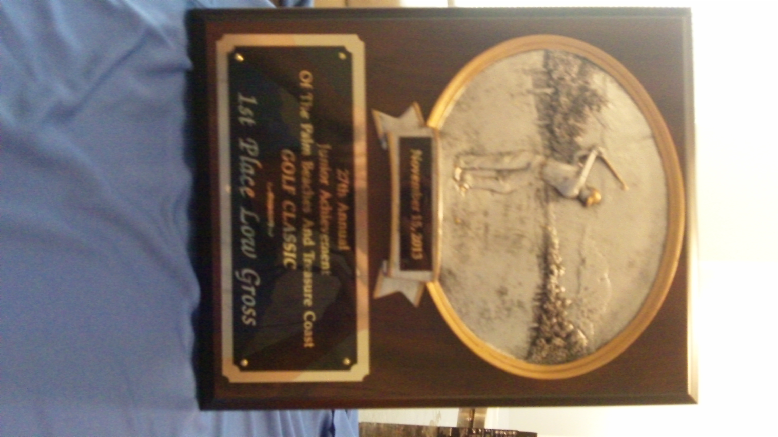
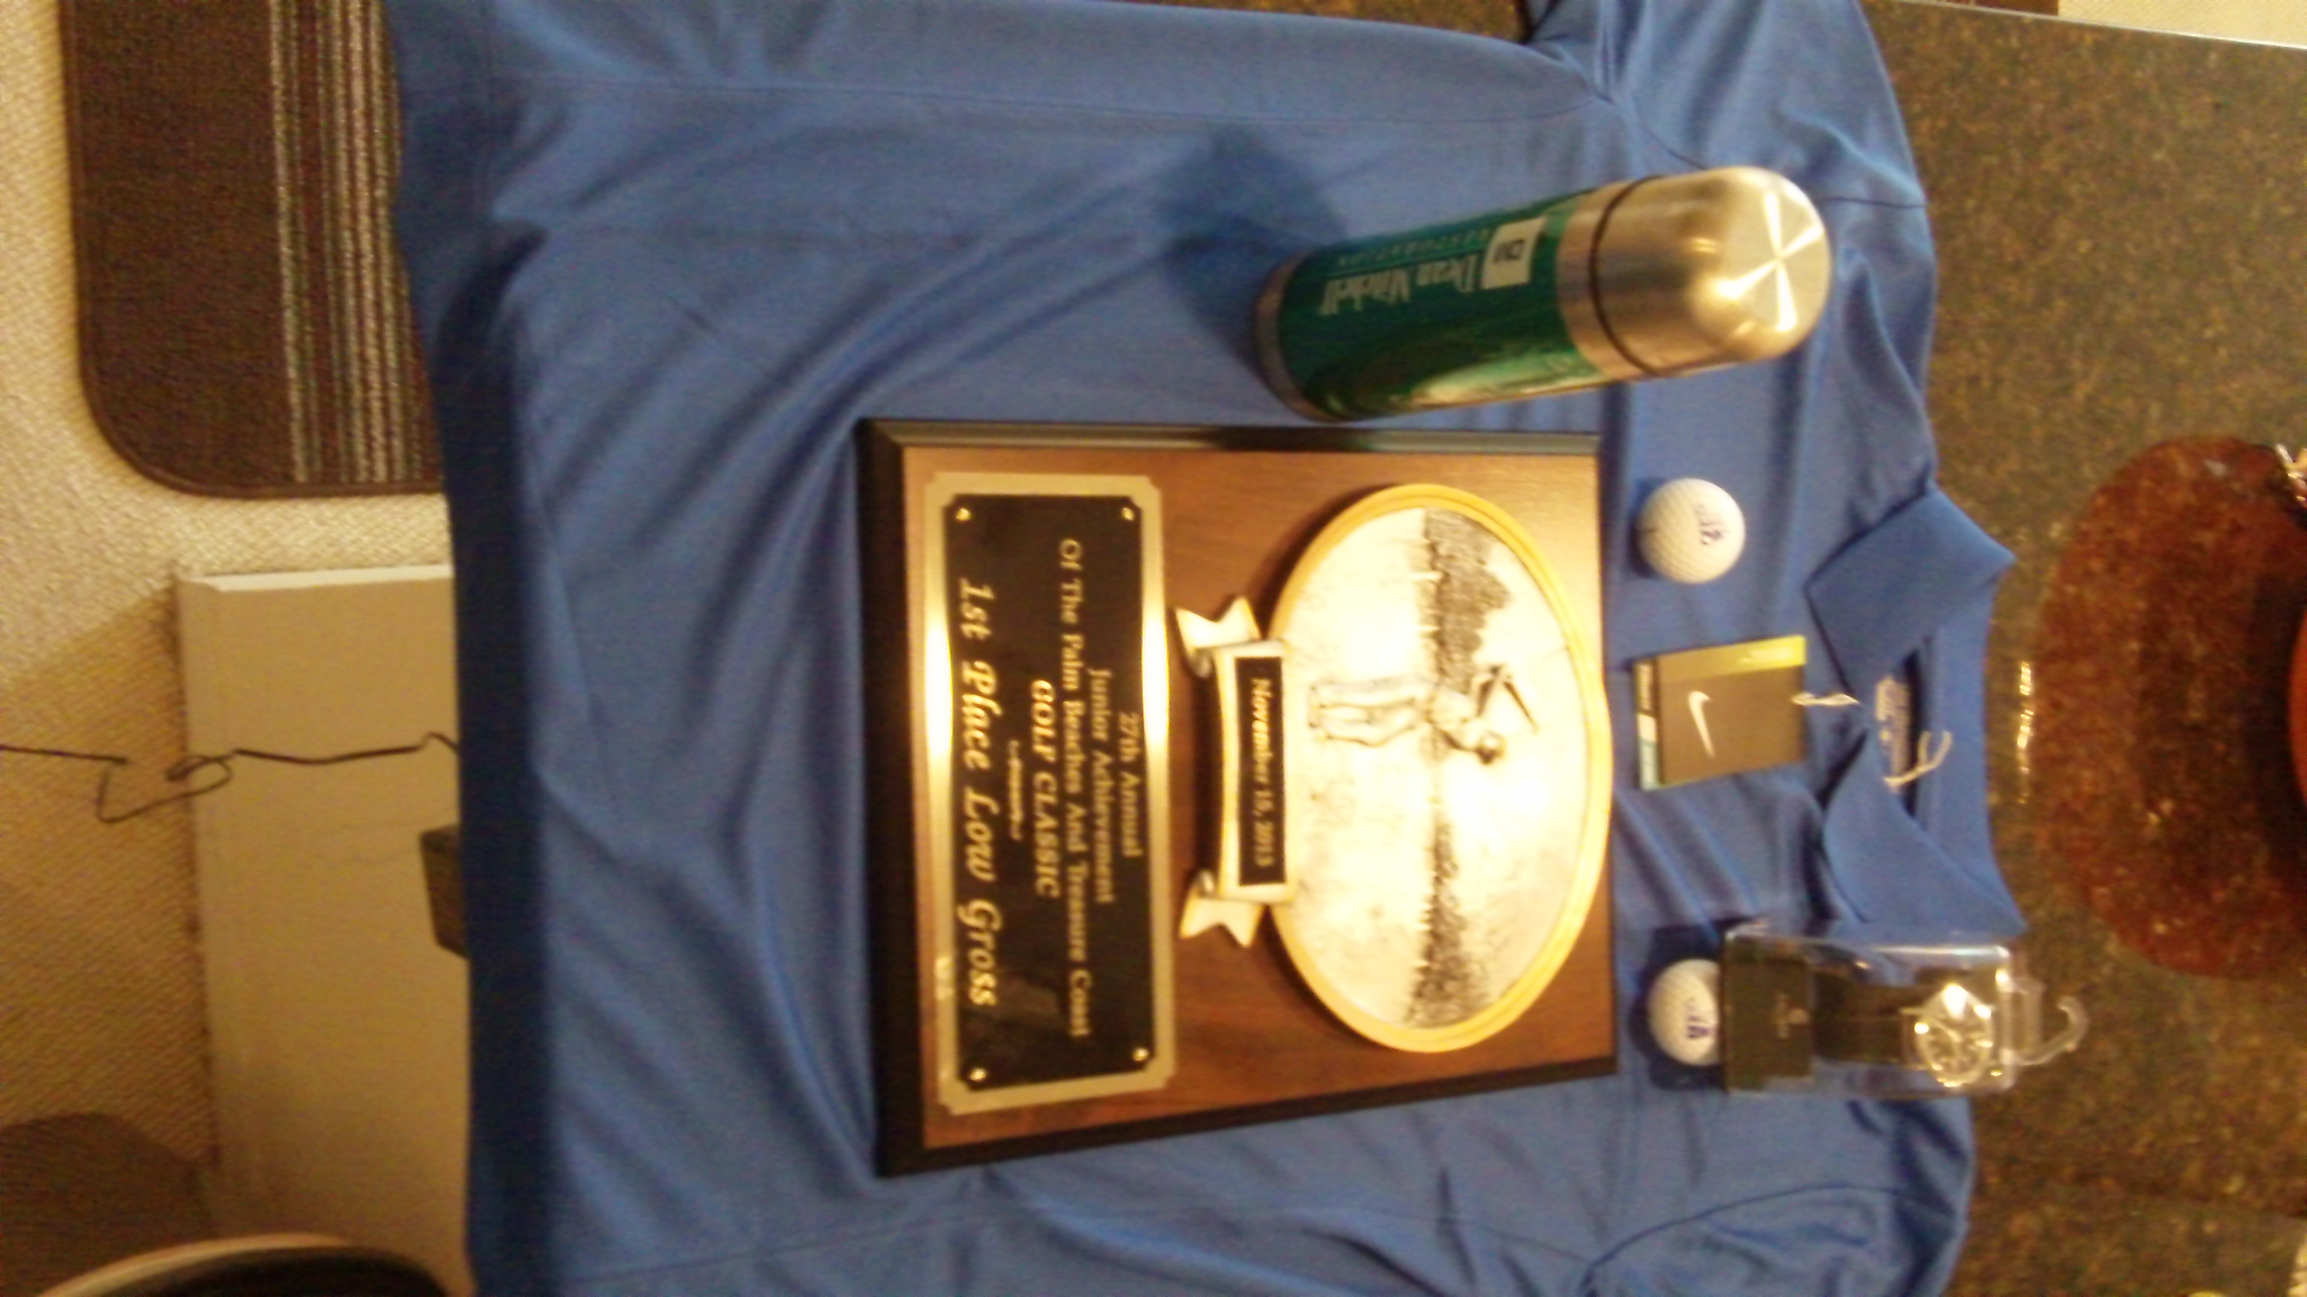

Of course, the round of golf was followed by “happy hour” and then a dinner of pizza and beer! But it was cheat day, so it was OK, right? And then disaster struck!
The football Sunday fiasco! (the disaster continues…)
I was literally days away from boarding a plane to Thailand. I had successfully shed pounds and shredded body fat. I was so close! And then disaster!
Specifically, it was football Sunday. I spent it with two friends who have no “caloric conscience” and once again I proved my lack of willpower.
Don’t get me wrong. I had a great time. They’re fantastic friends. They just don’t care about diet and fitness like I do. Few people do!
I met them at a restaurant/bar called Grease on Clematis on West Palm Beach wearing my Jay Cutler jersey. Not that I’m a big Jay Cutler fan, but growing up near Chicago, I am a fair weather Bears fan and I got the jersey at a bargain price somewhere so I wear it to show my support for the Monsters of the Midway!
When I arrived, my buddies were already on their second pail of Bud Light. I ordered an iced tea and told them I wasn’t drinking beer because I was getting myself in “beach shape” for Thailand.
But I didn’t last long. Within 20 minutes I was swilling a Bud Light. Then of course they ordered wings and sliders – things I rarely eat. I had a wing or two and I had a few sliders too – just the meat (no bun of course).
Five hours and who knows how many empty calories later, I walked back to the “party condo” disgusted with myself. I know I have no willpower. My best solution is to avoid those types of situations.
I could have said no, but what fun is it to sit on the couch alone and avoid life? It’s no fun at all! I like being sociable. It’s fun to hang out with friends and meet new people. So that’s what I decided to do.
But I was horrified to step on the scale and see the eye-popping numbers from a whole weekend of cheating. 172 pounds and 15% body fat!
Oh no! Three and a half weeks of discipline down the drain! I was almost back to where I started. What a bummer!
Fortunately, the “Thai Beach Body Challenge” was not over yet. I still had a few days so I went into massive caloric deficit mode as I’ve described previously.
And the results did not disappoint. The truth is that scales can be off so I may not have actually been 172 pounds and 16% body fat. That’s just what the scale said at the particular point in time when I stepped on the scale.
(Remember how I told you I had a low reading of 13.9% that I didn’t believe was accurate. I was hoping this reading was high).
In any event, by the time I left for Thailand, the final results were:
169 pounds and 14.2% body fat.
All things considered, I was very happy with the results.
Final “Thai Beach Body Challenge” results
So here is a summary of my weekly measurements:
Starting point: 175 lbs – 15.8% body fat
Week 1: 172 lbs – 15.2% body fat
Week 2: 170 lbs – 14.8% body fat
Week 3: 170 lbs – 14.7% body fat
Final Results: 169 lbs – 14.2% body fat
So you can see my results improved a little each week. Ultimately, I shed 6 pounds and shredded my body fat from 15.8% to 14.2% in just 28 days. Like I said, I am pleased with those results, and…
Here’s how you can experience even better results!
Those may not sound like impressive results but consider that I really didn’t have much excess weight to lose in the first place. I’m not bragging but my starting point of 175 lbs and 15.8% body fat is outstanding for a 47 year-old male.
The fact that I was able to shed 6 pounds and over 10% of my body fat in 28 days proves “Shed Pounds to Shave Strokes” delivers the results to back up its promises.
If you have more to lose than I did – in other words if you have 10, 20, 30, or more pounds to lose – then you should see even better, more outstanding results from following this program. And remember, I “cheated” liberally – at least one day each week – plus almost the entire last weekend when I caved in to the social pressures we all face.
That just proves you don’t have to starve yourself. It’s OK to “cheat” now and then as long as you eat sensibly most of the time and follow the exercise program laid out in “Shed Pounds to Shave Strokes.”
Also notice that I hit a plateau between Weeks 2 and 3. The results were almost identical. Remember, that’s when I consulted with Chris – the guy who created “Shed Pounds to Shave Strokes.”
And you can clearly see that following his advice quickly produced results as I torched off more stubborn body fat.
To recap, Chris told me I had reached a point where I needed to add muscle in order to reduce my body fat. He recommended building muscle by using more weight and doing less reps. And that’s exactly what I did.
Plus I increased my high-intensity cardio workouts by 4 minutes adding 2 more intervals to each session to burn off more calories.
The results clearly show that I did in fact shed pounds and shred body fat…but did I shave strokes off my golf score?
Added power and distance (more 300+ yard drives than ever!)
Unfortunately, to this point, I have failed in my quest to break 90 at Mayacoo Lakes golf course. My lowest score to date is 91 and I’ve shot in the low 90’s several times.
I’m convinced I had a great shot at achieving this goal recently. I shot a 44 on the front nine (could have been lower if not for that damn triple bogey! – but isn’t that usually the case?). So with a 45 or better, I’d have broken 90.
The back 9 started out promising with three straight bogeys. Barring a blow-up hole, I was on track to finally break 90 at Mayacoo Lakes! Unfortunately, it’s December. And what happens in December? It gets dark early!
So due to darkness, we were forced to end our round after only 12 holes. And we’ll never know if I’d have broken 90 that day. It’s frustrating to be so close and not have a chance to finish but that’s life. And there will be more chances.
It’s a very challenging and unforgiving course where just one bad shot can lead to a high score that ruins your round. I’m determined to break 90 at Mayacoo Lakes in the near future, but as of this writing I have not done it.
On the other hand, I have definitely added power and distance to my golf game. I’m hitting longer shots with all clubs more consistently.
For example, the other day at the Hill Country Club in San Antonio, I had three drives of 300+ yards.
Specifically, on the Creeks Course, I had a 140-yard approach shot on a 450-yard par 4 1st hole. That’s a 310-yard bomb.
My drive on the 538-yard 4th hole (a par 5) ended up right next to a marker indicating 223 yards to the green. That means I scorched my drive 315-yards.
And on the 530-yard 9th hole, another par 5, I only had 190 yards to the green after my drive. That’s a 340-yard drive.
And that was on only 9 holes. Considering two of the holes were par 3’s and I know I hit a 3-wood of at least one other tee, that means half my drives were over 300 yards – not bad for a 47 year-old!
To be clear, I could hit 300 yard drives before “Shed Pounds to Shave Strokes” but I don’t ever recall hitting the ball this far so consistently – and in play too! I can’t remember ever hitting three 300+ yard drives on 9 holes.
And it’s not just the driver. It’s my short irons too. For example, my 56 degree sand wedge has been my “100-yard club” for some time. But now I’m hitting it 110 yards. I know this because lately I’ve been consistently long from 100 yards – and it’s all been since I started the workouts Chris put together in “Shave Pounds to Shave Strokes.”
Based on my personal experience, I have no doubt this program has helped me shed pounds, shred body fat, and add power and distance to my golf game.
It hasn’t lowered my scores – at least not yet. However, I can’t blame that on Chris. I have to take responsibility for that. While my power and distance have improved noticeably, my accuracy has not.
When I increase my accuracy, I have no doubt I’ll shave strokes off my game with the power and distance I’ve added through “Shave Pounds to Shave Strokes.”
And I have no doubt you can see similar results in both your physical appearance and in adding power and distance to your golf game if you’ll make the commitment to try “Shed Pounds to Shave Strokes.”
how shed pounds to shave strokes can add power & distance
When it comes to distance, the key is clubhead speed. All other things being equal, when you increase your clubhead speed, you’ll hit the ball farther. It’s as simple as that.
So how do you increase your clubhead speed. One way is to increase your strength. Another way is to increase your flexibility. Even better is to improve both your strength and your flexibility at the same time.
And that’s exactly what the “Shed Pounds to Shave Strokes” program does. Follow it and you’ll improve both your strength and your flexibility. And when you do, you’ll notice you’re hitting the ball farther.
As a general rule, adding just 1 mile per hour (mph) to your clubhead speed adds 5 yards to your driver. So adding 4 to 5 mph to your clubhead speed adds 20 to 25 extra yards off the tee. And you’ll hit your irons farther too.
This added power and distance can make a tremendous difference in your golf game. Why?
Consider this example:
Let’s say you play a course with a 400-yard par 4 – that’s not unusual. And let’s say you hit your drives about 230 yards on average. That leaves you with an approach shot of 170 yards. You’ll probably hit a 5-iron – and you may even need more club than that.
Now let’s say you improve both your strength and flexibility through the “Shed Pounds to Shave Strokes” program. Let’s say you increase your clubhead speed by 4 mph. That means you’ll add about 20 yards to your drives. So now instead of a difficult 170-yard approach shot, you’ve got a much easier 150-yard approach shot.
So now you might hit a 7-iron instead of a 5-iron. How many more greens do you think you’ll hit with a 7-iron vs a 5-iron? Hopefully, you’ll hat a lot more greens (and be closer to the pin). After all, you ought to be more accurate with a shorter iron, right?
However, that’s not all. It’s not unreasonable to think with your added power and distance, you’ll also be hitting your irons farther. And you may need less club for a given distance.
For example, whereas before “Shed Pounds to Shave Strokes” your 150-yard club may be a 7-iron, with increased clubhead speed, you may now need only an 8-iron to cover the 150-yards.
This is a very real possibility. Personally, I’m still adjusting to my newfound power. I’m hitting irons over greens like never before. I’m consistently hitting one club less into greens.
So in this example, you could go from hitting driver, 5-iron to reach a 400-yard par 4 to hitting driver, 8-iron into the same hole! It’s a very exciting – and a very real possibility.
Plus, there’s the matter of improving your physical appearance and getting into “beach” shape. My own “before” and “after” photos show what’s possible when you commit yourself:

There’s no reason at all you can’t see a physical transformation similar to this – not to mention increasing your endurance and stamina and adding power and distance – when you commit to “Shed Pounds to Shave Strokes.”

If you’re ready to get started and make 2014 a transformation year:
Click Here NOW To Make 2014 The Best Year Ever
For Both Your Fitness Level And Your Golf Game…
[we need to add a special offer with urgency to this too!]
but did I regain the weight in Thailand?
Here’s the short answer: NO!
Don’t get me wrong, we took full advantage of the nightlife in Thailand! We didn’t hold back either. We enjoyed the excellent Thai cuisine and stayed out way past midnight eating and drinking.
I took my measurements after 2 weeks in Thailand and I was not surprised to see they had not changed much. As a matter of fact, my body fat had gone down!
Here are my post-Thailand measurements: 170 pounds – 14% body fat
How is that possible?
Simple. Commitment and discipline.
First of all, we were constantly on the move and walking a lot. That burns calories.
Secondly, I made a point to workout – not everyday but roughly every other day. Most of the hotels we stayed at had gyms with dumb bells and treadmills. So I was able to get a “Shed Pounds to Shave Strokes” workout in.
Remember, with this simple, proven, and scientifically tested program, it only takes about 45 minutes to complete a challenging workout. And, as you can see, the results justify the small effort.
And when no gym was available, I reverted to my bodyweight exercises. It’s amazing how effective using just your body can be. It’s a fantastic workout and I can definitely feel it the next day – especially in the legs.
Remember though, diet is more important than exercise, and I believe that was the real key. Fortunately, the friend I traveled with is just as serious about diet and fitness as I am – and possibly even more!
We usually only ate one or two small meals per day. That’s more or less intermittent fasting. And it came naturally. It wasn’t by design.
We stayed out late so we didn’t exactly wake up early! And for some reason, we just weren’t hungry much. I don’t know why. Maybe it was the excitement of being in Thailand, having so much to do, and being so active. Maybe it was because we don’t overeat to begin with. Who knows?
However, it was not a matter of starving ourselves to stay thin – not at all! We made sure to hit a Thai (or Indian) restaurant for dinner each night. And we drank beer with dinner too!
All in all, I’d say it was simply the discipline and commitment to diet and exercise that led to shredding even more body fat in Thailand. This proves you can go on vacation, have a great time, and still say thin!
Click Here NOW To Make 2014 The Best Year Ever
For Both Your Fitness Level And Your Golf Game…
After Thailand (long term results)
I’m now back in the US. I’m in Arizona for Christmas. You’d expect that perhaps I’d pack on some holiday pounds – but you’d be wrong! I’m staying fit.
Remember, earlier I explained how my definition of diet is completely at odds with the message the diet industry’s marketing machine wants you to believe.
To me, diet is a lifetime philosophy of eating – not a short-term solution to drop a few pounds. Then go back to eating crap! It’s ridiculous to think you’re not going to pack the pounds right back on when you go back to eating crap!
I’m still eating the same stuff I ate while on the “Thai Body Beach Challenge.” Mainly vegetables, some fruit, and for protein I’m eating chicken and cottage cheese.
As a matter of fact, the very first thing I did when I arrived in Arizona was to go to a local market and buy a refrigerator full of vegetables. Then I chopped them up into a salad.
For breakfast I dump some of the salad into a skillet with coconut oil, crack two eggs and scramble it all into a delicious breakfast. I also chop up a sweet potato and make sweet potato hash browns.
For lunch and dinner, I add chicken and the various dressings I’ve already shared. Ranch dressing made with cottage cheese (not buttermilk or sour cream!), salsa, and balsamic vinegar.
And on Saturday I cheated. We ordered a pizza and I drank some red wine.
In other words, I’m following the same “diet” I followed during the “Thai Beach Body Challenge.” It’s not a short-term “lose a few pounds” crash diet to me. It’s a long-term philosophy of eating that I stick too.
That’s how you shed pounds, shred body fat, and keep it off while still leaving the flexibility to “cheat” and enjoy the “junk food” you like. As a matter of fact, I encourage you to cheat! I explained the concept of “cheating” and its benefits earlier.
Click Here NOW To Make 2014 The Best Year Ever
For Both Your Fitness Level And Your Golf Game…
Golf in thailand
As I said, I played a round of golf while I was in Thailand. I played 9 holes at The Chiengmai Gymkhana Club. The course has only 9 holes. You can play 18 by going around a second time but I elected not to because I just wanted to get a flavor for golfing in Thailand. Believe me, there is plenty more to do in Thailand than playing golf!
One of the reasons I played this course is that it’s close to the city and that’s where I was staying. A short inexpensive cab ride of 200 Thai bahts (THB) got me safely to the course. That’s about $6 US.
I didn’t even have a tee time. I called the course from my hotel and they told me to just come on out. Upon my arrival, I was able to rent clubs and head for the first tee immediately.
At this course, golf was quite inexpensive. I don’t remember the exact breakdown on each particular item but I rented clubs (about 300 THB – less than $10 US), paid my greens fee (about 300 THB), paid for my caddie (100 THB – about $3 US), and bought some balls all for not much more than $20 US. That’s a lot cheaper than I would expect to pay anywhere in America.
To be honest, it was in fair condition – nothing spectacular. I’d compare it to an average muni course in the US – maybe even a little worse. But it was good enough for me. The price was right and the location was even better.
In my research, I discovered there are actually several highly-rated golf courses near Chiang Mai but most of them were a 30 to 60 minute drive from the city and I just didn’t want to add an hour or two of commuting time to my day.
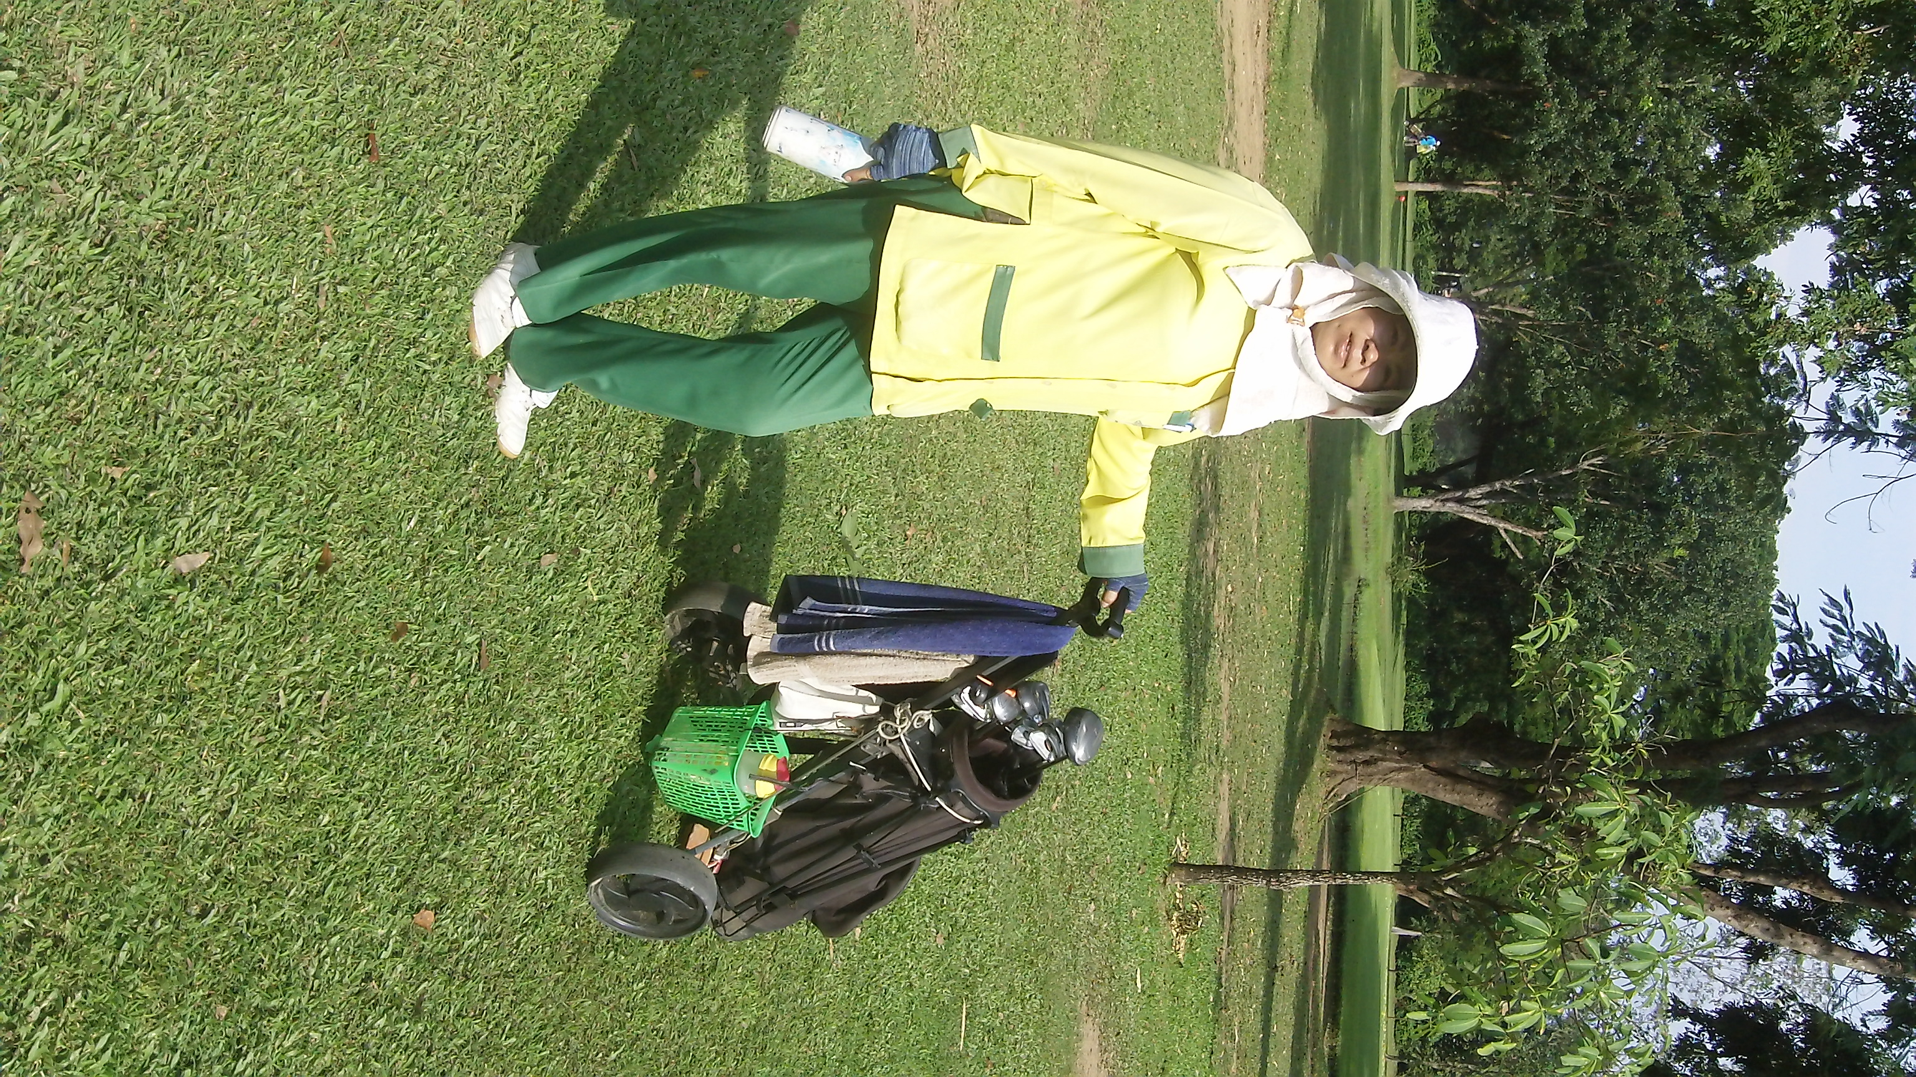
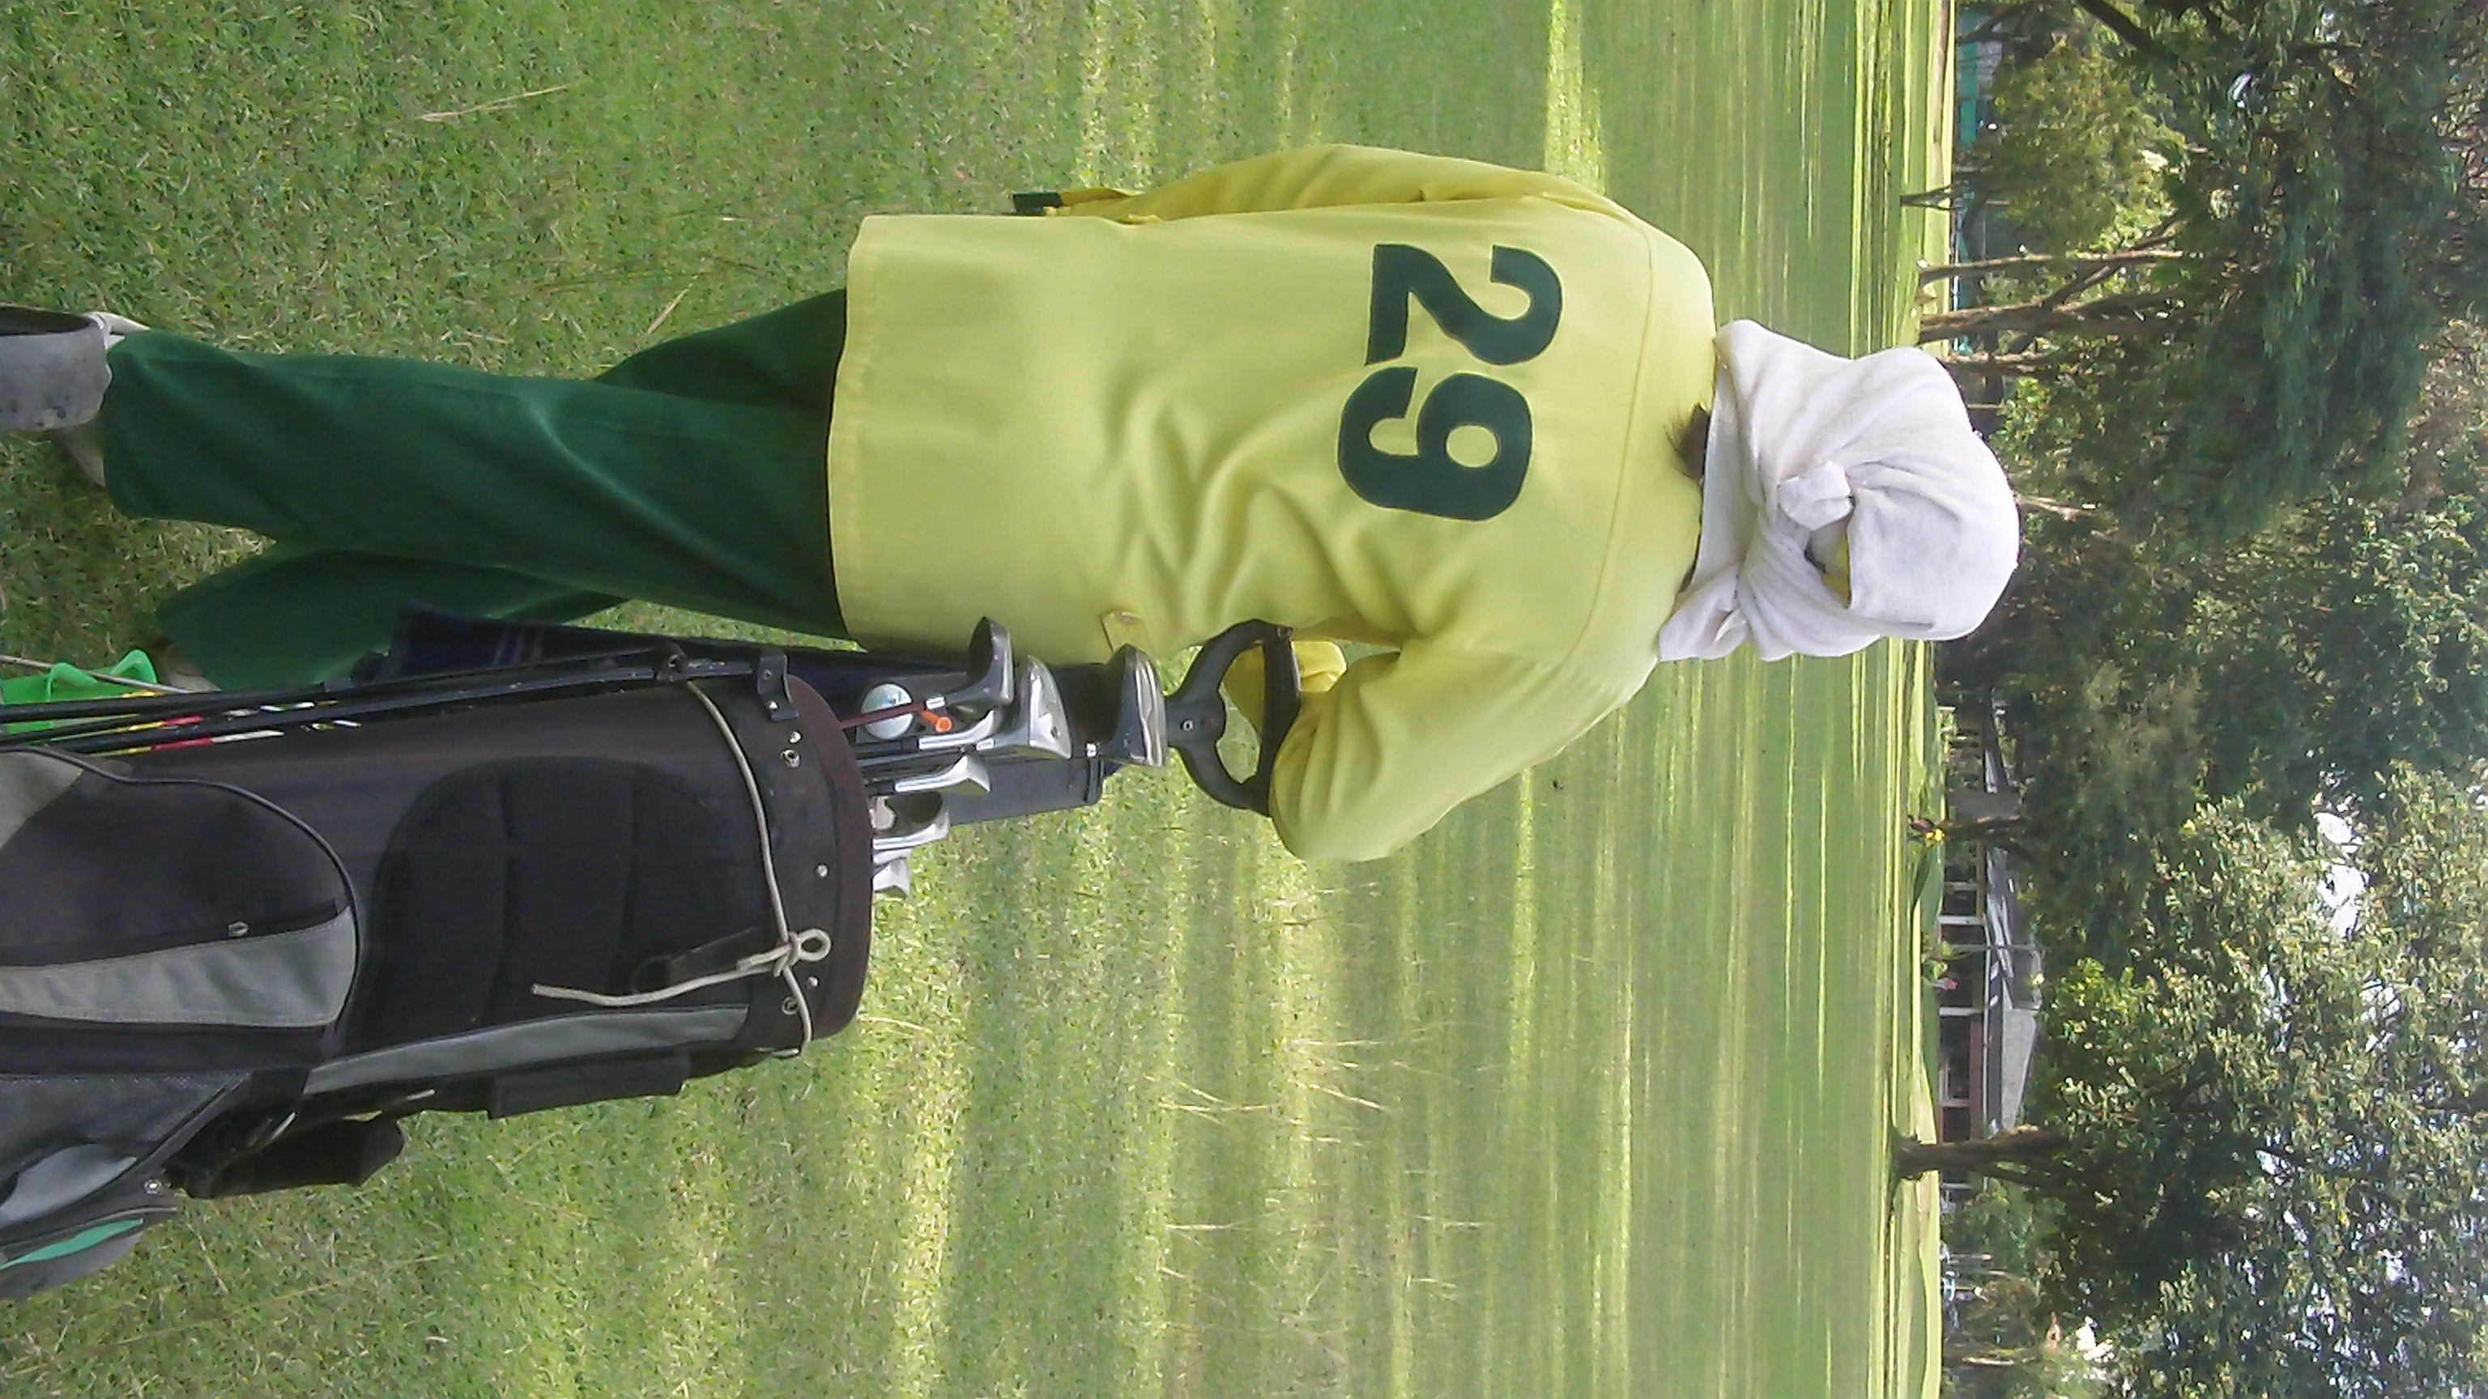
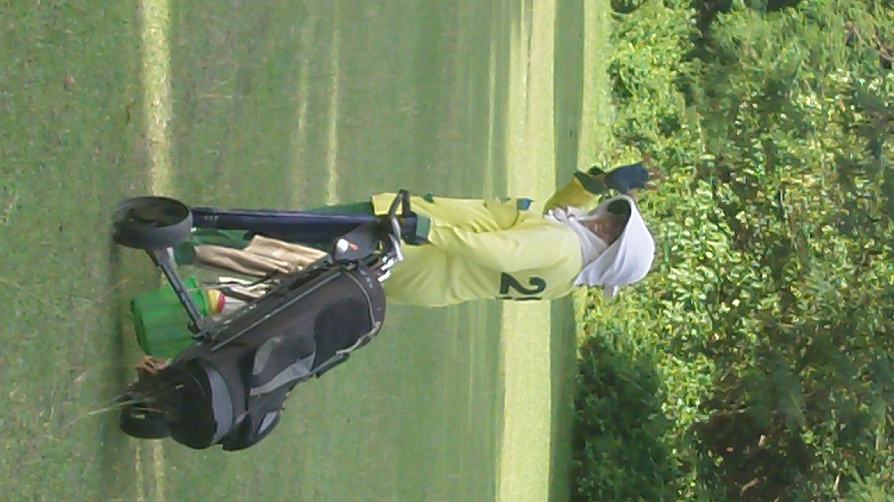
Here are a few photos of my caddie. I forgot her name but she was friendly, knowledgeable, and helpful. She gave me distances (in yards, not meters), suggested clubs, spots to hit shots, and gave me reads on the greens – everything you would expect from a caddie. And she spoke English well enough that we had no communication issues.

Thailand is warm but I didn’t find it particular hot. Of course, my reference point is south Florida and November – January is “the cool season.” Apparently my caddie disagreed. As you can see she was all bundled up to protect herself from the sun. To be fair, as a caddie, she probably spends most of the day in the sun and should take steps to protect herself.
And here’s the scorecard:
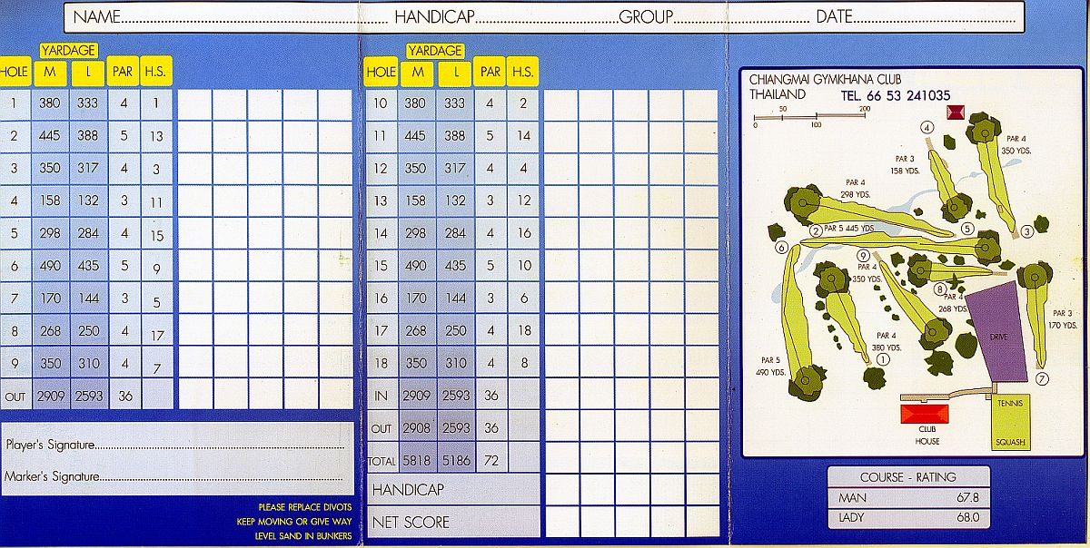
So you can see, it’s a short course too. Honestly, I think there are better courses to play but there were just too many other things to do in Thailand so I chose to play the nearest course as opposed to drive an hour both ways to play a much better course.
OK, so how about the round of golf? How did that go? It was basically the same old story: 3 tap in pars, 4 bogeys, and 2 of the dreaded “others.” Let the excuses begin!
Granted I would classify this as both a short course and an easy course. However, it’s tough playing any course with rented clubs! Especially with no warm-up!
Here are some of the highlights:
1st hole: I took a 3-wood and hit it straight down the middle! The only problem was I hit a ground ball that went about 50-yards – oops!! My caddie told me I had lifted my head. I’d have to agree!
So I asked for another ball because surely I get a “mulligan” on the first tee when I’m playing with rented clubs and didn’t get a chance to warm up, right? I pounded this one and it landed in the fairway – the wrong fairway!
I think it was the 6th fairway. So we walked over to my ball and my caddie told me I had 200 yards and handed me a 5-wood. And I put it on the green! The 6th green that is – so I took a drop and hit it over the green. At least it was the correct green this time!
Then I put it on the green and 2-putted for my double-bogey 6. Ouch! But that’s what happens when you don’t get to warm up! (Note: I think the diagram of the course on the scorecard is a bit off. I know I hit the wrong green on the first hole but I don’t see it on that course map).
My caddie must think I really stink after that exhibition, right? So we walk over to the 2nd tee box – short par 5 and my caddie hands me the driver and tells me to swing away. Here’s the view from the tee box (below). This course was short but it was also quite narrow!


I thought the group ahead of me looked a bit close but my caddie told me to hit so I did. And I connected!! I heard her gasp and then she yelled “fore!” The group in front of us scattered like ants as the ball landed amongst them! Considering I didn’t hit them – just scared them – I found it hilarious.
Here’s where my tee shot landed (the small white ball is bit below and the right of the center of this photo):


I only had a 7-iron in for my second shot. Admittedly that’s not so difficult on such a short par 5 but I hit my drive somewhere in the neighborhood of 300 yards. And from then on, my caddie never let me hit my tee shot until the group ahead was long gone.
Of course I yanked my approach shot left, chipped on to the green to about 20 feet or so, and just missed my birdie putt. It was oh so close! And the speed was about perfect – a foot past the hole. And I tapped in for a disappointing par.
I won’t bore you with the hole by hole, shot by shot recap. Just a few highlights:
I stuck my tee shot on the 4th hole to about 15 or 20 feet below the hole. Of course I missed the birdie putt! These greens were S-L-O-W! I knew the put was uphill and I knew the greens were slow.
I thought I had hammered the putt (never leave a birdie put short, right!) but apparently not. I left it five feet short (and right online of course!). Fortunately I made the par putt.
Here’s where it ended up (the ball is below the flag in the shadow of the tree almost right square in the middle of the photo):

Here’s the view of the clubhouse walking up the 9th hole. Apparently the big tree has gained a measure of notoriety. I have to admit it does look good, but rather than look at it I found it a great source of shade! I took full advantage of it when I enjoyed a cold beer after the round.




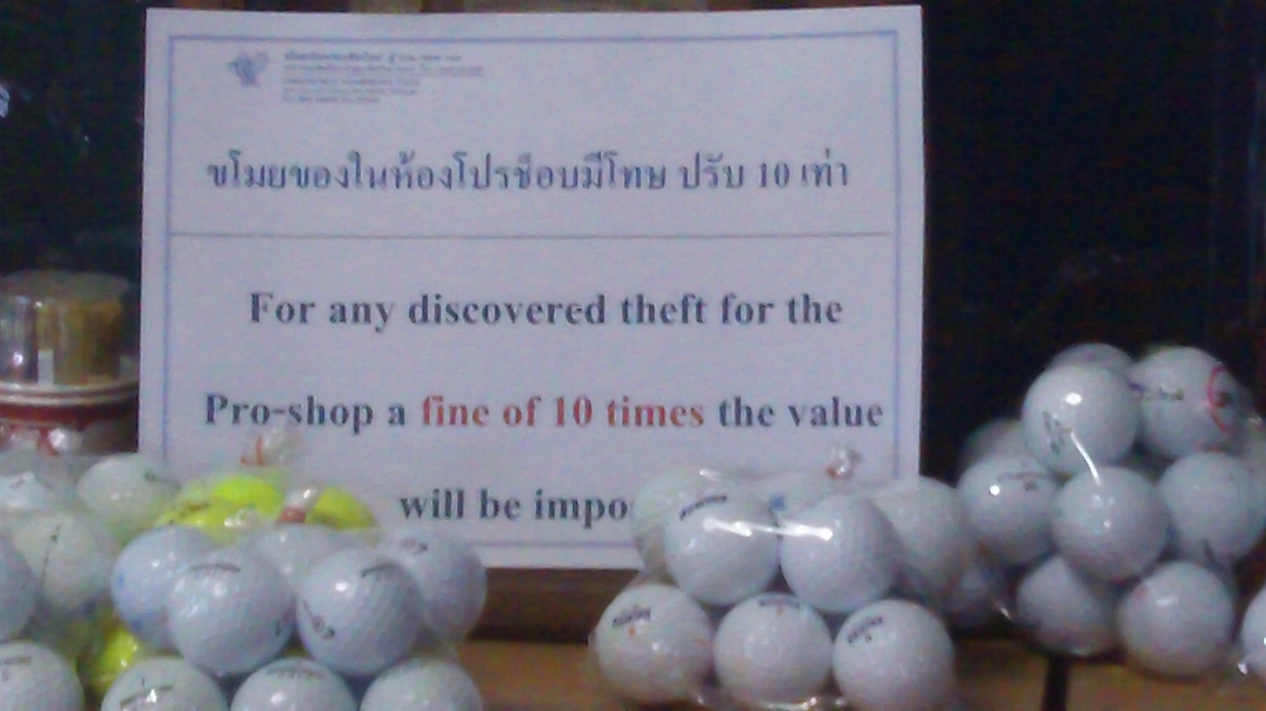
All in all it was a good afternoon. I’m glad I played a round of golf in Thailand – even if it was only 9 holes. After the round, when I returned my clubs, I noticed this sign in the pro shop:

Of course, that’s Thai at the top and I certainly can’t read it. However, English is widely spoken in Thailand and I found most signs to be written in both Thai and English. Stealing is a bad idea to begin with, but you don’t want to be caught stealing in Thailand or you’ll pay a fine of 10 times the value of the stolen merchandise!
And finally, here’s me enjoying my reward for surviving the short round – a tall bottle of Tiger beer! Mmmm! It really hits the spot on a warm, sunny day!


Here I am enjoying an ice cold Tiger beer after playing 9 holes in Thailand.

Oh, and one more thing. Remember the yellow t-shirt I showed at the beginning of this case study? This one:

I told you I found it so funny that I bought the t-shirt and I promised I’d tell you what it said. This is in Patong Beach in Phuket. It’s a very touristy place. There are “tuk tuks” – a kind of taxi – all over the place. And the tuk tuk drivers are constantly asking if you need a ride. In addition, there are massage parlors everywhere. And outside each massage parlor, you’ll find masseuses trying to sell you a massage. And finally, there are other vendors trying to sell suits.
So it seems like you can’t take three steps without being asked about a tuk tuk ride, a massage, or a suit. And trust me, it gets annoying after a while!
Don’t get me wrong. Thais are very friendly people. I didn’t find them obnoxious or rude. They were just out hustling, working, and trying to make money. I can respect that. Even so, it still gets annoying being constantly under attack!
So realizing this, some enterprising Thai had a t-shirt made up. It’s written in Thai on the front and in English on the back. Here’s the back of my t-shirt:

Just in case you can’t read that, it says:
NO I DON’T WANT A F*?K’N
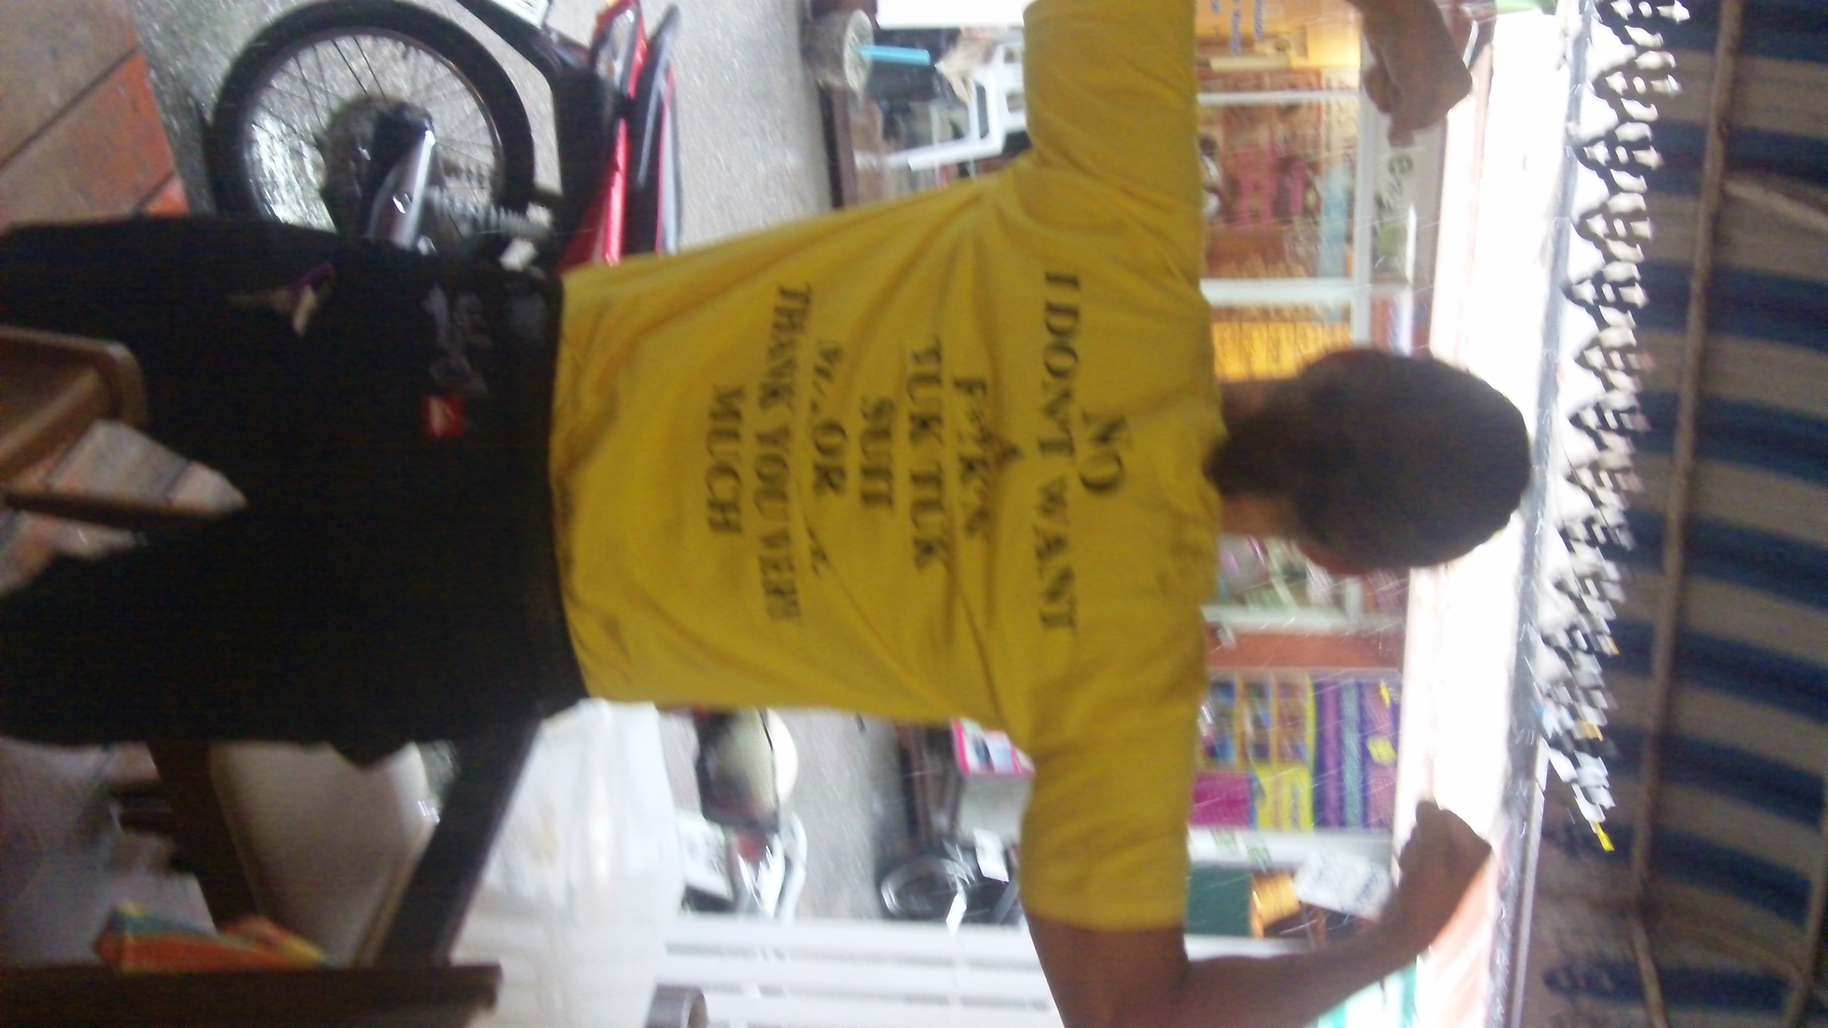
TUK TUK, SUIT, OR MASSAGE
THANK YOU VERY MUCH
If you don’t find that funny, then you
haven’t walked around the streets of Patong
Beach for a few days! Otherwise you would
definitely see the humor in it!
I hope you’ve learned something that will
help you achieve your goals in fitness,
in health, in golf, and in life.
And most of all I hope reading this case
study has inspired you to take your own
challenge to shed pounds, shred body fat,
improve your stamina and endurance, add
power and distance to your golf game, and
take steps to improve your overall health and
quality of life.
There’s no better time to get started than RIGHT NOW while you’re thinking about it!
Click Here NOW To Make 2014 The Best Year Ever
For Both Your Fitness Level And Your Golf Game…
[link to offer – probably need to add links in a few other places too]

Now go through this with Benson’s VSL formula in mind…tease what’s coming up…tell the reader to “keep reading”…and highlight important words and phrases in red…can I possibly use this report as the basis of a VSL?
talk about my diet and exercise in Thailand and in Phoenix….it’s the same…My “SPSS” diet was not temporary. It’s a philosophy of eating….

